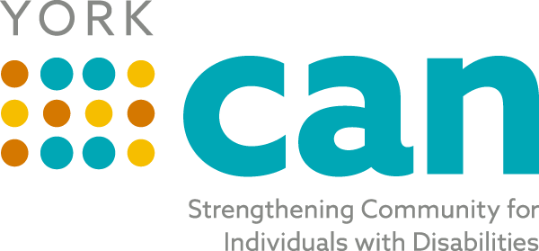
Envisioning a fully inclusive York County community with equitable opportunities for people of all abilities
Our Mission is to bridge self-advocates, service providers, families, caregivers and professionals to make York County a better place to live for people of all abilities.

Steering Team Agenda
Tuesday, October 19th, 2021
8:00 AM
Zoom : https://zoom.us/j/92271896496

Topic | Person
Welcome/ Review of Minutes from last meeting | Laura
Old Business/Updates:  Kickoff Event Report Out  Disability Employment Awareness Month Activities  York CAN Connect Work Group  Friendship Circle group  Transition Advisory Council | Samantha/Laura  Laura  Laura  Laura  Vicki
Topics for Today’s Discussion:  - Review current board and ideas of members to add/Officers identified in future  - Employment Strategic Team  - Resource Mapping Team? | Laura/All  All
Future Topics:
- Talent Pipeline
- ADA Coordinators
Review Action Plan Items/ Next Steps- Adjourn | All

Next Meeting: Tuesday, November 16th 2021 at 8:00 AM

