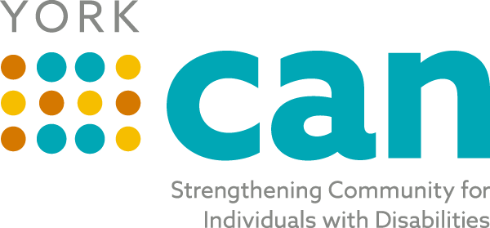
Envisioning a fully inclusive York County community with equitable opportunities for people of all abilities
Our Mission is to bridge self-advocates, service providers, families, caregivers and professionals to make York County a better place to live for people of all abilities.

Steering Team Agenda
Tuesday, August 17th, 2021
8:00 AM
In Person at Gravity Center- Basement-153 Oakland Ave, Rock Hill 29730
Zoom : https://zoom.us/j/92271896496

Topic | Person
Welcome/ Review of Minutes from last meeting | Laura
Old Business/Updates:  NDEA Mayor Proclamation Work Group  Disability Employment Awareness Month Activities  Lunch and Learn Work Group  York CAN Kickoff Team  Brochure  Newsletter | Laura/Michelle  Laura  Laura  Samantha  Laura  Lily
Topics for Today’s Discussion:  - Vote on final version of Articles of Collaboration and Organizational Structure  - Review current board and ideas of members to add  - Nominations Committee to be formed  - Website review and comments  - Next steps for Strategic Planning | Laura/All  All  All  All  All
Future Topics:
- Strategic Planning- September/October
- Talent Pipeline
- ADA Coordinators
Review Action Plan Items/ Next Steps- Adjourn | All

Next Meeting: September 21st 2021 at 8:00 AM

