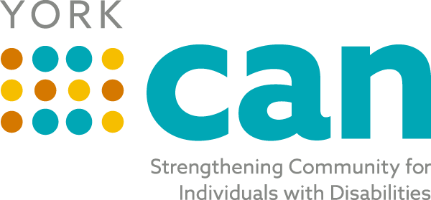
Envisioning a fully inclusive York County community with equitable opportunities for people of all abilities
Our Mission is to bridge self-advocates, service providers, families, caregivers and professionals to make York County a better place to live for people of all abilities.

Steering Team Agenda
Tuesday, July 20th, 2021
8:00 AM
In Person at Gravity Center- Basement-153 Oakland Ave, Rock Hill 29730
Zoom : https://zoom.us/j/92271896496

Topic | Person
Welcome/ Review of Minutes from last meeting | Laura
Website Update and Roll out | Sam Walton  Waxwing Creative
Old Business/Updates:  NDEA Mayor Proclamation Work Group  Lunch and Learn Work Group  York CAN Kickoff Work Group  ADA Coordinator Update  Focus and Partner Meeting Updates  Newsletter | Laura/Michelle  Laura  Samantha  Jordan  Laura  Lily
Topics for Today’s Discussion:  - Terminology for Steering Team and York CAN groups  - Collective Impact Model and our organizational structure  - Articles of Collaboration and Agency agreement | Laura/All
Future Topics:
- Strategic Planning- August/September
- Talent Pipeline- After Kickoff- November
Review Action Plan Items/ Next Steps- Adjourn | All

Next Meeting: August 17th 2021 at 8:00 AM

