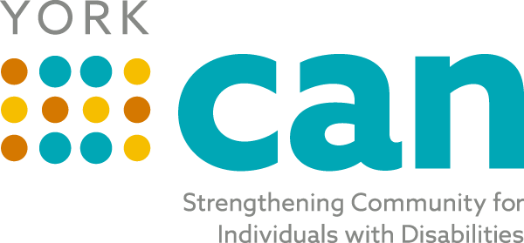
Envisioning a fully inclusive York County community with equitable opportunities for people of all abilities
Our Mission is to bridge self-advocates, service providers, families, caregivers and professionals to make York County a better place to live for people of all abilities.

Steering Team Agenda
Tuesday, June 8th, 2021
8:00 AM
In Person at Gravity Center- Basement-153 Oakland Ave, Rock Hill 29730
Zoom : https://zoom.us/j/92271896496

Topic | Person
Welcome/ Review of Minutes from last meeting | Laura
Old Business/Updates:  NDEA Mayor Proclamation  Webpage/Facebook Updates- post protocol- June launch  Follow Up from Greenville CAN Presentation | Laura/Michelle  Laura  All
New Business and Updates:  * Review of Themes from Focus groups/ Next group-6-17-21  * Next Informational Meeting- Thurs. 6-24-21 at Noon  * ADA Coordinator Information Update-? Next steps  *York CAN Kickoff- Resource Night- October 5th  * Lunch and Learn events- ? August  * Transition Advisory Council- Add as a Priority Work Group | Laura  Jordan  Samantha  All
Topics for Today’s Discussion:  - Terminology for Steering Team and York CAN groups  - Collective Impact Model and our organizational structure  - Articles of Collaboration and Agency agreement | Laura/All
Future Topics:
- Review website/guidelines for posting- July
- Strategic Planning- August/September
- Talent Pipeline- After Kickoff- November
Review Action Plan Items/ Next Steps- Adjourn
Next Meeting: July 20th 2021 at 8:00 AM

