York CAN, 05/18/2021 (EWD notes)
Attendees:
- Laura Elder; Lily Asaad; Liz Duda; Crystal Guyton; Jordan Hayes; Julia Khaled; Grace Lewis (for Samantha Krieghauser); Seth Zamek; Michelle Schaffer, Mandy Wolff
- Greenville CAN Guest speakers: Chris Sparrow and Mike Teachey
- Absent: Frank Keel; Warren Norman
Followups:
- Request articles of collaboration
- Identify ADA coordinators at municipalities and county
- Identify SHRM leader in York County
- Share focus group and organizational meeting notes, and takeaways/themes at our June meeting. Strategic planning
Potential followups:
- Jordan Hayes volunteers to roll through local businesses to see if they are wheelchair/ADA friendly.
- Due to scheduling issues the June Steering Team meeting will be moved to Tuesday, June 8th at 8:00 AM. We will resume our regular schedule in July.

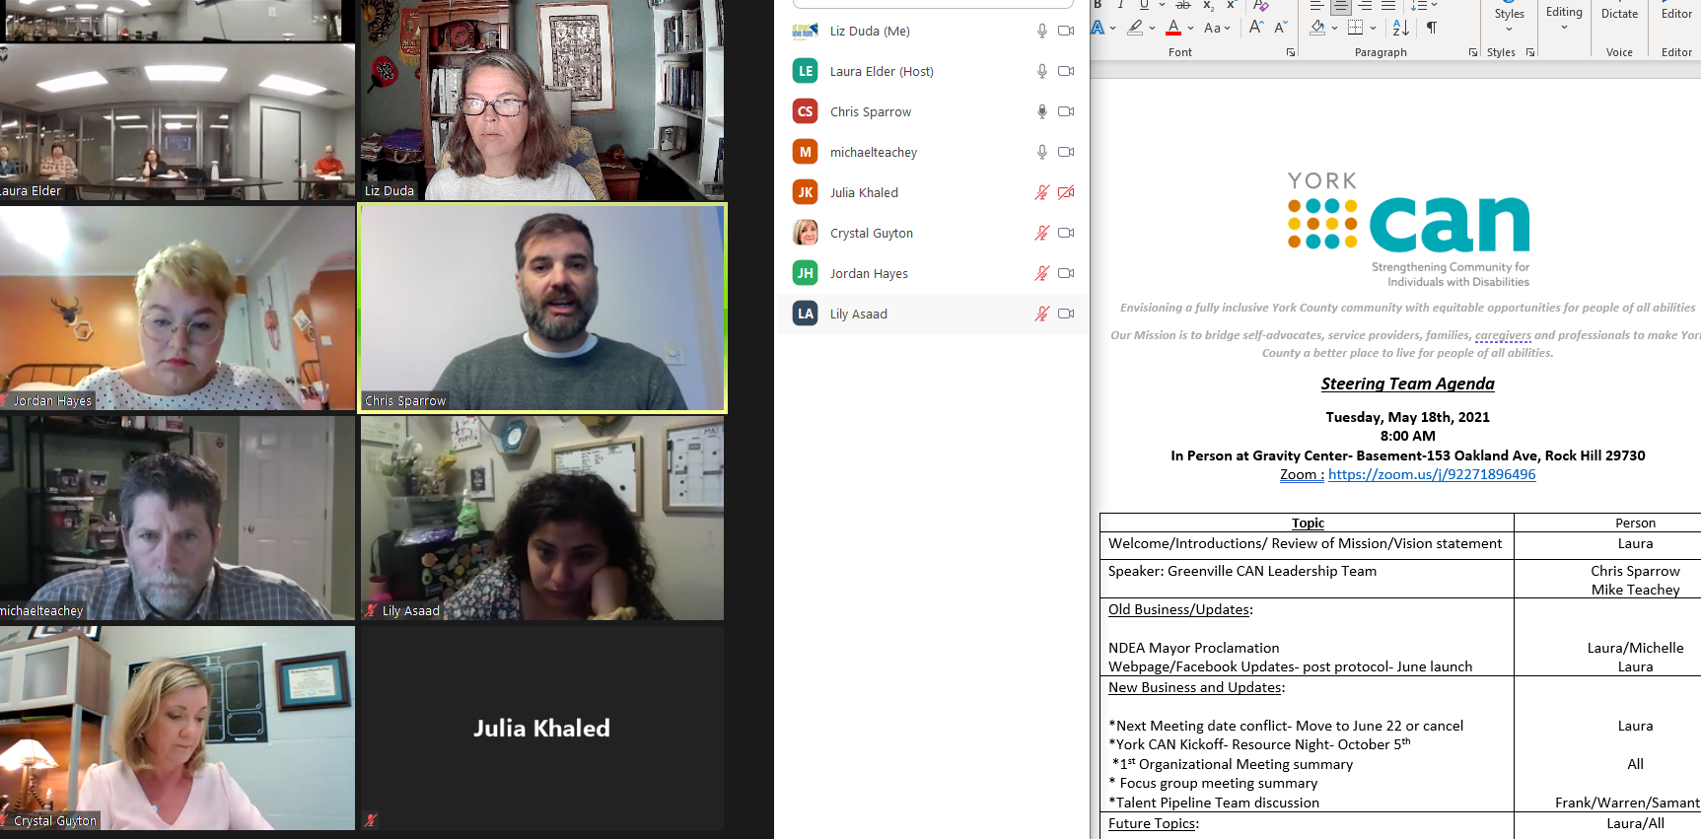
Teachey Discussion Highlights:
- Teachey is former lead facilitator of Greenville CAN; now is at Noble Aim Consulting, working with coalitions focusing on areas outside their spheres of control (e.g., health).
- Got started when they realized how hard it was to understand all of the offerings for people with disabilities; wanted to make it easier for people with disabilities to understand. Determined that goal would be to make it easier for folks who lived in Greenville County.
- Founding member of Live Well Greenville – he joined the obesity task force, from his role in the parks & rec department. Decided to focus on kids, then schools. Schools serve scratch-made meals grown with 70% local foods. Took same approach with parks and workplaces.
- Decided to take as similar approach to serving people with disabilities. Divided areas into buckets (e.g., transportation; housing; employment). Then pulled people into workgroups. Greenville CAN needed someone to have this effort as single focus. He was still a parks and rec director, but then decided to focus on this full time. Focus on equitable opportunities with people with disabilities. “Strengthening communities for people with disabilities” – so worked with the community, not people with disabilities.
  - ADA compliance was a big issue – jurisdictions did not have (meaningful) ADA coordinators. Now all cities and county have ADA coordinators, to help people access.
  - Employment – brought together local organizations (E,g., Goodwill, ABLE); introduced people, and realized there was competition between the agencies. Ultimately brought their leaders together too. Decided to have one person as a point of contact for employers (using grant money).
  - A success of his group was the culture ultimately took off the hat of their organizations and put on hat of serving their people. He recommends having a shared identity and culture.
- Launched in 2013; became Greenville CAN in 2015. Did not start with a strategic plan because had so many ideas. Did not come to consensus on housing. Took two years before decided focuses. Relationships are key. “Trust is action consistently applied over time.”
- Originally, everyone was a service provider or a parent of a person with disabilities. Two years into the process, added into “articles of collaboration” that 60% of leadership team would be people with disabilities. Goal was to look at systems, culture, and long-term change. Even creating opportunities for people to serve on boards and be voices in the communities helps to accomplish the goal.
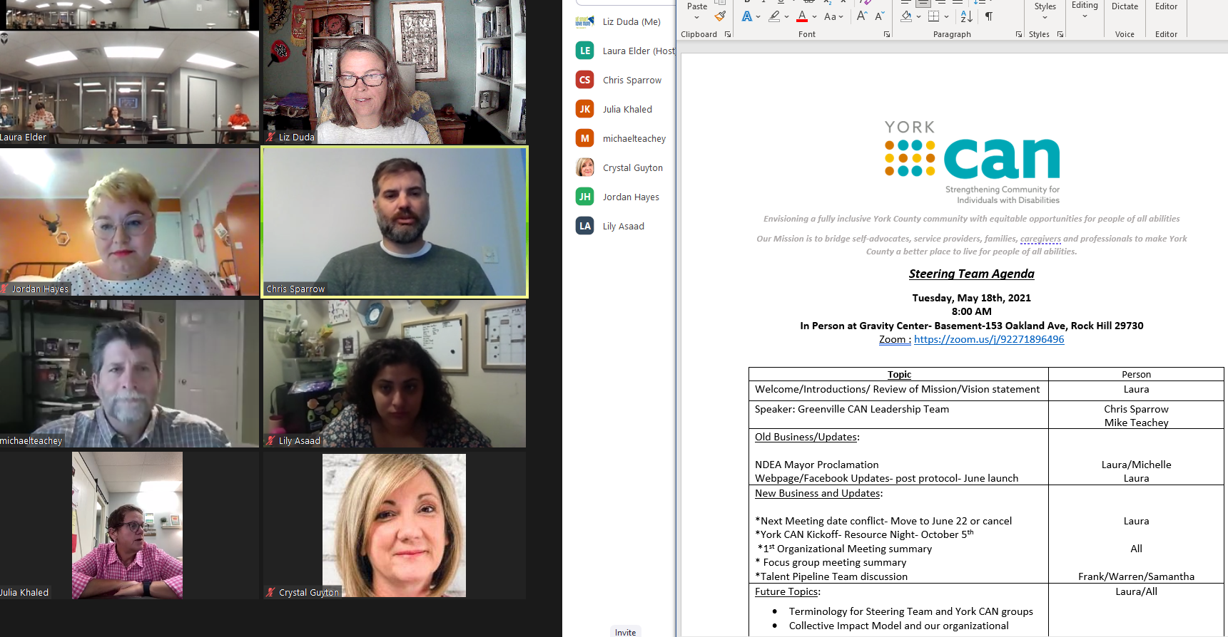 Sparrow Discussion Highlights:
- In 2018, decided to make the groups smaller because it was hard to control. And they realized they could not move the needle enough in certain areas such as transportation and housing. Created a smaller group with different team leads (employment; accessibility; community engagement; recreation) where they knew they could effect change. Invited individuals with disabilities to join grassroot efforts in place, and share their voices – embed their voices in transportation in housing. Created a group of people with disabilities, trained them to use their voices, helped connect them. Empowered people to have voices in the areas they were passionate about, with extra areas such as housing and transportation. One lady joined “GreenLink” is the transportation authority in Greenville training opportunities; she adopted a busstop; they will offer a rider education program to people with disabilities.
- Part of challenge was that community leaders saw disabilities as a separate category, and not a part of the existing categories (e.g., housing; transportation) – to see the person with a disability as having the same needs as everyone else. If people see people with disabilities embedded in the community, such as volunteering or in a leadership role, then they understand them better. Bring people with disabilities out to volunteer, helping others (flipping the narrative of people with disabilities needing the help).
- Current focus –
  - a lunch and learn for different organizations to share what they do with other organizations; they have recorded all lunch and learns form the beginning and have on the website;
  - CAN talks (TED talk) in which a person with a disability can have a more nuanced conversation to discuss issues that people might not otherwise discuss with people with disabilities. Got the second place runner up for America’s Got Talent who did a comedy routine before the show. Sellout. Brought in employers; local organizations.
  - Brought ADA coordinators throughout county into CAN. Enhanced communication and collaboration between groups.
  - Keep things positive. Recognize disagreement but find areas of agreement and work out from there.
- Employment –
  - partnered with Greenville Society of Resource Management so interfaced with employers. Identified barriers at the employment level. Created lunch and learns for employers to discuss areas they addressed – won a national award for that partnership. And their employment committee has now become the federally mandated committee. They consider this to be a system change, having created a culture link between organizations.
  - Employment – hired a person (Laura Bogardus) to lead employment; has data on jobs that have come through the process; it has been fairly significant. She also would be the point of contact for employers who need workers.
  - When created employment group originally, brought many different groups together.
    - “Workgroup” is come one come all and is more networking.
    - They now also have a business development group.
    - And they have a “stock” group which is the directors or the organizations.
Our takeaways from Greenville CAN discussion:
- Develop on relationships
- Goal/focus: Equity
- We should “focus: on no more than three areas
- Offer “linkage”
- Economic mobility
- Articles of collaboration (i.e., what is my commitment)
- CAN Talks
- Connect with SHERM – Society for Human Resources Managers
- ADA coordinators – we can start finding out who they are (county; RH; FM; Clover; York; TC)
New Business and Updates (Elder):
- Organizational meeting: 29 people; 13 organizations including recreational groups; school groups; case management providers
- Focus groups: Have held two of five people apiece
- Issues: Mental health
- Will continue focus groups over the next month. In June will hold one more organizational meeting for agencies. She will share takeaways/themes at our next meeting and share notes.

