Teacher’s Notes
Level | Intermediate +
Lesson Aims | Learners will develop reading skills and develop their ability to figure out the meaning of unfamiliar vocabulary from context
Approx Timing | 45-60 mins
Notes to the teacher | September is generally back to school month, and that means a lot more coffee for all that studying! This lesson honors National Coffee Day by focusing on some interesting, lesser known facts about the ever-popular drink. It’s a fun lesson and useful to develop your learners’ reading skills and their ability to deduce meaning of vocabulary from context.  The text is adapted from the Huffington Post- the full article has 15 facts, and here we’ll focus on just 7 in order to keep it achievable. Cheers!
Text Link | http://www.huffingtonpost.com/2014/02/11/things-you-didnt-know-about-coffee_n_4738957.html
Image Links | http://www.huffingtonpost.com/2014/02/11/things-you-didnt-know-about-coffee_n_4738957.html

Teacher’s Notes

- Warmer: Discussion

Show students a stock photo of coffee (or maybe a real cup!) and board the quote from the article “Even bad coffee is better than no coffee at all”- David Lynch. Give your own opinion about coffee and ask students to discuss how they feel about the drink in pairs. Ask for some student opinions on this and see how much agreement there is in the class.

- Pre-reading: Prediction

Tell students about National Coffee Day (September 29) and that they are going to read an article about some things they didn’t know about the drink. First, students should look at some pictures and discuss how they can link to coffee. It might help to take one example to get things started. After some discussion time, ask for some feedback. Don’t confirm answers at this stage.

- Reading 1: Reading for Gist

Before giving out the reading, set the task- read and decide what pictures are mentioned. After they read briefly, get the students to check in pairs. As a class, elicit some feedback about which pictures are relevant and which are not.

Answers:

- Reading 2: Reading for Specific Information

Ask students to fold down and work together to find out what the eight numbers in the text mean. If they do this alone, make sure they check with a partner before reviewing the answers as a class.

5) Reading 3: Reading for Detail

Ask the students to read the text again and answer the true/false questions. They should correct the ones that are false! As above, ask students to check in pairs and for some variety, get 1-2 fast finishers to board the answers. Confirm as a class and get students to explain the false answers, as well as any that seemed challenging.

6) Vocabulary from Context

Now you can focus on some of the more interesting, challenging vocabulary in the text. The numbers refer to the tip students will find the word in. They’ve been given the part of speech to help. In reviewing together, it might help to ask some concept checking questions to make sure students understand the words, and work on pronunciation as needed.

- Speaking: Follow Up Discussion

Finally, get the students speaking in response to the text! Five discussion questions are given and this can be worked through in pairs or small groups. Wrap up the lesson by getting some feedback on interesting answers and if possible, finish up with some delayed error correction.

You could modify the speaking by putting the questions around the room and inviting students to stand and discuss. If students finish early, you could ask them to create one or two of their own questions on the topic to continue the discussion.

Have fun with it and happy coffee day!

Teacher’s Notes: Student Worksheet Answer Key
3) Reading 1: Reading for Gist

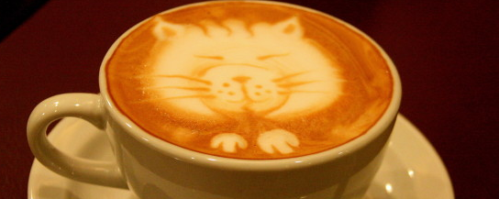  Yes- Fact 3 | Not mentioned |  | 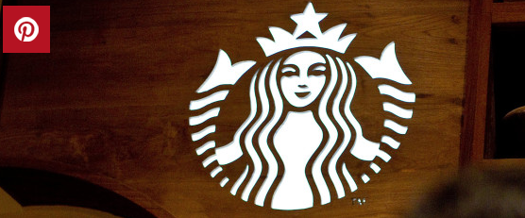  Not mentioned
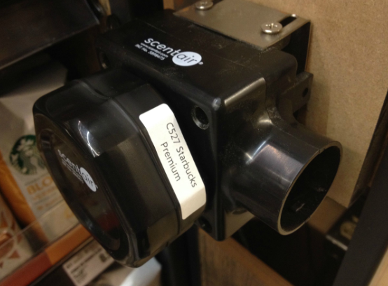  Yes- Fact 1 |  | 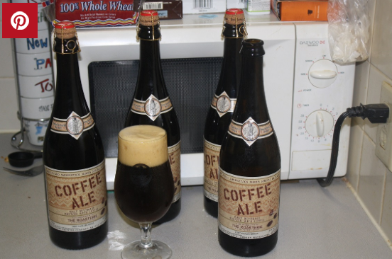  Not mentioned
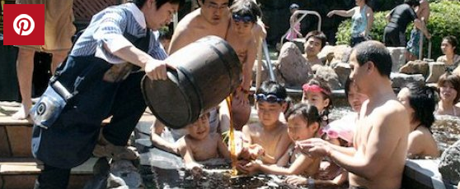
Yes- Fact 4

- Reading 2: Reading for Specific Information

30- locations of Tim Hortons
34- Grandpa Rex Allen’s age at death
38- Crème Puff’s age at death
500- One customer bought 500 coffees
1794- The year Tontine Coffee House opened
1970s- When ‘americano’ first started to be used
2005- The year Crème Puff died
2800- Yen, the price to enter Yunessun

5) Reading 3: Reading for Detail

1. Only places like Starbucks use scent technology to get customers. F- Store bought coffee such as Nescafe also put coffee aroma into their containers
2. Caffe sospeso began in France. F- It originated in Naples, Italy
3. The oldest cats in the world ate like regular humans. T- bacon, eggs and broccoli for breakfast
4. Coffee cups have changed a lot, as has how we drink coffee. T- The saucers were deeper and we often drank from them instead of cups.
5. The Tontine Coffee Shop still exists today. F- It burned down in 1835
6. It’s unclear how Americano got its name. T- There is still no definitive origin

6) Vocabulary from Context

- entice (1)
- snowballed (2)
- specialty (4)
- pervasive (7)
- diluting (7)
- definitive (7)
To encourage someone to go somewhere or do something (verb)
To happen repeatedly in a very short time (verb)
Something unique that you become famous for because it’s so good (adj)
Spreading to gradually affect all parts of something (adj)
To make something weaker (verb)
Something final, being very certain (adj)

Reading
Things You Didn’t Know About Coffee
By Todd Van Luling | Huffington Post Taste | Posted 02/11/2014 3:46 EST

"Even bad coffee is better than no coffee at all." - David Lynch

Have you ever swam in a pool of coffee? Have you ever thought about using the saucer to slurp? If not, you really need to coffree your mind. You very well may drink a cup of Joe like a thirsty fox every morning/afternoon/night but do you really "know" your coffee?

1. That wonderful scent in your corner coffee store may actually be fake.

Coffee companies such as Starbucks and Dunkin' Donuts sometimes use "fake coffee smell" to entice shoppers. ScentAir, a so-called "scent provider," is a popular choice in the coffee industry as well as retail stores, restaurants and hotels, where methods of "aromachology" are used along with the "latest in fragrance technology."Store-bought coffee like Nescafé also injects coffee aroma into the container to seem more fresh when first opening. That said, a person claiming to be a former "coffee production engineer" explained on Reddit that the "fake smell" injected into the containers is originally created from particles of real coffee beans, so the scent is at least fairly authentic.

2. Caffè sospeso may just restore your faith in humanity.

Caffè sospeso, which in Italian means, "suspended/pended coffee," is a tradition that involves paying for an extra cup of coffee for a future customer who may be down on their luck. People who can't afford a cup of coffee can come into a shop that observes this practice and ask if there are any sospesos available free of charge. The tradition is said to have originated in Naples around a century ago, but the practice has grown over the years to be recognized internationally. In 2013, an anonymous customer paid for 500 cups of coffee at a Tim Hortons in Edmonton, Canada, which snowballed into patrons donating 10,000 cups of coffee at over 30 locations.

3. The two oldest recorded cats drank coffee every day.

The Guinness-recognized "oldest cat ever" was Creme Puff, who lived to be 38 years old and died in 2005. The owner, Jake Perry, fed her coffee every morning along with bacon, eggs and broccoli. This is especially significant because Perry was also the owner of the previous record holder, Grandpa Rex Allen, who was fed the same diet and died at 34.

4. You can swim in coffee at a spa in Japan.

The Yunessun spa resort in Hakone, Japan has specialty spas that allow customers to bathe in variously delightful/sticky liquids, such as wine, chocolate, green tea, sake and coffee. For an admission price of just 2,800 Yen (about 27 dollars), bathers can have coffee poured on them and then stroll over to the newly opened ramen bath to swim among the noodles.

5. The saucer could have originally been used for slurping after cooling.

This claim is also bit tricky to pin down, but apparently around the 18th century, people used to drink coffee out of the saucer we mostly now consider a simple coaster for the cup and spoon. At the time, the saucers were much deeper, and the larger surface area allowed the coffee to cool much more quickly.

6. The original New York Stock Exchange was a coffee house on Wall Street.

The New York Stock Exchange began in the Tontine Coffee House, a real coffee shop opened in 1794 and located on the corner of Wall and Water St., before a fire burned it down in 1835. Named after Neapolitan banker Lorenzo di Tonti, the shop was a meeting place for "underwriters, brokers, merchants, traders, and politicians; selling, purchasing, trafficking, or insuring; some reading, others eagerly inquiring the news," according to an article from 1807.

7. You've probably heard incorrect stories about the origin of the terms "Cup of Joe" and Americano
Despite the pervasive story that "Americano" got its name from American soldiers diluting espresso shots during WWII, the term didn't show up until the 1970s. Unfortunately nobody seems to have a definitive take of how "Americano" actually came about. In another false etymology, there's a story that "cup of Joe" also comes from coffee drinking American G.I. Joes but this is just a myth as well. Although just as with "Americano" the true origin has never been proved, fact-checking site Snopes believes the phrase most likely came from the old coffee slang, "jamoke." The slang phrase, "cup of jamoke," became corrupted into a "cup of Joe."

http://www.huffingtonpost.com/2014/02/11/things-you-didnt-know-about-coffee_n_4738957.html

Discussion: How do these pictures connect to coffee?
Student Worksheet 1
Images 1-5 Gettys, 6 Yunesun
Reading 1: Read the article and find out. Not all pictures are in there!
- - - - - - - - - - - - - - - - - - - - - - - - - - - - - - - - - - - - - - - - - - - - - - - - - - - - - - - - - - - - - - - - - - - - - - -

Reading 2: Now read the article again and find what the numbers below mean:

Example: 2013: The year a customer paid for coffee at Tim Hortons

1. 30 ____________________________

2. 34 ____________________________

3. 38 ____________________________

4. 500 ___________________________
5. 1794 ____________________________

6. 1970s ___________________________

7. 2005 ____________________________

8. 2800 ____________________________

Reading 3: Now decide whether the statements are true or false. If it’s false, correct it!
Student Worksheet 2

1. Only places like Starbucks use scent technology to get customers.
2. Caffe sospeso began in France.
3. The oldest cats in the world ate like regular humans.
4. Coffee cups have changed a lot, as has how we drink coffee.
5. The Tontine Coffee Shop still exists today.
6. It’s unclear how Americano got its name.
- - - - - - - - - - - - - - - - - - - - - - - - - - - - - - - - - - - - - - - - - - - - - - - - - - - - - - - - - - - - - - - - - - - - - -

Vocabulary: Look back at your article and use the clues to match the words to the definitions. The numbers give clues to the section to look in.

Example: to slurp (intro)- to drink something noisily

- ________________ (1)
- ________________ (2)
- ________________ (4)
- _______________ (7)
- _______________ (7)
- _______________ (7)

To encourage someone to go somewhere or do something (verb)
To happen repeatedly in a very short time (verb)
Something unique that you become famous for because it’s so good (adj)
Spreading to gradually affect all parts of something (adj)
To make something weaker (verb)
Something final, being very certain (adj)

- - - - - - - - - - - - - - - - - - - - - - - - - - - - - - - - - - - - - - - - - - - - - - - - - - - - - - - - - - - - - - - - - - - - - -

Speaking: What do you think? Discuss with your partner.

- What fact do you find the most interesting? Why?

- Do you think scent technology really entices people to buy and drink more coffee?

- Would you like to visit the specialty spa? Which drink would you like to swim in most?

- What is the coffee culture like in your country?

- What should be done to celebrate National Coffee Day?

