(First Page)
Paper title

Author/s
First name, Last name
Affiliation

Corresponding Author: name@name.edu

Keywords
For library indexing and on-line searching, list up to 5 keywords

(Page 2 onwards)

Abstract

Your 300 word abstract should be included here.
(Two line space)
Introduction
Please provide a clear aim(s) and objective(s). Following the introduction, the main body of text, should be organized into appropriate sections: literature review, methodology, findings and analysis, discussion, conclusion. Followed by acknowledgments (where applicable), references, and appendices (where applicable).

Section Heads
Two-line spaces between end of previous paragraph and section headings. Section Heads should be in Times New Roman, 12point, bold and flush left in upper and lower case as shown above. For subsection headings, only the first letter is capitalized.

Figures
Place all figures center page and number figures consequently. Figures must include a caption, placed below figures, centered, one line spacing between main text, as shown below:
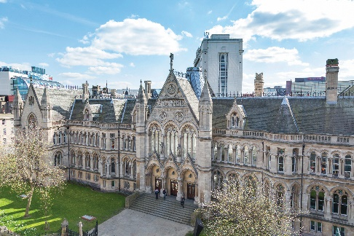

Figure 1: Arkwright building, Nottingham

When referring to a figure, use the figure number when referring to a figure (Figure 1). Place figures close to the sections in which they are referred to.

Tables
Number tables consecutively and use table numbers when referring to a table (Table 1). Place table center page, with caption above, as shown below:

 | 1 | 2
A
B
C
D

Table 1: Title of table

Acknowledgments
Please leave acknowledgments and references to funding sources until your paper has undergone the double-blind peer review and has been accepted for publication in the Conference proceedings. There will be an opportunity to complete this section before papers are finalized.

References
References must be in author alphabetical order following the Harvard referencing system. The style should follow these guidelines:
Last name, initials. (Year published). Title. City: Publisher, Page(s).
Last name, First initial. (Year published). Title. Edition. (Only include the edition if it is not the first edition) City published: Publisher, Page(s).
Last name, First initial. (Year published). Article title. Journal, Volume (Issue), Page(s).
Last name, First initial. (Year published). Article Title. Journal, [online] Volume(Issue), pages. Available at: URL [Accessed Day Month Year].
Within the text, references should be (author, date: page number) Please note quotations over 3 lines must be indented, 1/2inch from the left margin, without quotation marks.

Appendices
Please include related material not essential to present within the main body of paper. Appendices should be structured 1, 2, 3 etc.

