Skidmore College Information Guide

Facts about School
- Skidmore College is a private institution that was formed in 1903
- Skidmore’s founders were Lucy Ann Skidmore and her father Joseph Russell Skidmore
- First Skidmore was called The Young Women Industrial Club in 1903. Next, it was chartered under the name Skidmore School of Arts in 1911. The final name change was in 1961 when it was named Skidmore college
- Skidmore’s motto is Creative Thought Matters
- Skidmore’s acceptance rate in 2021 is 32%
- Skidmore has a mean SAT score of 1310
- Skidmore has a mean ACT score of 30
- Application Information
  - Common Application or the Coalition Application
  - Secondary School Report
  - Two academic teacher evaluation reports
  - Midyear Report
  - $65 application fee
  - College Scholarship Service Financial Aid Profile ( If you are applying for financial aid)
  - SAT or ACT scores
- Skidmore’s total undergraduate enrollment 2852
- Skidmore’s student-to-faculty-ratio is 8:1
- The tuition for Skidmore is 60,152

Campus and Environment
- Skidmore’s campus is 850 acres
- Skidmore’s campus is considered to be a suburban campus
- Skidmore is located in Saratoga Springs in New York
- The campus address is 815 N Broadway, Saratoga Springs, NY 12866
- This is the campus map:
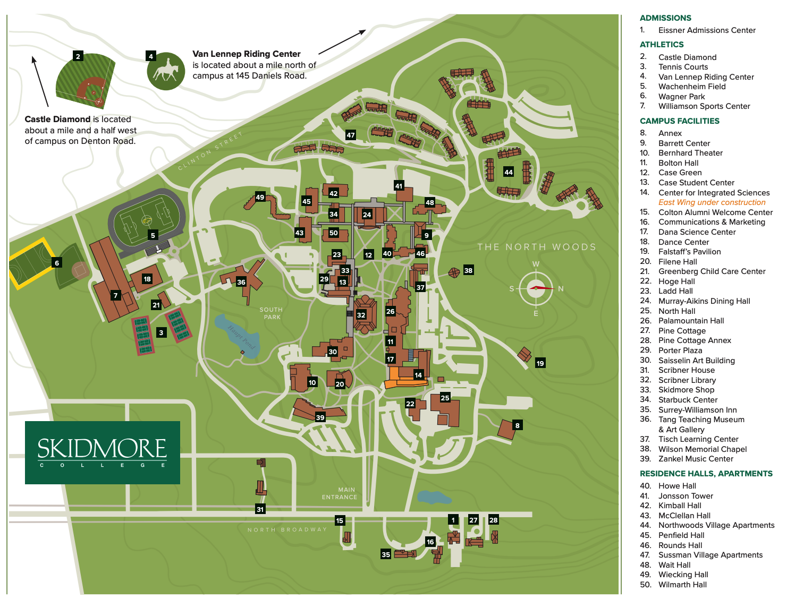
- 68% of students live on campus or campus owned buildings
- Campus safety and security services
  - 24-hour foot and vehicle patrols
  - Late-night transport/escort service
  - 24-hour emergency telephones
  - Lighted pathways/sidewalks
  - Controlled dormitory access (key, security card, etc.)
- Services for LD students
  - Reading machines, note-taking services, readers, extended time for tests, tutors, priority registration, the substitution of courses, typist/scribe, other testing accommodations
- Services for physically disabled students
  - Note-taking services, tape recorders, special housing, tutors, reader services, interpreters for hearing-impaired
Dorms/Housing
- North Quad
  - Howe Rounds Hall
    - All grades
  - Jonsson Tower
    - All grades
  - Wait Hall
    - All grades
- South Quad
  - Mcclellan Hall
    - All grades
  - Penfield Hall
    - All grades
  - Wiecking Hall
    - Sophomores, Juniors, Seniors
  - Wilmarth Hall
    - All grades
  - Kimball Hall
    - All grades
- Northwoods Village
  - Juniors and Seniors
- Sussan Village
  - Upper Sussman
    - Sophomores, Juniors, Seniors
  - Lower Sussman
    - Juniors and Seniors
Food
- Meal Plans
  - Unlimited Meal Plan
    - Includes $50 Dining Bucks each semester to be used at any dining location including vending machines.
    - Price = $3284
  - Thoroughbred Gold Plan
    - This plan includes $100 Dining Bucks for the semester and 100 meals (either breakfast, lunch, dinner, or late-night meal) to be used at the Dining Hall or Spa for the semester
    - Price = $1045
  - Thoroughbred Dinner Plan
    - This flexible block meal plan option allows students 10 meals during any meal period in the Dining Hall or Spa during a semester (unused meals roll over from the Fall semester to the Spring semester)
    - Price = Each 10 Dinner Blocks: $125 (purchase 5 or more blocks and save - $100.00/block)
  - Thoroughbred Lunch Plan
    - This modified block meal plan allows students any 10 breakfast, lunch, or late-night meals in the Dining Hall or Spa during a semester (unused meals roll over from the Fall semester to the Spring semester).
    - Price = Each 10 Dinner Blocks: $100 (purchase 5 or more blocks and save - $90.00/block)
  - Dining Bucks
    - Dining Bucks may be used in any allotment, at any campus dining location including vending machines, at any time throughout the academic year.
    - 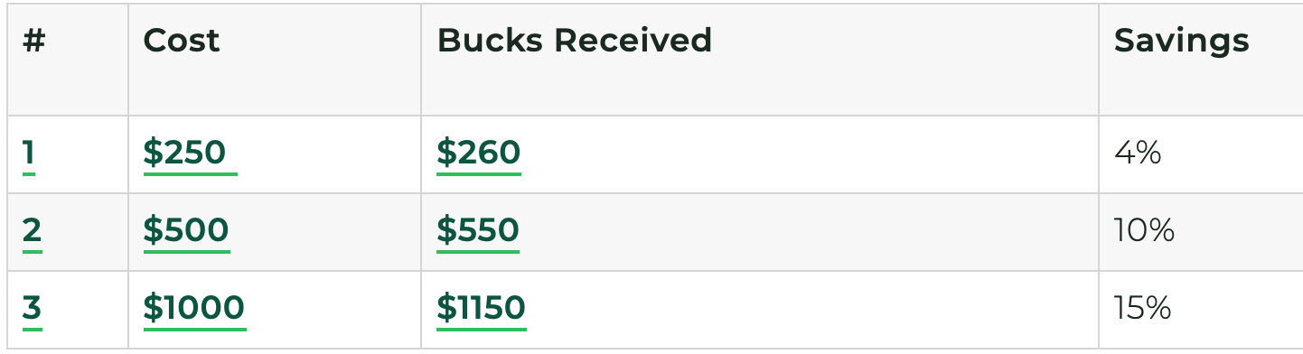
- Dining Locations
  - Murray-Aikins Dining Hall
  - Spa
  - Burgess Cafe
  - Atrium Cafe
- Off-Campus Dining
  - Druthers Brewing Company
  - Triangle Dinner
  - Olde Bryan Inn
  - Church Restaurant
  - Scallions
Academics
- List of Majors
  - Bachelor Of Arts (B.A.)
    - American Studies, Anthropology, Arts Administration, Art History, Asian Studies, Biology, Chemistry, Chinese, Classics, Computer Science, Economics, English, Environmental Studies and Sciences, French, Gender Studies, Geosciences, German, History, Intergroup Relations, International Affairs, Italian, Japanese, Latin American and Latinx Studies, Management, and Business, Mathematics and Statistics, Media and Film Studies, Documentary Studies, Music, Neuroscience, Philosophy, Physics, Political Science, Psychology, Religious Studies, Self Determined Majors, Sociology, and Spanish
  - Bachelor of Science (B.S.)
    - Art (Studio), Dance, Education Studies, Health and Human Physiological Sciences, Social Work, and Theater
- List of Minors
  - American Studies, Anthropology, Art (Studio), Art History, Arts Administration, Asian Studies, Biology, Black Studies, Business, Chemistry, Chinese, Classics, Computer Science, Dance, Economics, Education Studies, English, Environmental Studies and Sciences, French, Gender Studies, Geosciences, German, Health and Human Physiological Sciences, History, Intergroup Relations, International Affairs, Italian, Japanese, Latin American and Latinx Studies, Mathematics, Media and Film Studies, Music, Philosophy, Physics, Political Science, Religious Studies, Sociology, Spanish, Statistics, and Theater
- School Strengths
  - 1. Skidmore is ranked 17th best college for Kinesiology and Physical Therapy in America
  - 2. Skidmore is ranked 25th best college for Performing Arts in America
  - 3. Skidmore is ranked 29th best college for Public Policy in America
  - 4. Skidmore is ranked 37th best college for Art in America
  - 5. Skidmore is ranked 48th best college for International Relations in America
- Graduation Requirements
  - Foundation Requirements
    - Expository Writing: Complete one course, either EN105, EN105H, EN110, or a course designated as EW by the end of the sophomore year. Students who need the preparation of EN103 must complete this course during the first year of study. In some cases, students may be required to complete certain preparatory courses in their first semester, prior to enrolling in EN103. (4-11 Semester Hours) (Students also complete a writing requirement in the major.)
    - Quantitative Reasoning 1: Complete through standardized test scores or bypassing the
    - Skidmore Quantitative Reasoning Exam by the end of the freshman year, or by completing MA100 by the end of the sophomore year. (0-3 Semester Hours)
    - Quantitative Reasoning 2: Complete one course designated as QR2 by the end of the junior year. (3-4 Semester Hours)
  - Breadth Requirements
    - Natural Sciences: Complete one course with a laboratory designated in biology, chemistry, exercise science, geoscience, physics, psychology, and other disciplines. (3-4 Semester Hours)
    - The Arts: Complete one course for 2, 3, or 4 credits (or two 1-credit courses) that involves the creation or performance of an artwork. Courses designated in studio (visual) art, creative writing, dance, music, theater, and other disciplines. (2-4 Semester Hours)
    - Humanities: Complete one course designated in art history, classics, dance (history and theory), literature (in English and in other languages), music (history and theory), philosophy, religion, theater (history and theory), and other disciplines. (3-4 Semester Hours)
    - Social Sciences: Complete one course designated in American studies, anthropology, economics, government, history, sociology, and other disciplines. (3-4 Semester Hours)
  - Culture-Centered Inquiry
    - Foreign Language: Complete one course in a foreign language designated in the departments of Classics or World Languages and Literatures. The course must be appropriate to the student’s level of language expertise as determined by Advanced Placement, Achievement Test/SATII, or Skidmore placement test scores. (3-4 Semester Hours)
    - Complete One of the Following:
      - Non-Western Cultures: Complete one course (3 or 4 credits), designated among various disciplines, that explores a non-Western culture.
      - Cultural Diversity: Complete one course (3 or 4 credits), designated among various disciplines, that compares two markedly different cultures, one of which must be non-Western in origin.
Student Life
- Skidmore has over 100 student-run clubs and organizations
- Skidmore does not have any Greek Life
- Student Clubs
  - Multicultural Clubs
    - African Heritage Club, Asian Cultural Awareness, Chinese Culture Club, HAYAT, Hip Hop Alliance, El club Espanol, French Club, International Student Union (ISU), Lift Every Voice Gospel Choir, NihonGo!, Raices, Skidmore Pride Alliance, Ujima
  - Athletics and Outdoor Clubs
    - Alpine Ski Team, Circus Club, Club Basketball, Cycling Club, Fly Fishing Club, Geology Club, Open Ice Hockey Club, Martial Arts Club, Nordic Ski Club, Outing Club, PoloClub, Quidditch Club, Running Club, Sailing Club, ThoroughBears, Snow Sports Club
  - Performance Clubs
    - Music
      - Accents, Bandersnatchers, Drastic Measures, Dynamics, DJs Anonymous, Lift Every Voice Gospel Choir, Lively Lucy’s Coffeehouse, Pulse!, Skidaiko, Sonneteers, Student Entertainment Committee (SEC), TrebleMakers, WSPN Radio
    - Dance
      - 213, Breakbeats, Rythmos, Irish Dance Club, Stompin’ Soles
    - Comedy
      - Ad Liberal Artists (Ad-Libs), Sktechies, Skidomedy
    - Theater
      - Awkward Kids Talking, Cabaret Troupe Club
    - Circus Club, Late Night Club
  - Media, Print and Publicants Clubs
    - Anime Club, BARE, Film Club, Folio, LINE Art Review, Photography Club, Skidmo’ Daily, Skidmore News, SkidTV, Harry Potter Club
  - Religious Club
    - Christian Fellowship, Hillel, Lift Every Voice Gospel Choir, and Newman Club
  - Academic Clubs
    - Chemistry Club, Chess Club, Model EU, Model United Nations Club, Society of Physics Students, Pre-Law Club, Pre-Health Club
  - Political, Advocacy, and Awareness Clubs
    - Active Minds, Benef-Action, Democracy Matters, Center for Sex and Gender, Environmental Action Coalition (EAC), FeelGood, Feminist Action Network, HIPS Club, J Street U, Model EU, Model UN, Pro-Arts, SkidBuilds, Skidmore Democrats, Skidmore Peace Action, Skidmore Republicans, Skidmore Education Taking Action (SETA), Students United for Public Education (SUPE), Voices for Planned Parenthood (VOX)
  - Specialty Clubs
    - Chess Clubs, eSports, Fight Club, Foundry Club, FreeKing Studious, Humans versus Zombies, Knit Wits, Paranormal Skidmore, Pro-Arts, Random Acts of Crafts, Skidmore College Emergency Medical Service, SkidEats, Skidmore Investment Club, Skidmore Spoon, Speaker’s Bureau, Tabletop Gaming Club, UNICEF, Women in Business
  - Skidmore’s mascot is Thoroughbred's
  - Diversity within students
    - Gender: 59 percent of Skidmore students are female; 41 percent are male.
    - Students of color account for 26 percent of Skidmore’s student body, breaking out as follows: Asian, 5.4 percent; Hispanic, 9.6 percent; black, 5.0 percent; and two or more races, 5.4 percent.
Unique Tradition and Alumni
- Unique Traditions
  - Beatlemore Skidmanaia
    - The annual tribute concert was initially inspired by students in a Beatles seminar who just wanted to jam with their friends. Now, it's so popular that it fills the biggest concert hall on campus for three sold-out shows and is live-streamed for alumni and fans around the world to see.
  - Ujima Fashion Show
    - Ujima, Skidmore's Caribbean and African American club, has hosted more than 25 fashion extravaganzas. Student models take to the runway to demonstrate, through beauty and strength, how people of color excel in spite of life's obstacles.
- Alumni
  - Lake Bell
  - Finn Carter
  - Ariana Richards
  - Eddie Cahill
  - Evan Dando

Sources
- https://www.skidmore.edu/history/index.php
- https://en.wikipedia.org/wiki/Skidmore_College#History
- https://www.collegeconfidential.com/colleges/skidmore-college/admissions/
- https://www.niche.com/colleges/skidmore-college/
- https://www.skidmore.edu/admissions/apply/index.php
- https://www.skidmore.edu/directions/docs/top-view-map.pdf
- https://www.usnews.com/best-colleges/skidmore-college-2814/campus-info
- https://www.skidmore.edu/reslife/residence-halls.php
- https://www.skidmore.edu/diningservice/plans/meal-plan-options.php
- https://www.tripadvisor.com/RestaurantsNear-g48562-d5789893-Skidmore_College-Saratoga_Springs_New_York.html
- https://www.skidmore.edu/academics/
- https://www.skidmore.edu/academics/majors.php
- https://www.skidmore.edu/registrar/current/degreereq.php
- https://www.skidmore.edu/sga/clubs/index.php
- https://www.skidmore.edu/diversity/community/index.php
- https://www.skidmore.edu/admissions/why/traditions.php
- https://www.famousfix.com/list/skidmore-college-alumni

