Rensselaer Polytechnic Institute Information Guide

Facts about the School
- The Rensselaer School is a private institution established in 1824
- Rensselaer Polytechnic Institute was founded by Stephen Van Rensselaer
- In 1833, the school became the Rensselaer Institute
- The name was changed to the Rensselaer Polytechnic Institute in 1861
- The motto of Rensselaer Polytechnic Institute “Knowledge and Thoroughness”
- Rensselaer Polytechnic Institute’s acceptance rate in 2020 was 57.3%
- Rensselaer Polytechnic Institute’s mean SAT score is 1390
- Rensselaer Polytechnic Institute’s mean ACT score is 31
- Application Information
  - High School Transcript
  - Letter of Recommendation
  - Test Scores
  - Common Application Essays
  - Application Fee
  - Portfolio (if required)
  - Early Decision Agreement Form (if required)
- Rensselaer Polytechnic Institute has Early Decision I, Early Decision II, Early Action, and a BS/MD program for application options
- Rensselaer Polytechnic Institute’s total undergraduate enrollment is 6,283
- Rensselaer Polytechnic Institute’s student-to-faculty-ratio is 14:1
- The tuition for Rensselaer Polytechnic Institute is $58,526

Campus and Environment
- Rensselaer Polytechnic Institute’s campus is 256 acres
- The campus is considered a suburban campus
- The campus is located in Troy, New York
- The campus address is 110 8th St, Troy, NY 12180
- Here is the campus map:
- 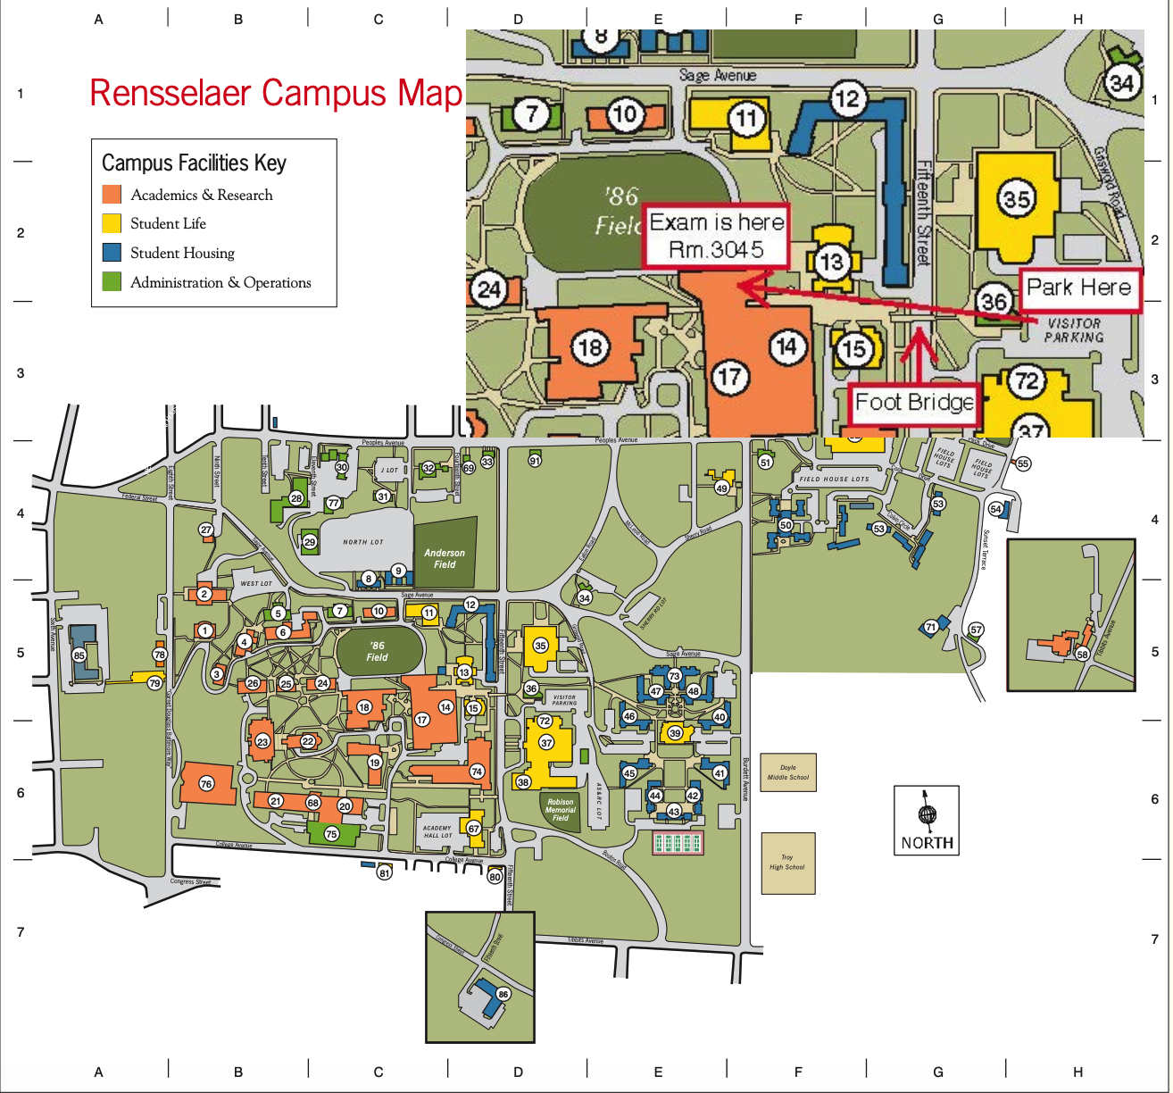
- 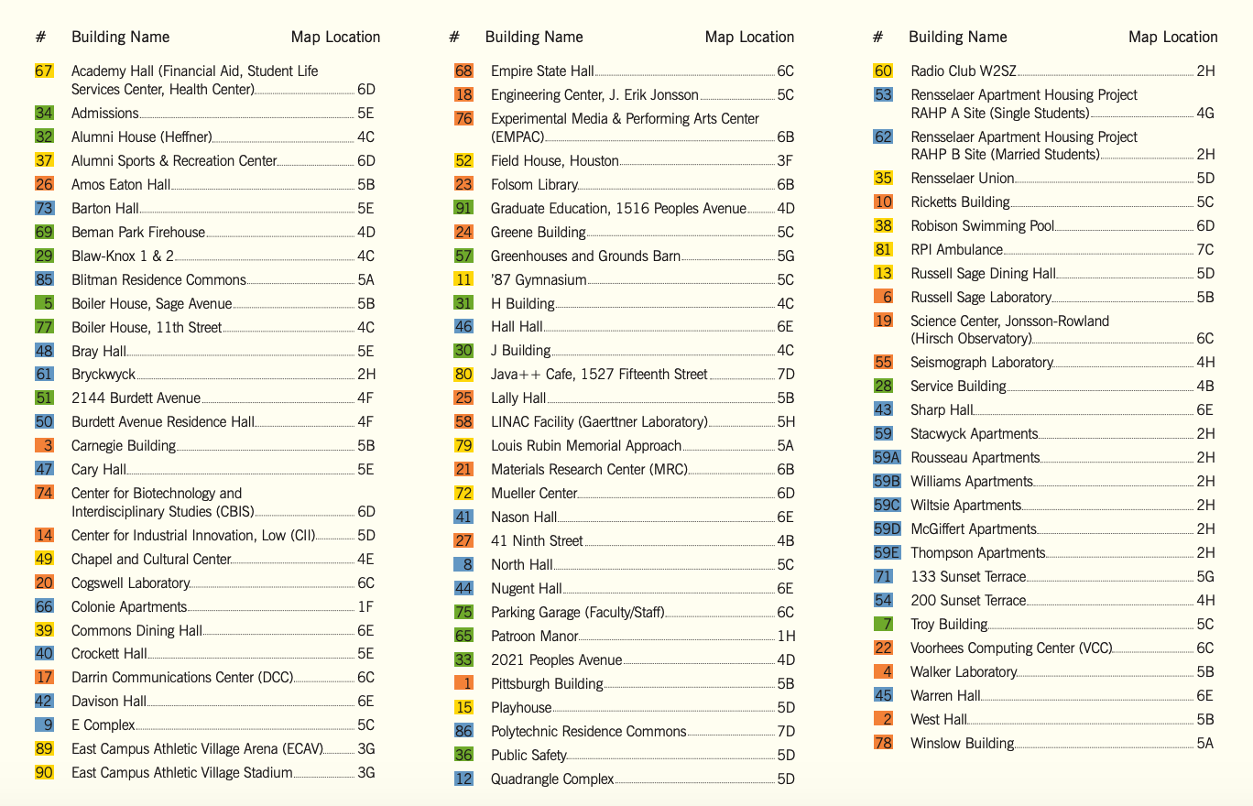
- In Rensselaer Polytechnic Institute, 21% of students live on campus
- The campus is readily reached by car, and there is rail, bus, and air service to the region

Dorms/ Housing
- The twelve resident halls
  - Davison Hall - Freshman
  - Barton Hall - Freshman
  - Bray Hall - Freshman
  - Burdett Avenue Residence Hall (BARH) - Freshman
  - Cary Hall - Freshman
  - Crockett Hall - Freshman
  - Hall Hall - Freshman
  - Nason Hall - Freshman
  - Nugent Hall - Freshman
  - Warren Hall - Freshman
  - Sharp Hall - Freshman
  - Beman and Brinsmade - Sophomore
  - Blitman Residence Commons - Sophomore
  - Colonie Apartments - Sophomore
  - Colvin and Albright - Sophomore
  - E-Complex- Sophomore
  - North Hall- Sophomore
  - Quadrangle - Sophomore
  - Stacwyck Apartments - Sophomore
  - Bryckwyck Apartments - Junior
  - City Station South - Junior
  - Polytechnic Apartments - Junior
  - City Station West - Senior
- ll rooms have (for each student):
  - A bed
  - A dresser
  - A desk
  - A closet
  - A chair
  - A shelving piece (typically fits over desk or dresser)
Food
- Rensselaer Polytechnic Institute’s Food plan Options
  - Unlimited
    - Unlimited meals per week to be used in Resident Dining Halls, plus $150 Flex Dollars per year. Non-transferable. Available to all students; required for residential first-year students. $7,270/year
  - 19 On-Demand
    - 19 anytime meals per week to be used in Resident Dining Halls, plus $300 Flex Dollars per year. Non-transferable. Not available to first-year students; available to all other students. $7,150/year
  - 15 On-Demand
    - 15 anytime meals per week to be used in Resident Dining Halls, plus $500 Flex Dollars per year Non-transferable. Not available to first-year students; available to all other students. $7,060/year
  - 12 On-Demand
    - 12 anytime meals per week to be used in Resident Dining Halls, plus $700 Flex Dollars per year. Non-transferable. Not available to first-year students; available to all other students. $6,350/year
  - 5 on Demand
    - Five anytime meals per week to be used in Resident Dining Halls, plus $600 Flex Dollars per year. Non-transferable. Only available to RAs, graduate students, or those undergraduate students approved to be living off-campus or in an approved Greek residence. $2,870/year
- Top 5 off-campus dining options
  - Druthers Brewing Company
  - Bard & Baker Board Game Cafe
  - Dinosaur Bar-B-Que
  - Nighthawks
  - Lo Porto Ristorante Caffe

Academics
- List of majors
  - Aerospace Engineering Curriculum, Applied Mathematics, Applied Physics, Architecture, Biology, Biomedical Engineering, Building Sciences, Chemical and Biological Engineering, Chemistry, Civil Engineering, Communication, Communication with a concentration in Graphic Design, Computer and Systems Engineering, Computer Science, Computer Science and Philosophy, Computer Science and Psychology, [Design, Innovation and Society], Economics, Electric Power Engineering, Electronic Arts (multiple discipline options), [ Electronic Media, Arts, and Communication], Environmental Engineering, Geology, Hydrogeology, Industrial and Management Engineering, Information Technology, Information and Communication, Information technology - Arts, Management, Materials Engineering, Mathematics, Mathematics of Computation, Mathematics of Operations Research, Mechanical Engineering, Nuclear Engineering Curriculum, Philosophy, Philosophy, Physician-Scientist, Physics, Product Design and Innovation in Management and STS, Program for Graduate of U.S Navy Nuclear Power Training School, Psychology, [Sample Design, Innovation, and Society/ Management Dual Major Template], Science and Technology Studies
- List of Minors
  - Anthropology, Architectural, Astrobiology, Astronomy, Astrophysics, Biochemistry, Biology, Biomedical Engineering and Management, Biomedical Engineering, Biophysics, Brian and Behavior, Chemistry, Civil Engineering, Cognition, Communication, Community and Health Psychology, Computer and Systems Engineering, Computer Science, [Ecological Economics, Values, and Policy Minor], Economics, Electric Power Engineering, Electrical Engineering, Electronic Arts, Environmental Engineering, Environmental Science, Financial Technology, French, [Gender, Science, and Technology], General Psychology, Geology, History, Human Factors, Hydrogeology, Industrial/Organizational Psychology, Information Technology, Interschool Minor in Energy, Lighting Minor, Literature Minor, [Logic, Computation, and Mind], Management and Technology, Marketing, Material Science and Engineering, Mathematics, Music, Nuclear Engineering, Philosophy, Physics, Political Science, Psychology, [Science, Technology, and Society], Social Psychology, Sociology, Sports Psychology, Studio Arts, Technological Entrepreneurship, and Technology Commercialization and Entrepreneurship.
- School Strengths
  - 1. Rensselaer Polytechnic Institute is ranked 19th best college for Information Technology in America
  - 2. Rensselaer Polytechnic Institute is ranked 25th best college for Architecture in America
  - 3. Rensselaer Polytechnic Institute is ranked 28th best college for Computer Science in America
  - 4. Rensselaer Polytechnic Institute is ranked 36th best college for Physics in America
  - 5. Rensselaer Polytechnic Institute is ranked 38th best college for Engineering in America
- Special Programs
  - Physician-Scientist Program
    - This program allows students to get a B.S and M.D in seven years. Students spend three years at Rensselaer Polytechnic Institute followed by four years at Albany Medical College, with no MCAT requirement. Due to the nature of the program, students enrolled in the accelerated medical program are not able to dual or double major.
  - Accelerated Business and Management-Law Program
    - This program allows students to get a B.S and J.D in six years. Students sit for the LSAT and complete their law coursework at Albany Law School or may be nominated by their adviser to apply to Columbia Law School. Due to the nature of the program, students enrolled in the accelerated law program are not able to dual or double major.
  - Accelerated Science, Technology and Society-Law Program
    - This program allows students to get a B.S and J.D. Students sit for the LSAT and complete their law coursework at Albany Law School or may be nominated by their adviser to apply to Columbia Law School. Due to the nature of the program, students enrolled in the accelerated law program are not able to dual or double major.
  - The ACCEL Program
    - The program allows the student to complete their degrees in three years.
  - Co-Terminal Program
    - This program allows students to complete their Bachelor’s and Master’s degree in five years.
  - EngMBA
    - This program allows students to get a B.S in an engineering discipline and an MBA from the Lally School of Management.
  - SciMBA
    - This program allows students to get a B.S in a science discipline and an MBA from the Lally School of Management.
  - School of Sciences B.S/Ph.D. Program
    - This program allows students to get a B.S and a graduate degree in seven years
  - MANE Department B.S./Ph.D. Program
    - The Mechanical, Aeronautical, and Nuclear Engineering Department offer a B.S./Ph.D. program where students are able to conduct research during their undergraduate studies, begin their Ph.D. immediately after receiving their B.S. degree and get paid to do so.
  - FlexMed Program
    - The Icahn School of Medicine at Mount Sinai holds up to three spots in its FlexMed program for Rensselaer sophomores who qualify for the program each year.
Student Life
- Rensselaer Polytechnic Institute has over 200 unique clubs
- Greek Life
  - Fraternities
    - Acacia, Alpha Chi Rho, Alpha Phi Alpha, Alpha Phi Omega, Alpha Sigma Phi, Chi Phi, Delta Kappa Epsilon, Delta Phi, Delta Tau Delta, Lambda Chi Alpha, Phi Gamma Delta, Phi lota Alpha, Phi Kappa Theta, Phi Mu Delta, Phi Sigma Kappa, Pi Delta Psi, Pi Kappa Alpha, Pi Kappa Alpha, Pi Lambda Phi, Psi Upsilon, Rensselaer Society of Engineers, Sigma Alpha Epsilon, Sigma Phi Epsilon, Tau Epsilon Phi, Theta Chi, Theta Xi, and Zeta Psi
  - Sororities
    - Alpha Gamma Delta, Alpha Phi, Alpha Omega Epsilon, Pi Beta Phi, Omega Phi Beta, and Kappa Phi Lambda
- Rensselaer Polytechnic Institute’s mascot is Puckman
- Diversity within Students
  - Male to Female Ratio
    - 67.8% are men and 32.2% are women
  - Racial/ Ethnic Breakdown
    - 44.4% are White, 22.2% are International, 13.6% are Asian, 8.6% are Hispanic, 5% are Multiethnic, 3.7% are African American or Black, 2.4% are unknown, and 0.1% are Native Hawaiian or Pacific Islander

Unique Traditions and Alumni
- Each senior class creates a banner which is representative of their time at the school. This is a great community event.
- Five Famous Alumni from Rensselaer Polytechnic Institute
  - Reid Hoffman
  - George Washington Gale Ferris Jr.
  - Steven Sasson
  - Ray Tomlinson
  - Richard Mastracchio

Sources
- https://archives.rpi.edu/institute-history
- https://www.usnews.com/best-colleges/rpi-2803#:~:text=Rensselaer%20Polytechnic%20Institute%20admissions%20is,score%20of%2029%20and%2034.
- https://www.niche.com/colleges/rensselaer-polytechnic-institute/
- https://en.wikipedia.org/wiki/Rensselaer_Polytechnic_Institute
- https://admissions.rpi.edu/undergraduate/apply
- http://www.vision.cs.rpi.edu/contact/RPI_Campus_Map.pdf
- https://www.n2ty.org/RPI_Campus_Map_HAM_Exam.pdf
- https://rpirooms.com/
- https://sll.rpi.edu/housing-comparison
- https://webforms2.rpi.edu/rensselaer-student-dining-plan-change-form
- https://www.tripadvisor.com/RestaurantsNear-g48739-d5789836-Rensselaer_Polytechnic_Institute-Troy_New_York.html
- https://www.rpi.edu/academics/
- http://catalog.rpi.edu/content.php?catoid=4&navoid=88
- https://admissions.rpi.edu/undergraduate-admissions/accelerated-combined-programs
- https://en.wikipedia.org/wiki/List_of_RPI_fraternities_and_sororities
- https://www.collegefactual.com/colleges/rensselaer-polytechnic-institute/student-life/diversity/
- https://commencement.rpi.edu/traditions
- https://www.ranker.com/list/famous-rensselaer-polytechnic-institute-alumni-and-students/reference

