Dartmouth College Information Guide

Facts about school
- Dartmouth is a private institution that was founded in 1769
- Dartmouth's founder was Eleazar Wheelock who was a congressional minster from Connecticut
- Dartmouth is one of the eight Ivy League colleges
- Dartmouth’s motto is Vox clamantis in deserto
- The acceptance rate for Dartmouth is 8.7%
- Dartmouth has a mean SAT score of 1483
- Dartmouth has a mean ACT score of 33

Application information
  - The application fee is $80
  - You need a report with your school profile, a counselor application, and an evaluation from your high school
  - You need a minimum of two recommendations from your teacher
  - You need to complete the Dartmouth Writing Supplement which is comprised of supplemental essays
  - If English is not your first language, you are required to take the Test of English as a Foreign Language
  - You are recommended to have SAT or ACT scores (Due to Covid-19 Dartmouth is going test-optional until the class of 2026)
- Dartmouth’s total undergraduate enrollment is 4,459
- Dartmouth’s Student-to-faculty ratio is 7:1
- The tuition for Dartmouth $59,458 per year

Campus and Environment
- Dartmouth’s campus is 237 acres of land
- Dartmouth’ campus is located in Hanover New Hampshire
- Its facilities are valued at $419 million
- Here is the campus map :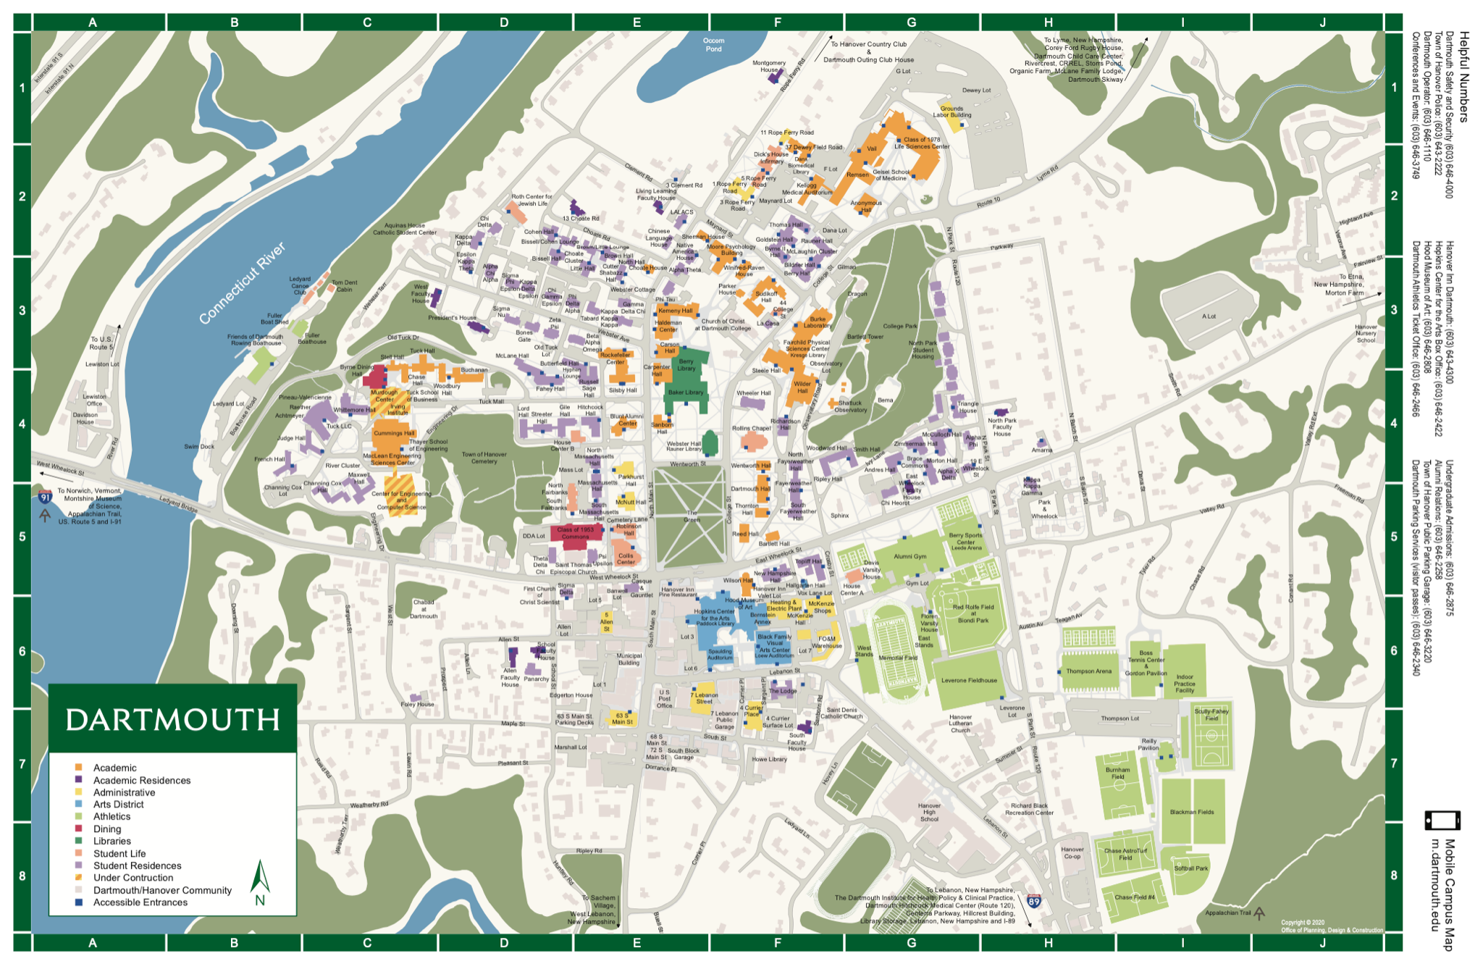
- 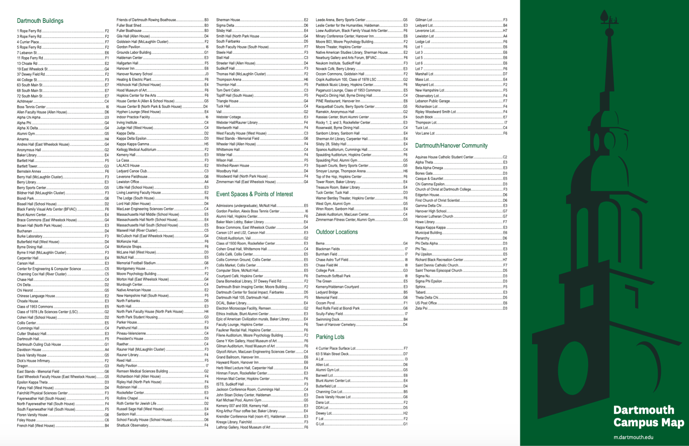
- A very interesting feature of the campus is that it has a lot of trees including 200 American Elm Trees
- Dartmouth’s buildings range from modern to the oldest buildings Wentworth and Thornton Hall being built in 1820

Dorms/Housing
- Nearly 90% of Dartmouth’s undergraduates live on campus
- For undergraduate living, there are 6 houses
  - Allen house
    - The Allen House is a co-ed residential building. The house has singles, two-room doubles, and two-room triples. First-year students will live on the first-year floor with other first-year students
  - East Wheelock House
    - The East Wheelock House is a co-ed residential house. This building has singles, two-room doubles, a few two-person and three-person suites, and four-person suites. First-year students will live on the first-year floor with other first-year students
  - North Park House
    - The North Park House is a co-ed residential building. Ripley, Woodward, and Smith residence halls are part of the North Park House.The house has singles, a two-room double, and Woodward has two, four-room quads. First-year students will live on the first-year floor with other first-year students
  - School House
    - The School House is a co-ed residential building. The Hitchcock, Mid Mass, North Mass, and South Mass residence halls are part of the School House. The house has singles, one-room doubles, two-room doubles, two-room triples, and a few quads. First-year students will live on the first-year floor with other first-year students
  - South House
    - The South House is a co-ed residential building. The New Hampshire, Topliff, and Lodge residence halls are a part of the South House. The house has singles, one-room doubles, and a few two-room doubles. First-year students will live on the first-year floor with other first-year students
  - West House
    - The West House is a co-ed residential building. The Russell Sage, Fahey & McLane and Butterfield residence halls are a part of West House The house has singles, two-room double, two-room triples, a few one-room doubles, and a few five-person suites. First-year students will live on the first-year floor with other first-year students
- Also, for first-year students, there are all first-year residence halls
- Additionally, on campus, there are organizations houses and Greek letter houses
- When living off-campus, all students must report their address each term
Food
- The main location for dining is in ’53 Commons which is located at 6 Mass Row, Hanover, NH 03755.
- The hours are based on the meal times which are 7:30 am -10:59 am is Breakfast, 11:00 am - 3:59 is Lunch, 4:00 - 8:30 is Dinner and 9:00 pm - 12:00 am is Late Night
- Other locations for Dining are participating cafes on campus
- Dartmouth follows 3 different plans
- The Ivy league dining managing plan
  - This means that you can purchase meals for a term for $2,220
  - You get unlimited food
- The 115+ Plan
  - You get 115 swipes at any of the locations above and you pay $1965 per term
  - You can use two meal swipes during the same meal
- The 80+ Block
  - You get 80 meal swipes at any of the locations above and you pay $1950 per term
  - You can use two swipes during the same meal
- Off-Campus Dining
  - The Box Food Truck: This is a food truck that is student-run and is placed around Dartmouth’s campus. Food recommendations include falafels and half-and-half bowls
  - Tuk Tuk Thai: This is a restaurant that is very convenient for takeout. It is known for being quick in its delivery and reliable in its quality of food. Food recommendations include the shrimp green curry and the sweet mango sticky rice

Academics

List of majors
  - Arts and Performing Arts: Art History, Film and Media Studies, Music, Studio Art, and Theater
  - Engineering: Engineering Sciences, Biomedical Engineering Sciences, Engineering Physics, Human-Centered Design, Materials Science, Bachelor of Engineering
  - Humanities: Asian Societies, Cultures and Languages, Classics, English, French and Italian, German Studies, Philosophy, Religion, Russian, Spanish and Portuguese
  - Interdisciplinary: African and African American Studies, Middle Eastern Studies, Comparative Literature, Jewish Studies, Latin American, Latin and Caribbean Studies, Linguistics, Native American Studies, Quantitative Social Science, Women’s, Gender and Sexuality Studies
  - Physical and Life Sciences: Biological Sciences, Chemistry, Climate Science, Computer Science, Earth Science, Environmental Studies, Mathematics, Physics and Astronomy
  - Social Sciences: Anthropology, Economics, Education, Geography, Government, History, Psychological and Brain Sciences, Neuroscience, Sociology

School Strengths
  - 1. Dartmouth is ranked 3rd best college in Anthropology and Sociology in America
  - 2. Dartmouth is ranked 4th best college in Global Studies in America
  - 3. Dartmouth is ranked 6th best college in the Film and Photography
  - 4. Dartmouth is ranked 11th best college in Psychology
  - 5. Dartmouth is ranked 13th best college for national colleges
- Academic Requirements for Graduation
  - First-year students have to complete the First-year Writing Requirement which includes:
    - Writing course which can be either Writing 5, Writing 2-3 or Humanities 1
    - First-year Seminar of Humanities 2
  - All Dartmouth Students are required to take 35 credits before their graduation. Usually, students decide to take 3 classes per quarter for 12 terms to reach their requirements. Additionally, any PE courses that students register for do not count towards the 35 credits that they are required to take before graduation
  - Before students graduate, they must have completed 3 terms of physical education and they have to pass a 50-yard swimming test. Some sports may count for the physical education credits.
  - See the link here for more information: https://students.dartmouth.edu/ugar/faculty/advising/resources/general-academic-requirements-graduation
- Dartmouth has internships that help you enhance your networking such as the Career guidance from the Center for Professional Development and a Public Policy internship where you can intern in Washington D.C at Rockefeller Center
  - See the link here for more information https://home.dartmouth.edu/education/undergraduate-experience/internships
- The Senior Fellowship Program is when students who are chosen are able to explore an area of study in which they are passionate. Each fellow is chosen because they have a high academic caliber and a curiosity for a topic that relates to their own area of study. This can be a way for students to go in-depth in a project they are passionate about.

Student Life
- Dartmouth has 33 club sports which can be nationally competitive or for recreational purposes
- Dartmouth’s mascot is Keggy the Keg
- Dartmouth has Hopkins Center for the arts which annually holds the event “Hop” which includes a variety of performances in the arts by the students
- Dartmouth has more than 160 art groups which are run by students
- 27% of undergraduate men are in a fraternity and 31% of undergraduate women are in sororities at Dartmouth
- Gender council inclusive Greek council includes Alpha Theta, Phi Tau, and The Tabard
- Interfraternity Council includes Alpha Chi Alpha, Beta Alpha Omega, Bones Gate, Chi Gamma Epsilon, Chi Herorot, Gamma Delta Chi, Kappa Kappa Kappa, Phi Delta Alpha, Psi Upsilon, Sigma Nu and Theta Delta Chi, Zeta Psi
- National Pan-Hellenic Council includes Alpha Phi Alpha, Alpha Kappa Alpha, and Delta Sigma Theta
- Inter-Sorority Council includes Alpha Phi, Alpha Xi Delta, Chi Delta, Epsilon Kappa Theta, Kappa Delta, Kappa Delta Epsilon, Kappa Kappa Gamma, and Sigma Delta
- Diversity within the students
  - Of the student population, 50% are White, 15% are Asian, 10% are Hispanic, 9% is International students, 6% are African American, 5% are Multiracial, 3% are Unknown, 2% are Native American
  - Of the student population, for their primary residence 85% have out-of-state, 10% have international, 3% are unknown and 2% are in-state

Unique Features, Traditions, and Alumni
- A unique feature of Dartmouth is that it has a quarter-system calendar called the D Plan. The D plan is made up of four 10 weeks terms which gives the students more variety and flexibility with their class schedule and time in college.
- Dartmouth gives out Financial aid through need-blind admissions. This means that financial aid is not given based on the financial circumstances of the student. Student households with total incomes of $100,00 or less will get financial aid.
- An exciting tradition of Dartmouth is the Winter carnival. This Winter Carnival has a different theme each year which adds an element of surprise. This Carnival began in 1911 and celebrates the achievement of Dartmouth’s winter sports teams. Activities in the past have included Ice sculpture contests, polar Bear Swim, and Human Dogsled Races.
- Another Tradition of Dartmouth is the First-year trips. This helps the incoming students get introduced to Dartmouth. First-year trips are a pre-orientation program that lasts 5 days. It is a student-run and outdoor experience that helps foster relationships and connections between the upperclassmen and the incoming students.
- A tradition of Dartmouth that was initiated in 188 was the Dartmouth Night and Homecoming where the alumni of Dartmouth visit their alma mater and interact with the current students. Additionally, there is a parade and a bonfire which is greatly enjoyed by the community.
- Five Famous Alumni from Dartmouth:
  - Dr. Seuss - Poet
  - Meryl Streep - Actor
  - Mindy Kaling - Comedian
  - Robert Frost - Playwright and Poet
  - Shonda Rhimes - TV show Director

Sources
- https://admissions.dartmouth.edu/about/history-traditions
- https://www.niche.com/colleges/dartmouth-college/
- https://www.usnews.com/best-colleges/dartmouth-college-2573
- https://blog.collegevine.com/what-does-it-really-take-to-get-into-dartmouth/
- https://admissions.dartmouth.edu/apply/class-profile-testing
- https://admissions.dartmouth.edu/academics/areas-study
- https://students.dartmouth.edu/ugar/faculty/advising/resources/general-academic-requirements-graduation
- https://dining.dartmouth.edu/dining-plans/dining-plans-summer-2021
- https://admissions.dartmouth.edu/follow/blog/cindy-shen/comprehensive-hanover-food-guide
- https://home.dartmouth.edu/life-community
- https://www.niche.com/colleges/dartmouth-college/students/
- https://blog.collegevine.com/what-is-dartmouth-college-known-for/
- https://home.dartmouth.edu/sites/home/files/home/wysiwyg/11x17-dartmouth-map-2020_0.pdf
- https://www.collegefactual.com/colleges/dartmouth-college/overview/location/
- https://home.dartmouth.edu/life-community/residential-life/undergraduate-housing
- https://www.ranker.com/list/famous-dartmouth-college-alumni-and-students/reference

