California Institute of Technology Information Guide

Facts about School
- California Institute of Technology is also called Caltech as a nickname
- Caltech is a private institution that was formed in September 1891
- Caltech’s founder was Amos Throop who was a philanthropist in Pasadena
- Caltech has been under many names Throop University (1891-1907), Throop Polytechnic Institute and Manual Training School (1907-1913), and Throop College of Technology (1913-1920)
- Caltech’s motto is the truth shall make you free
- Caltech’s acceptance rate in 2021 was 6.4%
- Caltech has a mean SAT score of 1545
- Caltech has a mean ACT score of 35.5
- Application Information
  - Common Application Essays
  - You are recommended to have SAT or ACT scores (Due to Covid-19 Caltech is going test-optional for the students applying fall 2021 and 2022)
  - Two teacher evaluations
  - High School Report
  - Academic transcripts
  - $75 application fee
- Caltech’s total undergraduate enrollment is 901
- Caltech’s student-to-faculty-ratio is 3:1
- The tuition for Caltech is $58,680

Campus and Environment
- Caltech’s campus is 124 acres
- The campus is considered a Mid Sized City campus
- Caltech’s campus is located in Pasadena, California which is a city northeast of Los Angeles
- Here is a campus map:
  - 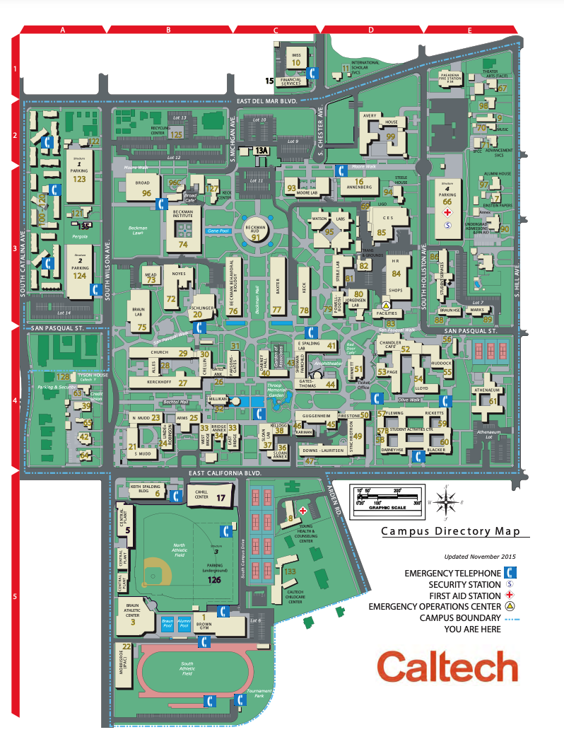
- The campus address is 1200 E California Blvd, Pasadena, CA 91125
- In Caltech, only 1% of students live on campus
- There are bus and train lines for transportation to downtown
- Campus safety and security services
  - 24-hour foot and vehicle patrols
  - Late-night transport/escort service
  - 24-hour emergency telephones
  - Lighted pathways/sidewalks
  - Controlled dormitory access (key, security card, etc.)
- Caltech Archives Collection
  - The Caltech Archives is an extensive repository of historical documents, scientific papers and records, artifacts, and rare photographs chronicling the scientific achievements of the Institute for the past 100 years and earlier. The Institute also houses the Einstein Papers Project, the collected papers of Albert Einstein (over 40,000 documents).

Dorms/Housing
- South Houses
  - Ricketts House
    - Ricketts House was founded and named after the mining engineer L.D Ricketts
    - Ricketts House traditions include fire-related activities and the brake drum
    - Ricketts House house approximately 70 students
  - Blacker House
    - Blacker House was founded and named after a trustee of Caltech Robert Roe Blacker
    - One tradition of Blacker house is the Hellride
    - Blacker House has its halls painted as Heaven and Hell, and a small lounge and kitchenette in between them known as Purgatory
  - Dabney House
    - Dabney House was funded and named after Joseph B Dabney, the owner of Dabney Oil Syndicate
    - Dabney started the Student Coffee House, hosts Drop Day, and Dabney Metal Night as traditions
    - Dabney’s motto is Fidelis et gratis "Faithfulness and thankfulness"
  - Fleming House
    - Fleming House was funded and named after Arthur H Fleming, the then chairman of Caltech’s Board of Trustees
    - Members of Fleming House are called Flems
- North Houses
  - Lloyd House
    - Lloyd House was founded and named after Ralph B Llyold
    - Lloyd House is the smallest of the three North Houses
  - Page House
    - Page House was founded and named after J.R. Page, former vice president of the First National Bank in Los Angeles
    - Page House is one of the largest houses
  - Venerable House
    - Venerable House was formerly known as Ruddock House
    - Venerable House was named after Albert Ruddock

Food
- Meal Plans
  - Anytime Plan
    - The Anytime Plan includes weekday House Dinners, Weekend Brunch service, Weekday Open Kitchen, Special Dinners, and all food item purchases for breakfast, lunch, dinner, and snacks, at Browne Café, Red Door Marketplace, Broad Café, and Avery Kitchen during normal hours
  - The Flex Plan
    - The Flex Plan includes weekday House Dinners, Weekday Open Kitchen, and any Special Dinners. A declining balance can be used for all other meals, including breakfast, lunch, snacks, and weekend meals, at any of the dining locations during normal hours (excluding vending machines).
- Guest Meals For Purchase
  - $12.50 for Waited Dinner or Burger Night
  - $14.50 for Steak Night
  - $17.50 for Dress Dinners
- Off-campus dining
  - Pie n’ Burger
    - This is a diner-style American restaurant that makes a great old-fashioned burger and the pies are to die for
  - The Arbour
    - This is an American restaurant with a simple but elegant ambiance and the sea bass comes highly recommended
  - Athenaeum
    - This is an American restaurant that has a grill buffet that cannot be missed

Academics
- List of Majors
  - Applied and Computational Mathematics, Applied Physics, Astrophysics, Bioengineering, Biology, {Business, Economics, and Management}, Chemical Engineering, Chemistry, Computational and Neural Systems, Computer Science, Economics, Electrical Engineering, Engineering, and Applied Science, English, Geobiology, Geochemistry, Geology, Geophysics, History, History, and Philosophy of Science, Information and Data Sciences, Materials Science, Mathematics, Mechanical Engineering, Philosophy, Physics, Planetary Science, Political Science
- List of Minors
  - Aerospace, Chemistry, Computer Science, Control and Dynamical Systems, English, Environmental Science, and Engineering, Geological and Planetary Systems, History, History, and Philosophy of Science, Information and Data Sciences, Philosophy, Structural Mechanics
- Academic Divisions
  - Division of Biology and Biological Engineering
  - Division of Chemistry and Chemical Engineering
  - Division of Engineering and Applied Science
  - Division of Geological and Planetary Sciences
  - Division of the Humanities and Social Sciences
  - Division of Physics, Mathematics, and Astronomy
- School Strengths
  - 1. Caltech is ranked 2nd best college for Physics in America
  - 2. Caltech is ranked 4th best college for Computer Science in America
  - 3. Caltech is ranked 5th best college for Chemistry in America
  - 4. Caltech is ranked 7th best college for Engineering in America
  - 5. Caltech is ranked 14th best college for Math in America
- Graduation Requirements
  - Freshman Mathematics
    - 27 units (covering Multivariable Calculus and Linear Algebra)
  - Freshman Physics
    - 27 units (yearlong course)
  - Freshman Chemistry
    - 15 units (classes) and 6 units (lab)
  - Freshman Biology
    - 9 units
  - Menu Class
    - 9 units (subjects include Astronomy, Environmental Science and Engineering, Energy Science, Geosciences, Information, and Logic)
  - Additional Introductory Lab
    - 6 units (multiple options)
  - Scientific Writing
    - 3 units
  - Humanities and Social Sciences
    - 36 units in Humanities, 36 units in Social Sciences, and 36 additional units in either
  - Physical Education
    - 9 units
- Special Programs
  - Mellon Mays Undergraduate Fellowship (MMUF)
    - The MMUF is a national program focused on increasing the number of underrepresented students who will do doctorate degrees in fields in the arts and sciences.
  - Summer Undergraduate Research Fellowships (SURF)
    - The SURF gives students an opportunity to do research under the guidance of experienced mentors.
  - SURF Exchanges
    - This program is an extension of the SURF program which is trying to immerse students in another culture and helps them learn to research in another environment.
  - GROWTH SURF
    - The GROWTH SURF allows undergraduate students to spend up to 10 weeks abroad in international partner institutions in Germany, Taiwan, India, Israel, Japan, Sweden, or the United Kingdom.
  - LIGO SURF
    - This is a summer program at the LIGO observatory sites.
  - Amgen Scholars
    - Amgen Scholars Program is a national program aimed at increasing research opportunities for students committed to pursuing careers in the sciences.
  - WAVE Fellows
    - The wave fellows program is aimed to foster diversity by increasing the participation of underrepresented students in science and engineering Ph.D. programs
Student Life
- Caltech has over 100 clubs and organizations
- For music, Caltech has a symphony orchestra, chamber orchestra, concert band, two jazz bands, and over 25 music ensembles.
- Caltech does not have greek life
- Caltech’s Mascot is a beaver
- Diversity within students
  - Male to Female Ratio
    - 54.7% are men and 45.3% are women
  - Racial/Ethnic Breakdown
    - 31% are International, 30.2% are White, 21.4% are Asian, 10.2% are Hispanic, 5.5% are Multi-Ethnic, 1.1% are African American, 0.5% are unknown, and 0.1% Pacific Islander

Unique Traditions and Alumni
- The Flems fire their cannon several times a year
- Every Halloween, Dabney House has a pumpkin drop from the top of Millikan Library
- Before winter break, Lloyd House constructs a "light tree" on Millikan Library
- Senior Ditch Day is also a long-standing tradition at Caltech
- Five Famous Alumni from Caltech
  - Howard Hughes
  - Benoit Mandelbrot
  - William Shockley
  - John McCarthy
  - David Bohm

Sources
- https://www.caltech.edu/about/legacy/history-milestones
- https://en.wikipedia.org/wiki/California_Institute_of_Technology
- https://www.acceptancerate.com/schools/california-institute-of-technology
- https://www.niche.com/colleges/california-institute-of-technology/#admissions
- https://blog.collegevine.com/the-ultimate-guide-to-applying-to-the-california-institute-of-technology/
- https://blog.collegevine.com/caltech-acceptance-rate-what-does-it-take-to-get-in/
- https://www.usnews.com/best-colleges/california-institute-of-technology-1131
- https://www.caltech.edu/documents/9/2021_Caltech_Campus_Map-combined.pdf
- http://www.seismolab.caltech.edu/pdf/Caltech_Campus_Map_5_2016.pdf
- https://en.wikipedia.org/wiki/House_system_at_the_California_Institute_of_Technology#Blacker_House
- https://dining.caltech.edu/documents/20196/Anytime_vs_Flex.pdf
- https://dining.caltech.edu/board-program#meal-plans-9c2ac120-tab
- https://www.tripadvisor.com/RestaurantsNear-g32859-d5789361-California_Institute_of_Technology-Pasadena_California.html
- https://www.admissions.caltech.edu/explore/academics/majors-minors
- https://www.admissions.caltech.edu/explore/academics/core-curriculum
- https://www.admissions.caltech.edu/explore/academics/research
- https://www.admissions.caltech.edu/explore/student-life/clubs-activities
- https://www.collegefactual.com/colleges/california-institute-of-technology/student-life/diversity/
- https://www.admissions.caltech.edu/explore/student-life/traditions-pranks
- https://www.thefamouspeople.com/california-institute-of-technology.php

