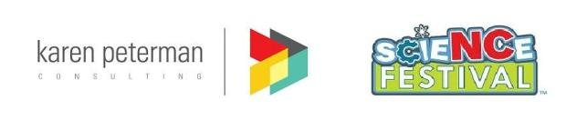

Short-Term Field Researchers Needed

Karen Peterman Consulting, Co. is hiring short-term field researchers to help collect data during the North Carolina Science Festival. Field researchers will attend local Festival events to collect survey data from the public.
REQUIRED QUALIFICATIONS:
--A Bachelor's degree and some graduate courses in developmental psychology, education, school psychology, human development, or related fields
--Experience or coursework in social science research data collection (observation, survey administration etc.)
-- Must be available between 10am – 3pm on April 13th
--Must have your own transportation
Researchers will be paid $25/hour and work 5 hours
If you are interested, please email Karen Peterman (karenpetermanphd@gmail.com) with a cover letter and resume. Resumes submitted without cover letters will not be considered.

