IUL Haters–there are some in the industry who truly despise IUL. Most of the advisors I run into who don’t like IUL don’t really understand the product or can’t sell it.

Hater talking points–the returns in an IUL won’t be any good because 1) the product has a cap on growth and 2) the returns pegged to the S&P 500 do not include dividends (meaning returns won’t be very good).

These talking points are a wrong. Let’s look at what the CAGR (compound annual growth rate) on the cash inside an IUL over the last 10 years would have returned and compare that to the S&P 500 with dividends, a 60/40 mix of stocks and bonds, and AGG.

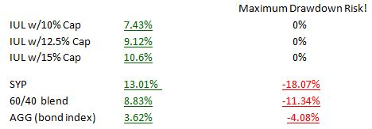
Many advisors use AGG as a place for safe money. It’s been true that using AGG has been fairly safe, but when you consider that an IUL has no downside risk and yields that rival a 60/40 mix, you can see why I like IUL as a conservative asset class. Also keep in mind that the IUL numbers are “net” and the other numbers quoted are a gross return (no money management fees and no taxes).
The more interesting numbers are from 1998-2008 (what people call the Lost Decade). During the Lost Decade the S&P 500 with dividends had a CAGR of 0.93%. How would the cash in an IUL have done?
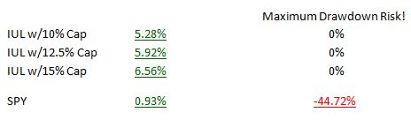
(There are no numbers for a 60/40 mix or AGG because bond indexes weren’t available until 2003)
These numbers were derived from the OnPointe Risk Analyzer program.

Why are the Lost Decade numbers more interesting? Because most advisors I’ve talked with think the next 10 years are much more likely to look like the Lost Decade more so than the last ten years. If so, using IUL as an asset class will be very beneficial to a client’s overall portfolio.

Why don’t more advisors use IUL as an asset class?

They just don’t know anything about IUL. No offense, but usually Series 7 licensed advisors who are with bigger Broker Dealers (BDs) have never really learned anything about IUL policies. BDs, as a general statement, don’t want their advisors using IUL (doesn’t make the B/D a trail fee). Fee-only advisors also don’t seem interested in learning about IULs because they pay a commission. RIAs/IARs are more likely to use IUL but there are still far too many who know too little or nothing at all about IUL.

Contractually forbidden! Captive agents who work at companies like Northwestern Mutual, New York Life, Guardian, etc. can’t sell IUL policies. In fact the whole life crowd has done everything in their power to discredit the use of IUL. Virtually all captive agents are ignorant when it comes to IUL.

Why am I such a fan of IUL?
It’s a simple matter of mathematics-I’m agnostic to product type or AUM platform style. I just look at the numbers and decide for myself if an asset should be used as part of a financial or retirement plan. The math, coupled with reasonable assumptions, has told me for years that an IUL can be a vital tool for a many clients.

What will happen in the stock market the next 10, 20, 30 years? We don’t know!
What we do know is that mathematically if you grow wealth in a product that has no downside risk and pegs its returns to the S&P 500 (without dividend) with a cap of 10% or more, the client’s money will be protected and will most certainly generate an after-tax return that far exceeds CDs and money market accounts (and mathematically should generate returns that are similar to a 60/40 investment mix but with NO risk of loss from market downturns).

Should ALL advisors research the pros and cons of IUL?
Absolutely (and those with a fiduciary duty owe it to their clients to learn about IUL).

