_______________
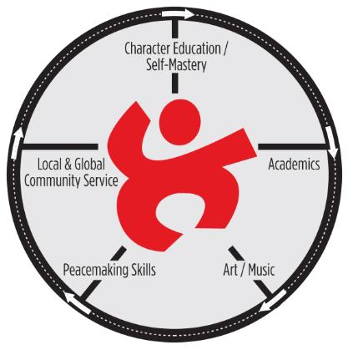

Template for Full-Circle Learning Unit Plan

13-S FORMULA

Copy and use this template to make notations on your overall plans for each unit of study.

HABIT-OF-HEART: ______________________________________

DATES: _______________________________________________

COMMUNITY NEED/S STUDENTS WILL ADDRESS: __________

______________________________________________________

DESCRIPTION OF STEP | NOTES TO GUIDE PREPARATION
SENSE IT.  Present an anticipatory set or attention-getting activity that piques curiosity, links to ultimate service goals, or connects to prior knowledge to explain the significance of the habit-of-heart, using as many of the senses as possible. Follow up with descriptions or examples to demonstrate the meaning of the word. | Steps to Tapping the Senses; Correlation to Later Steps:  Examples:  Related Homework:
SEE IT.
Write the habit-of-heart on the board in large letters.

SAY IT.
Clap out the number of syllables. Students clap along.

SYNCHRONIZE IT.
Students give the syllables in the word different pitches and sing or chant the word together. Synchronizing pitch and syllabic sounds is especially effective with long words. The chant becomes a cheer to use when students are practicing the habit-of-heart.

SHAPE IT.
Draw the shape of the word around the written word in a way that suggests a visual metaphor. Conduct a kinesthetic activity to reinforce the meaning, such as building a human train to represent cooperation. Have younger students write the word and draw the shape to promote word recognition and to reinforce the concept.

SYMBOLIZE IT.
Have students agree on an action associated with the word. (Prohibit gang signs.) Have the class practice this action. When calling the class to show the habit, instead of using the cheer, a student or teacher can silently use this gesture.

STORYTELL IT.
Use real-life applications, current events, examples in recent assignments, role plays or literary passages that present opportunities to discuss the habit-of-heart. Discuss how the plot might have ended differently if certain characters had applied or not applied the habit-of-heart. Students imagine the most positive endings.

SHOW IT.  Collect examples of relevant applications from curriculum, current events and school culture.  1. Assign hypothetical demonstrations on the conflict bridge, using interpersonal, community-based and international conflicts.  2. Use guided imagery to help all students envision the application of the quality in their lives.  3. Reinforce the habit by making Habits-of-Heart homework a tradition. (Students show/describe how they practiced the habit. Parents participate.) | Describe the Conflict Participants  - Interpersonal Conflict:  - Community-based Conflict:  - Global Conflict:  Guided Imagery Theme (repeated twice weekly)
SING IT  Rehearse a Habit-of-Heart song about the current habit, emphasizing that music serves two purposes, as a gift of joy and comfort or as a tool to inspire action or advocacy | Song/s:
STANDARDS-BASED LEARNING  Look for thematic threads of continuity in core content areas. You will find suggestions throughout this book. Here, students express the habit through research, study and action. Apply process-based learning and project-based learning where possible. Use graphic organizers, to connect thematic and academic content. Integrate two relevant ideas to the end service goal or to the objects being produced as a service to society. Apply authentic outcomes wherever possible, as students create artifacts that become gifts to honor those working in the fields or products used for advocacy or problem-solving. | In the spaces that follow, describe the content-driven activities you will add to unit.
SEND IT.  Create a wisdom exchange with another class. Seek information or send congratulations from a research facility. Mail or email a wisdom exchange to a global classroom collaborator. Write to newspapers, professionals or officials, in reference to a service goal.  For global collaborators, if possible, include photos or drawings of the students and artifacts of their project, telling of its impact and relationship to the habit-of-heart. Challenge the distant brothers and sisters to share ideas and to join them as they address the issue. (i.e. poverty, deforestation, energy concerns.) | Service Objective/s and Learning Goal/s Reinforced:
SHARE IT.
By now, students may have already experienced a distant connection with the human family. They also need to witness the value of their teaching and learning in their own community. They teach or advocate for a cause or share something they have created with their knowledge to help the community. They may sing and present to an audience they are honoring on a service-learning field trip. Alternatively, in some cases, local service occurs onsite, by bringing a guest presenter in or by creating an in-school museum.

SUSTAIN IT  This step helps students reflect and recognize the value of their unit-long efforts to enhance the wellbeing of those served. (It is not the project steps being sustained but the lifelong commitment to the habit-of-heart.)  To “sustain the habit,” conduct a layer cake activity or a discussion with a talking stick or a shared pair activity or a journal writing activity or all the above. Challenge students to first layer responses and then to write responses as they identify the potential positive impact of the Share It and Send It steps on the local and/or global community. Give them a chance to reflect on their own personal growth and especially to discuss their group impact on community transformation.  Commit the class to make the habit-of-heart an ongoing part of their code-of-ethics and pattern of life as an altruist/change agent/ sage/ hero/ ambassador/helper/vision seeker/humanitarian, etc.  After this step, the class is ready for the next habit-of heart unit. | Activity for Reflecting on Community Impact:  Challenge for Sustaining the Habit-of-Heart:

