2022 – THE YEAR IN REVIEW @ SOUTH TIPPERARY ARTS CENTRE

Spring

2022 has been a busy year here at STAC, and to mark the year’s end we would like to share some of the highlights with you all. Beginning the year was ‘Edgelands’ – a new body of work by John Kennedy, who was our Tipperary Artist in Residence for 2021.
February brought us ‘The Sculptural Imagination of Seánie Barron’ in collaboration with Askeaton Contemporary Arts. The exhibition was accompanied by a publication of the same name, giving a wonderful insight into Seánie’s approach to stickmaking.
In March we were delighted to collaborate with artist Marine Kearney in the Artist Pledge for Ukraine which saw €14,400 raised in total across two events, which blew us away!
In April we had the privilege of hosting performance artists Pauline Cummins & Frances Mezzetti whose Retrospective ‘Walking in the Way’ was a culmination of a decade long collaboration between the artists. This was also accompanied by a comprehensive publication ‘Walking in the Way: Performing Masculinity’.
There was huge excitement later that month as we took the gallery onto the streets of Clonmel. A new mural by street artist Joe Caslin was installed on the façade of the old museum building in Parnell Street, while an open call to local artists saw 7 large scale works being installed at various locations around the town of Clonmel, where they continue to bring colour to the streets.
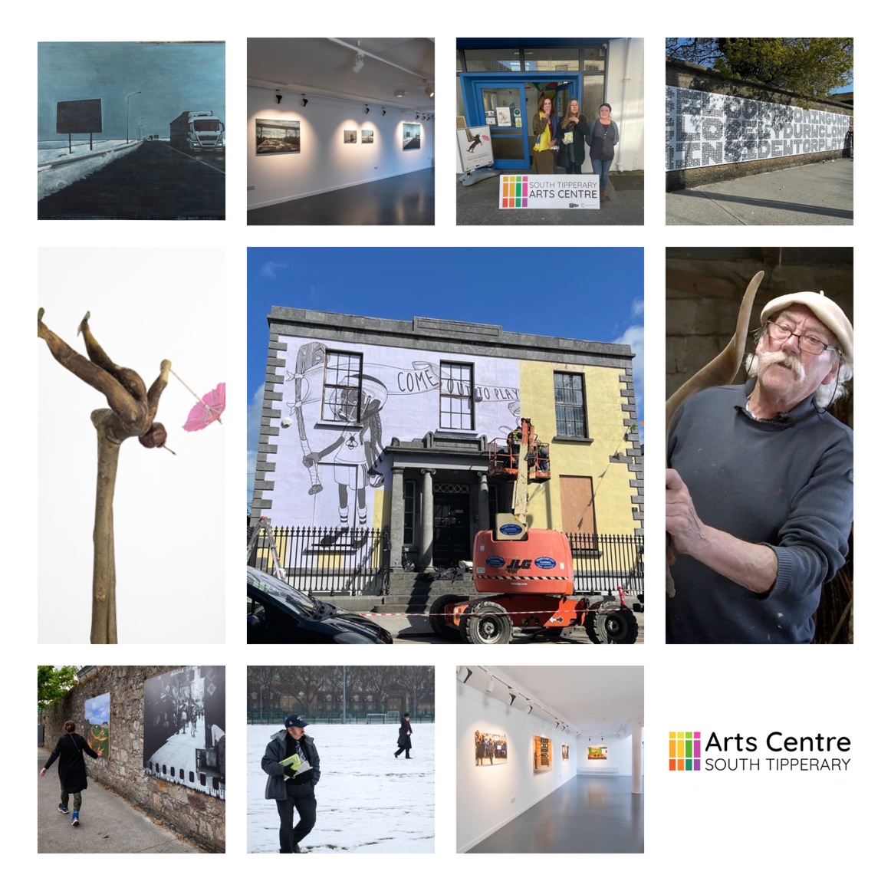

Summer

The Summer season always brings plenty to keep us occupied, and plenty of opportunity for collaboration with our Arts partners.
June saw Michael Holly’s ‘The Parish’ celebrate the GAA community. Cruinniu na nÓg is always a signal that Summer is here, and we pulled out all the stops for our first in person celebration of the day in quite a while with our Doopity Doo Day.
Under the banner of #ClonmelArts we launched a visibility campaign with Clonmel Junction Arts Festival and Finding a Voice concert series, promoting the vibrant arts scene the town has to offer to audiences young and old.
We were delighted to partner with our friends at Clonmel Junction Arts Festival once again in July, inviting sound artist Ed Devane to transform the gallery with his interactive sound sculptures. We also collaborated with Tipperary Dance and Digital Animation Production students at TUS in other events as part of the festival programme. Arts & Crafts summer camps & mindfulness workshops, along with the opening of for our annual Artist in Residence made sure that we didn’t get bored!
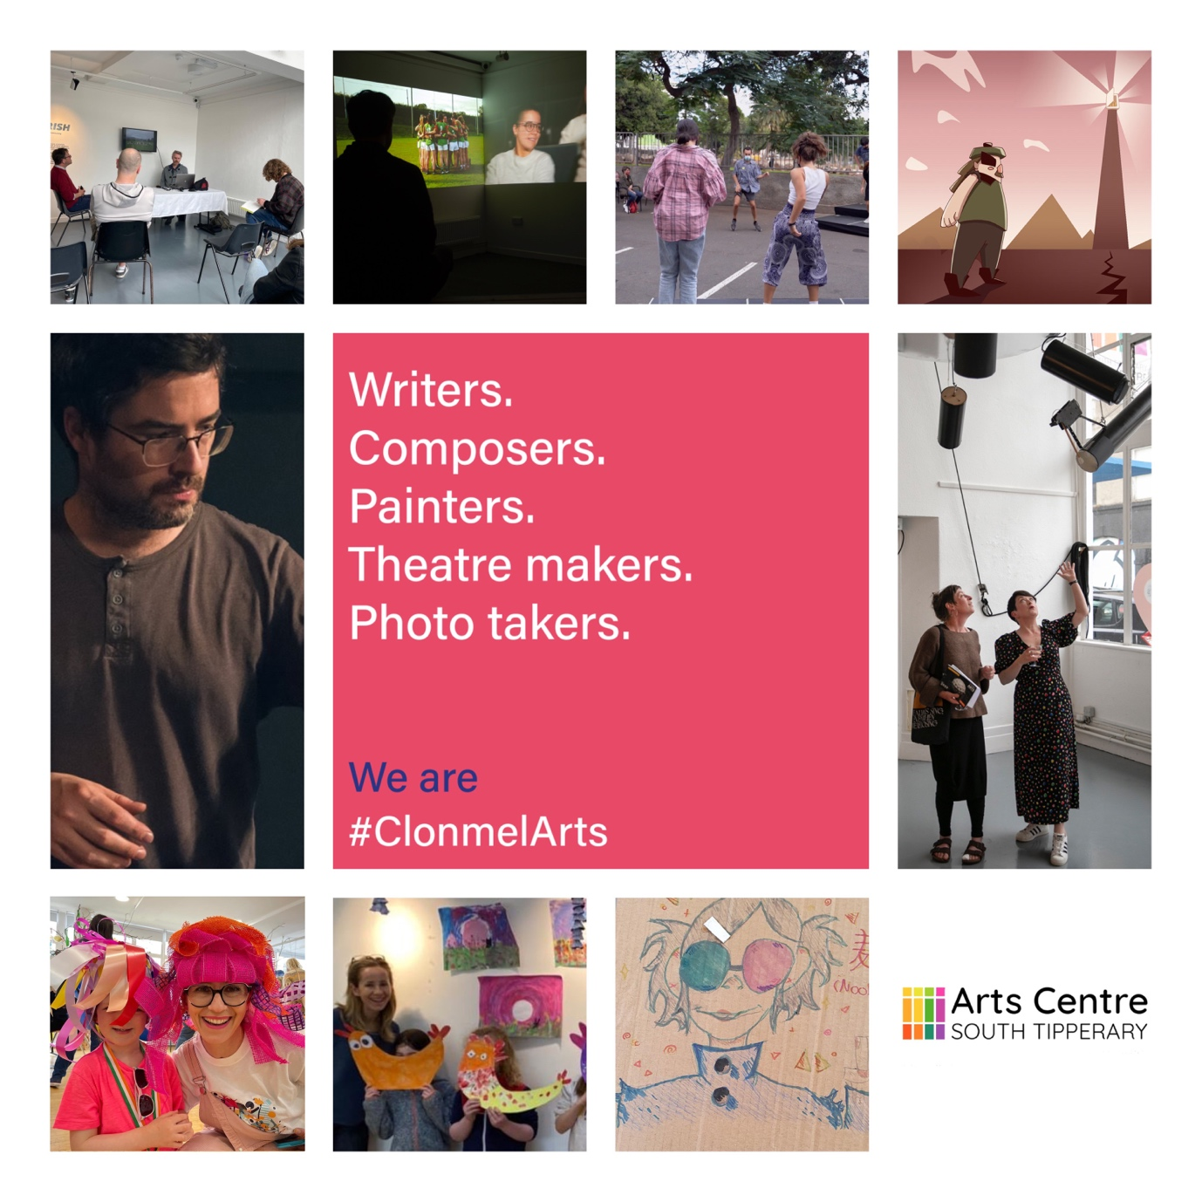

Autumn

The shorter evenings and back to school time always signal the return of art classes at STAC, both for our children’s and adult classes. This year we added extra sessions to our kids’ classes as well as introducing a new class for Junior Cycle students.
September for anyone working in the arts is synonymous with Culture Night, the night when cultural institutions around the country throw open their doors to the public and present a programme of free events for all. At STAC, we were delighted to host Stephen Brandes wonderfully quirky exhibition ‘The Trotskys in Kilsheelan and Other Histories of Unreliable Origin’ with an open conversation in the gallery on the night between Stephen and fellow artist Sean Lynch. We also had an opportunity to share the short film, ‘Now and Then’ – which documented our intergenerational Creative Ireland Project for 2022 with the wider public. On the big night another highlight was the premiere of Clonmel Song Cycle, which brought to a close the ambitious programme of In The Open|Faoin Spéir events.
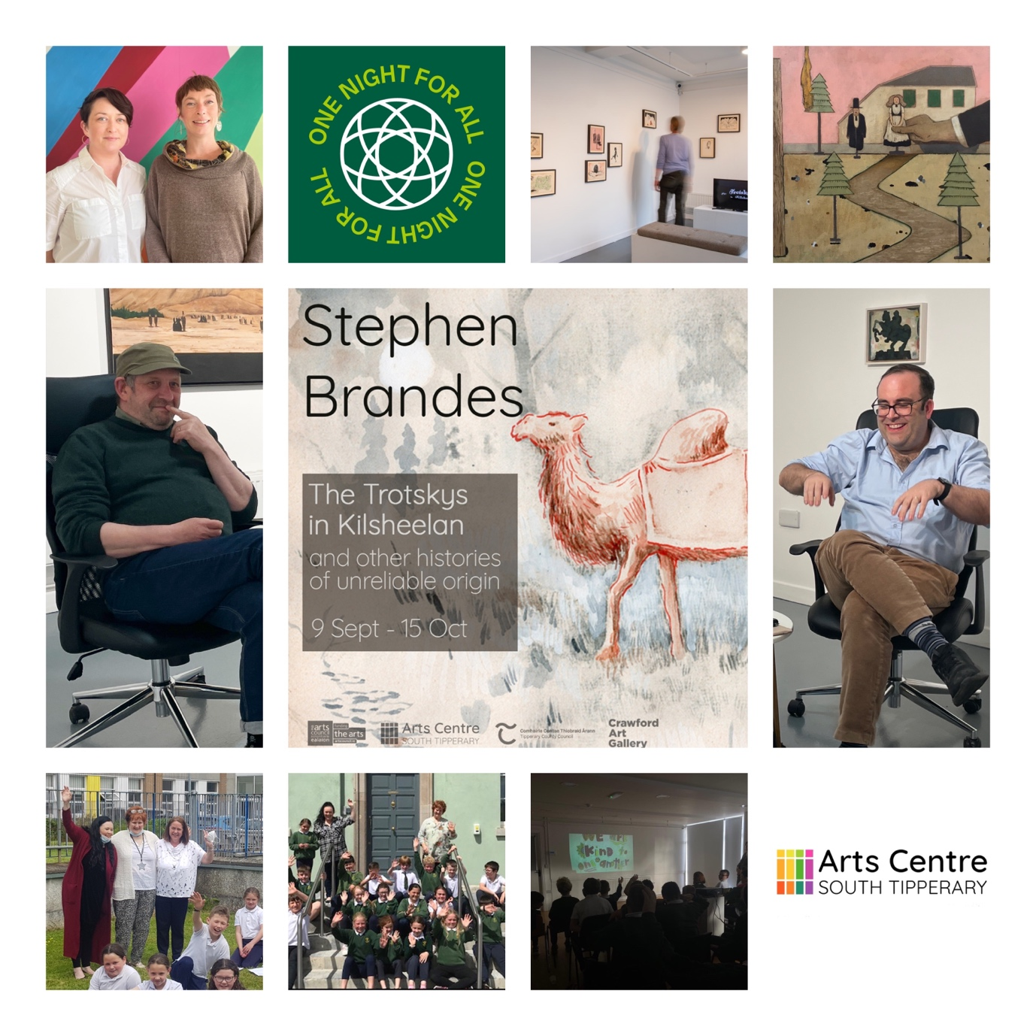

Winter

2022 has been a busy year here at STAC, and to mark the year’s end we have been posting some of our highlights over the last few days.
Our highlights of winter begin with a series of intimate acoustic sessions in the gallery here at STAC, featuring the best of local talent across several genres. The sessions were a big hit with both audiences and performers alike and were made possible under the Local Live Performance Programming Scheme. The gallery hosted ‘She’ll Give You All She Has’ which looked at farming and agricultural life, from the perspective of three female artists with connections to this world- Laura Fitzgerald, Orla Barry & Chloe McKeown.
Our Christmas season of workshops rounded out the year and, in the gallery, ceramic work from around the region was showcased. The workshop space was transformed once again by Elke and her team of elves into Santa’s Sensory Grotto which this year spanned 2 full days, our biggest ever, with the support of Rotary Clonmel, Tesco Clonmel and Tipperary Arts Office. We wish all our friends, partners, and funders all the very best for 2023 and we look forward to working with you in the New Year.
