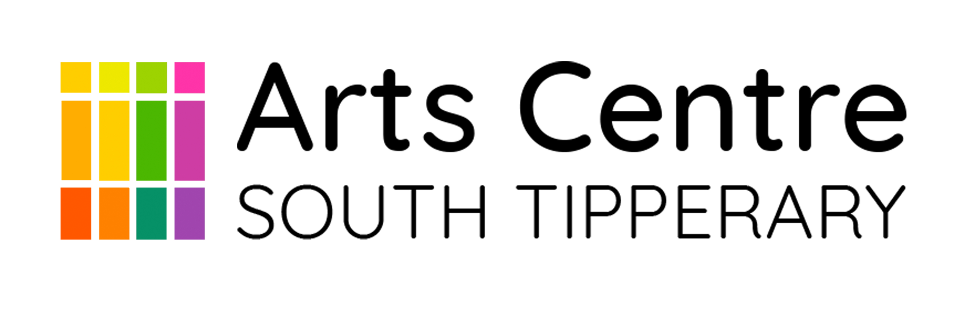

Residency Programme 2022
South Tipperary Arts Centre and Tipperary Arts Office

OPEN CALL FOR ARTISTS

Contemporary artists are invited to apply for participation in the STAC Artist In Residence Programme 2022, supported by Tipperary Arts Office.

Applicants MUST be born in or domiciled in County Tipperary.

The Aim of this award is:
- To encourage and support the development of new work by Tipperary artists.
- To support artists in getting work through the stages of research and experiment towards production and presentation.
- To provide a support structure for an early or mid-career artist to develop new work.

One artist will be selected to participate in the Programme. We welcome applications from artists working across all forms of contemporary art practice including socially engaged or research based work that can be shown in an exhibition context.

The award will cover a residency period from September 2022 to January 2023, culminating in an exhibition in the Main Gallery at the South Tipperary Arts Centre in early January 2023.

The selected artist will be awarded €3,500 to support the creation of new work for exhibition and will also receive mentoring and curatorial support throughout the residency. Also covered will be basic installation costs, PR and exhibition opening reception. Applicants must be available for the duration of the residency. Studio space is not provided, however meeting space can be made available if required during the residency.

Note: Proposals should consider the impact that any changing Covid-19 Public Health Restrictions may have on plans for the residency and address contingency planning options in the proposal.

To apply: please send a Residency Proposal (incl. budget), CV, artist statement and a PDF of no more than 15 images or media links to info@southtippartscentre.ie

Closing date: Wednesday 10th August at 5pm.
Late applications will not be accepted and the decision of the project partners is final.

This project is supported by the Tipperary Arts Office arts programme, which is supported by The Arts Council.
