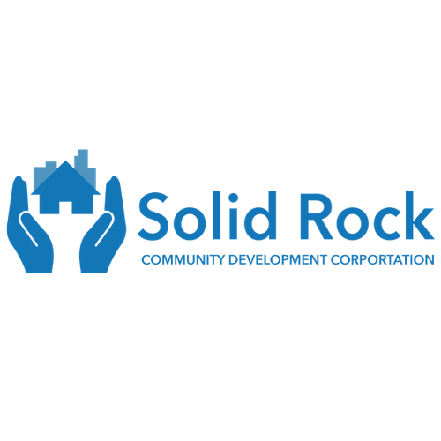
Solid Rock
Community Development Center

2022 Strategic Plan

December 2021

Table of Contents
No table of contents entries found.

Executive Overview

What we do

The Solid Rock Community Development Corporation (CDC) is a nonprofit, community organization dedicated to revitalizing Southeast Colorado Springs through the following program focus areas:

- Affordable housing development
- Local business development support
- Healthy community creation
- Policy advocacy

Leadership & Staff

Solid Rock CDC is led by Executive Director Ben Anderson, with following key staff members:

- Latrina Ollie, Assistant Director
- James Johnson, Property Acquisition Manager
- Yevgeniya Tsyganok, Food Pantry Coordinator
- Jadonna Brewton, Youth Center Coordinator
- Nicholas Crutcher, Youth Services/Mentorship

Board of Directors

Mattie Gullixson, Chair (National Cybersecurity Center Program Director)
John Conaway, Vice Chair (Editor)
Shawn Gullixson, Treasurer (Vectra Bank, Market President)
Demitta Clausell-Reese (Navigators, Cultural Journey Supervisor)
Dr. George Houston (Center for Creative Leadership, Global Markets Design and Delivery Mgr)
Wanda Anderson (Navigators, Director of Corporate Affairs & Risk Management)
Gaspar Martinez (MTZ Construction, Owner)
Juaquin Mobley (Community Works, VP Programs)
Hannah Van-Nimwegen Mcguire (City of Colorado Springs, Senior Planner)
Tony Exum, Sr. (Colorado State Representative)

Vision & Mission

Vision
We seek to support a revitalized Southeast Colorado Springs that becomes a destination area for living, business development, and diverse culture and attractions through innovative community collaboration.

Mission
The Solid Rock CDC will lead the effort to accomplish this vision through:

- Housing diversity advocacy and development
- Business development support
- Facilitating healthy community connections
- Policy advocacy within the community and state

Goals & Initiatives - Overview

Our Strategic Plan focuses on increasing the capacity and outreach of Solid Rock CDC’s core programs by aligning actions with the Board’s recommended goals:

1. Increase Southeast residents’ ability to take advantage of diverse housing options

2. Enhance Southeast business access to community and resources

3. Leverage and develop community partnerships to raise awareness of CDC resources & Southeast region

4. Improve SE region’s ability to advocate for policy frameworks that support each major programmatic area

With the appropriate combination of resources, funding, and focus, our actions will improve the strategic focus, reach and impact of the Solid Rock CDC’s programs in Southeast Colorado Springs and the broader Colorado Springs community.

2022 Initiatives

Our 2022 Strategic Initiatives are designed to support the Board’s recommended goals.

Planned 2022 Initiatives | Goal 1 | Goal 2 | Goal 3 | Goal 4
Develop property committee
Deploy a financial literacy course for renters
Jumpstart home ownership for SE residents through bridge homes
Become a resource for rental assistance in SE COS
Successfully execute CIT project
Leverage XI/T Rowe Price connections to advance resources
Develop a business directory for the SE
Host summer community event to educate community on CDC
Improve visibility of the CDC in the community
Launch CDC branding effort
Establish a policy advocacy committee
Conduct policy gap analysis & advance stakeholder engagement

Goal 1 – Diverse Housing Options

Increase Southeast residents’ ability to take advantage of diverse housing options

Sub-Goals | Key Actions | Metrics
Develop property committee | - Identify key individuals to participate  - Establish goals and parameters of committee | - Establish regular meeting schedule & determine outcomes
Host financial literacy course for renters | - Identify financial literacy course for renters in SE  - Establish pilot & outcomes | - # pilot participants  - % participants improve their financial habits
Create bridge to home ownership | - Identify a lender to help purchase properties  - Purchase/build property  - Develop loan program to create a bridge to home ownership | - # homes purchased  - # participants successfully becoming homeowners
Become a resource for rental assistance in SE | - Leverage relationship with Affordable Housing Collaborative to funnel info on SE options  - Leverage relationships with orgs that distribute rental assistance to advance info flow to SE residents | - Website hits/Facebook likes & shares on affordable housing project info & rental assistance info shared

Goal 2 – Business Community Development

Enhance Southeast business community connections and resources

Sub-Goals | Key Actions | Metrics
Successfully execute CIT project | - Secure property  - Advance community education on investment  - Begin local investments | - # educational outreaches held  - # participants & level of investment
Leverage XI/T-Rowe Price connections to advance resources | - Learn how to use database developed by T-Rowe Price  - Identify if need additional staff to support  - Engage SE entrepreneurs for classes & support | - Leverage database by May 2022  - Launched pilot class  - # SE entrepreneurs participating
Develop a business directory for the SE | - Identify if need to contract opportunity out to complete a directory  - Develop web page dedicated to sharing SE businesses | - SE business directory developed by Oct 2022

Goal 3 – Improve Community Awareness of CDC

Leverage and develop community partnerships to raise awareness of CDC resources & Southeast region

Sub-Goals | Key Actions | Metrics
Host summer community event in SE | - Identify event plan  - Develop strategies for enhancing advocacy of CDC services  - Create committee to help plan & leverage community relationships | - Host even by August 2022  - % attendees increase awareness of CDC programs  - # of new users of various CDC programs
Improve visibility of CDC in community | - Identify community-wide events that could be held in SE  - Develop calendar & establish engagement to host events in SE to raise awareness of CDC across COS | - # events identified to host in SE in 2022  - # events hosted in SE in 2022  - # participants for each event
Launch CDC rebranding effort | - Finalize branding for CDC by April 2022 (utilize survey)  - Develop branding materials & messaging by June 2022  - Launch new brand (w/community event?) by August 2022 | - # individuals participating in survey  - % individuals with increased awareness of CDC

Goal 4 – Enhance Policy Advocacy for SE
Improve SE region’s ability to advocate for policy frameworks that support each major programmatic area

Sub-Goals | Key Actions | Metrics
Conduct gap analysis | - Identify how current policies are made around affordable housing, business development and healthy communities (including infrastructure such as public transportation, etc.) – report by end of Feb 2022  - Meet with policy makers in those areas to identify how to get connected on the decision process – end of Feb 2022 | - Policy area meetings w/policymakers  - Identified gaps in opps to engage with local decisions makers
Establish policy advocacy committee | - Identify key community members to assist in opening doors/connections across variety of policy areas by Feb 2022  - Host regular meetings w/policy team & stakeholders beginning January 2022  - Develop cadence of reporting between committee & community on upcoming policy changes | - Communication around upcoming policy changes  - Community members sharing opinions with decisions makers in COS  - Regular meetings w/decision makers on strategic priorities

