Southeast Community Investment Trust (SECIT)
2021
─
Solid Rock Community Development Corporation

Colorado Springs, CO 80910

Overview
The CIT model is designed to spur community-based ownership via financial literacy
and real estate investment. Community members within predetermined regions (zip
codes 80910 and 80916) are encouraged to invest in local property development.
The property is not exclusive in the types of tenants it can house. The collective
investments from community members lead to the improved financial stability of individuals as well as economic development of the area. All individual investments are protected from loss by a letter of credit from a bank.

Goals
- Decrease asset poverty and increase community capital.
- Raise the economic status of the Southeast community through equitable development.
- Increase community members’ financial literacy and confidence in their investment skills.
- Generate interest in businesses located in CIT due to community member’s investment in the property.
- Build and maintain community-based ownership.

Specifications
A feasibility study was conducted in the summer of 2019 by Mercy Corps targeting zip codes 80910 and 80916 which is Southeast Colorado Springs. After conducting a series of site visits including meetings with community leaders, potential partners, funders and community members, and potential investors within 80910 and 80916. It was found that Southeast Colorado Springs was an ideal location for a Community Investment Trust. While this engagement with Mercy Corps was initiated by CONO, and the report includes a brief assessment of CONO, the report findings are valid and valuable to any organization in Colorado Springs with the organizational capacity and community trust to initiate a CIT.

- Ownership structure
The CIT property will initially be purchased by Solid Rock CDC. Solid Rock CDC will serve as the primary impact investor, providing the down payment for the CIT property. This down payment will eventually be converted into a loan once ownership has been transferred to a C-Corporation. Once the property has been purchased, a C-Corporation (Southeast CIT) will be set up as the entity that receives ownership of the CIT property. Shareholders of the Southeast CIT will be limited to residents of 80910 & 80916. The Southeast CIT board will consist of identified experts in finance and real estate, including residents of Southeast Colorado Springs and shareholders. Solid Rock CDC will be the guarantor for the Southeast CIT mortgage.

- The structure of the CIT
1. Community members from 80910 and 80916 are recruited to participate in financial literacy classes, with an option to invest in the CIT upon completion of classes by trusted community Leaders.
2. Community investors participate in a financial literacy course that focuses on how to save, invest, and manage finances to build wealth.
3. Community investors buy equity shares in the Southeast CIT at low-dollar ($10-$100) monthly investments.
4. CIT tenants pay monthly rent.
5. Community investors receive annual dividends which are based on the performance of the property through a collection of rents.
6. Share price for Southeast CIT is adjusted annually based on pay down of debt and growth in value of the property through an annual appraisal.
7. Over time, community investors/residents buy out the initial down payment on the CIT.

- Project Timeline
When looking at the best approach to acquire property it was best determined to implement a 90-120 day plan. The plan consisted of the following:
- Form real estate advisory committee
- Fundraise for CIT Program Operations
- Identify target properties
- Conduct due diligence
- Purchase property
- Contract with Mercy Corps for educational programming
- Implement marketing plan

Milestones

Solid Rock CDC acquires the Southeast CIT
Initially, Solid Rock CDC sought out this project and offered to assist through fiscal sponsorship. After several meetings with the SRCDC Board and the individuals working to start the CIT, everyone agreed it made the most sense for SRCDC to take on the financial literacy classes as a program, and to have a role as a principal investor in the CIT.

Completed Operational Funding- Year 1
For operational funding, it was determined that three years would be the goal. Currently, SRCDC is focused on getting year one funding which includes (licensing education curriculum, board training, investor management port legal framework, and entity formation) and the goal is almost completed.
Sources of funding include:
Solid Rock CDC, Pikes Peak Community Foundation, Dakota Foundation, Calm Foundation, and local donors.

Property Identified
Once property has been identified in Southeast Colorado Springs, CO 80910. This freestanding, single-story property is 11,058 square feet currently occupied by 3 tenants and a large open vacant space. This property has been identified as off-market, which is an advantage due to the scarcity of commercial properties in Southeast Colorado Springs. Upon reaching out to the owner, he stated he is open to selling. Our team has walked the property and received documentation of the property expenses to complete a Pro-forma. The real estate committee has evaluated the potential deal and has determined it makes sense from an investment standpoint. We have identified a price point and the negotiation has begun with the owner.

Roles and Responsibilities
Role: Operations Manager - James Johnson
This role will be responsible for evaluating and updating the project overview, attending weekly staff meetings, ensuring the project is following all state and federal regulations, and the overall success of the Southeast CIT project.
- Interfacing with Property/Leasing Manager
The Operations Manager’s responsibilities will be to review all property management financial statements, as well as review bids over a certain threshold, in addition to assisting with the annual budget. The Operations manager will also be responsible for approving leases with Board consent.
- Investor Management
The Operations Manager will manage the process for annual appraisal and work with the Board to establish a new share price. They will also manage the annual audit of the property’s financials to report out to shareholders. Lastly, the Operations Manager will work with banks to request transfers from LC( Letter of Credit), and fill file IRS forms as along with ensuring annual dividends are paid out on a timely basis.
- Impact Investors/Banks
In working with Impact Investors and Banks, responsibilities include Finalizing a Bank for Letter of Credit and providing impact Investors with reporting on their investment. . Reports will include documentation of transfers to impact investors and documentation of quarterly interest payments.
- Classes/Education
The operations Manager will be responsible for sourcing potential Trainers for “ Train the Trainers curriculum as well as working with marketing experts to build a pipeline of community investors to invest in SECIT( southeast community investment trust.)

Role: Advisory Committee Plan

An Advisory Committee is being brought together to assist Solid Rock CDC in getting the Southeast CIT off the ground. This committee will be updated on a bi-weekly basis as to the progress that has been made for the Southeast CIT to foster transparency and trust-building with partners and community members.

The committee will be broken into sub-committees (Marketing & Outreach, Finance, Real Estate, Executive/Governance, Education/Programming, Legal and Fundraising committee) which will help at various stages of getting the Southeast CIT set up. To begin, we will heavily utilize the Real Estate/Finance committee since there is a need to find and purchase a property within 3-4 months (90-120 days).

Next, we will focus on building out the legal committee, fundraising committee, and education and outreach committee. The legal committee will create a C-Corporation and work on the legal framework for issuing securities (shares) to community members. The education and outreach committee will help James in finding community facilitators for teaching the “Owing to Owning“ course and for developing an outreach plan for the community. This committee will build upon our existing partnership with Harrison School District 2 to establish a youth investment program. With the possibility for youth to purchase shares based on a volunteer program. This program is still in the exploratory stage and we will look into this as the project progresses.

The fundraising committee will focus on writing grants and establishing connections with local funders for Pastor Ben, James, and Max to pitch. Fundraising will prioritize paying for legal assistance to get the C-Corporation created, paying James as Operations Manager, and licensing for the education curriculum. Once the building has been purchased and funds have been raised, we will pull in the marketing committee to help execute the marketing plan developed by Anthony Carlson of 6035 Strategies, this will ensure that we are meeting our targeted goals of paying impact investors in a timely manner. This will allow for the overall success of the Southeast CIT by becoming 100% community-owned.

Once the C-Corporation has been established, we will work with an Executive/Governance Committee in providing the Community Board for the C-Corporation guidance and training in running a Board and managing the CIT property under their ownership.

Advisory Committee Members

Max Cupp – Manager of Philanthropic Services, Pikes Peak Community Foundation
Andrea Jones –Owner, Links Management Solutions, Southeast Resident
Fhilecya Moore –Member Experience & Engagement Officer, Harrison Federal Credit Union, Southeast Resident
Kevin Butcher – Owner, Strata Group Commercial Real Estate
Heather McBroom –President, Precision Services, Southeast Resident
Diego Lujan –Owner, Alphalete Plumbing, Southeast Resident
Sam Clark – Executive Director, Pikes Peak Real Estate Foundation
Stephanie Surch – Executive Director, Council of Neighbors and Organizations
Steve Ogle – Attorney, Sparks Wilson
Latrina Ollie – Liaison, Associate Director, Solid Rock Community Development Corporation

CIT Fundraising
Year 1: May 2021- April 2022
We are currently fundraising for year 1 administration, operational and coffee shop and co working expenses totaling $773,350.

Southeast CIT Fundraising Plan, 2021 Operations - Goal $773,350

Goal | Strategy & Action | Who leads | When | Expenses
$700,000 | - Powerpoint presentations  - Investor meetings | James/Max/Solid Rock CDC | 05/21 - 11/21 | Printing, legal, staff, travel, meetings
$73,350 | - Powerpoint presentations  - Investor mixer | James/Max/Solid Rock CDC | 11/21 - 4/22 | Legal, staff, material, travel, meetings

Individuals and Foundations for Outreach
- Maureen Lawrence – El Pomar
- Stu Davis – COSILoveYou away from potential FSC grantors – Pastor ben
- Sachs Foundation
- Moniker Foundation
- Chapman Foundation
- Dakota Foundation – Kelsey Nolan
- Calm Foundation – Lisa Tessarowicz
- Loo/Lane Foundation – Tony Rosendo/Jenny Stafford
- Classic Homes – Doug Stimple
- GE Johnson – Stella Hodgkins – James/Lee Patke
- Randy & Melanie Brisbin – PPCF
- Jack Dammann – PPCF
- BJ Scott
- Rick Brown
- Harrison Federal Credit Union
- Gates Foundation
- Rocky Mountain Microfinance Institute - https://www.rmmfi.org/
- Centura Health
- Schuck Initiative
- Joe Woodford

Banking
Solid Rock CDC will obtain financing for a mortgage by engaging with a local bank that understands the impact and importance of community development and wants to go beyond a mere transactional process to create a relationship that will create lasting change.
Solid Rock CDC has met with Vectra Bank and feel they are the right financing partner, as they are a local presence in the community and also understand the impact of community development. Shawn Gullixson, Vectra Bank's Senior Vice President understands the importance of a financial inclusionary tool in Southeast Colorado Springs and the profound impact it will have on generations to come.
Additionally, our team is exploring opportunities that will deepen our relationship with Vectra Bank and continue our mission of community development. An example is for community reinvestment act benchmarks to be met.
Interest rates are at an all-time low due to the unprecedented times we find ourselves in due to Covid-19. This allows us to obtain great rates for the project due to historic lows and the low cost of borrowing money.
Solid Rock CDC has an affordable housing project that is anticipating revenue of $100,000 a year over 10 years. To show our commitment we will use this revenue as collateral for a stronger financial position for the underwriting to obtain a loan.

Summary of Acquistion (below)

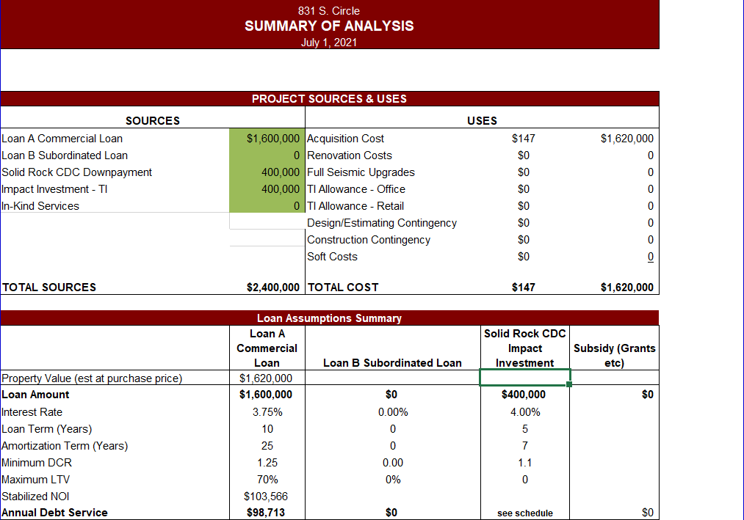
($20k in closing cost*)

Solid Rock CDC will provide a downpayment of $420k for the purchase of a property at 1.6 million price and be the guarantor of the commercial loan.
Vectra Bank will hold the mortgage and we have an additional $300-400k from our impact investors which will be used for tenant improvements and renovation.
Solid Rock CDC anticipates commercial loan terms will be a 25 year mortgage at 3.75% interest rate
Impact investor terms including SRCDC, for repayment of investment, will be at 4% interest rate which is paid quarterly with a repayment horizon of 10 yrs for the down payment, with the aim of fulfilling obligation of invested dollars returns between 5-7 yrs.

Acquisition Process

Our acquisition process began with assembling a real estate committee of professionals in the field. Using an investment software, Costar, we searched for properties that matched the characteristics of our Property Evaluation Tool. The demographics that we are interested in looking at surrounding the property include poverty rate, % of minority populations, median family income, homeownership rate, and free and reduced lunch rate.

- Our first step was to aggregate a list of properties that fit our criteria and then drive the properties to see which properties match the characteristics described above.
- After narrowing down properties, we reached out to property owners to see which properties may be available.
- We then scheduled site visits for the Real Estate Committee and Leadership Team with properties that had the potential for purchase.
- If we determined that the property was worth pursuing further, we requested operating expenses from the property owner and developed pro-forma to determine what price we should be considering with purchase.
- After developing the pro forma, we enter negotiations with the seller to find a price that will make the development profitable for Southeast CIT.
- Once a property is under contract, we will conduct further due diligence to include environmental and engineering studies, surveys of the property, leases, building inspection reports, etc.
- After completing due diligence, we will have a more accurate estimate of potential costs and revenues and will renegotiate, if needed, to purchase the property, or walk away from the property to pursue other options.

Prospective Property
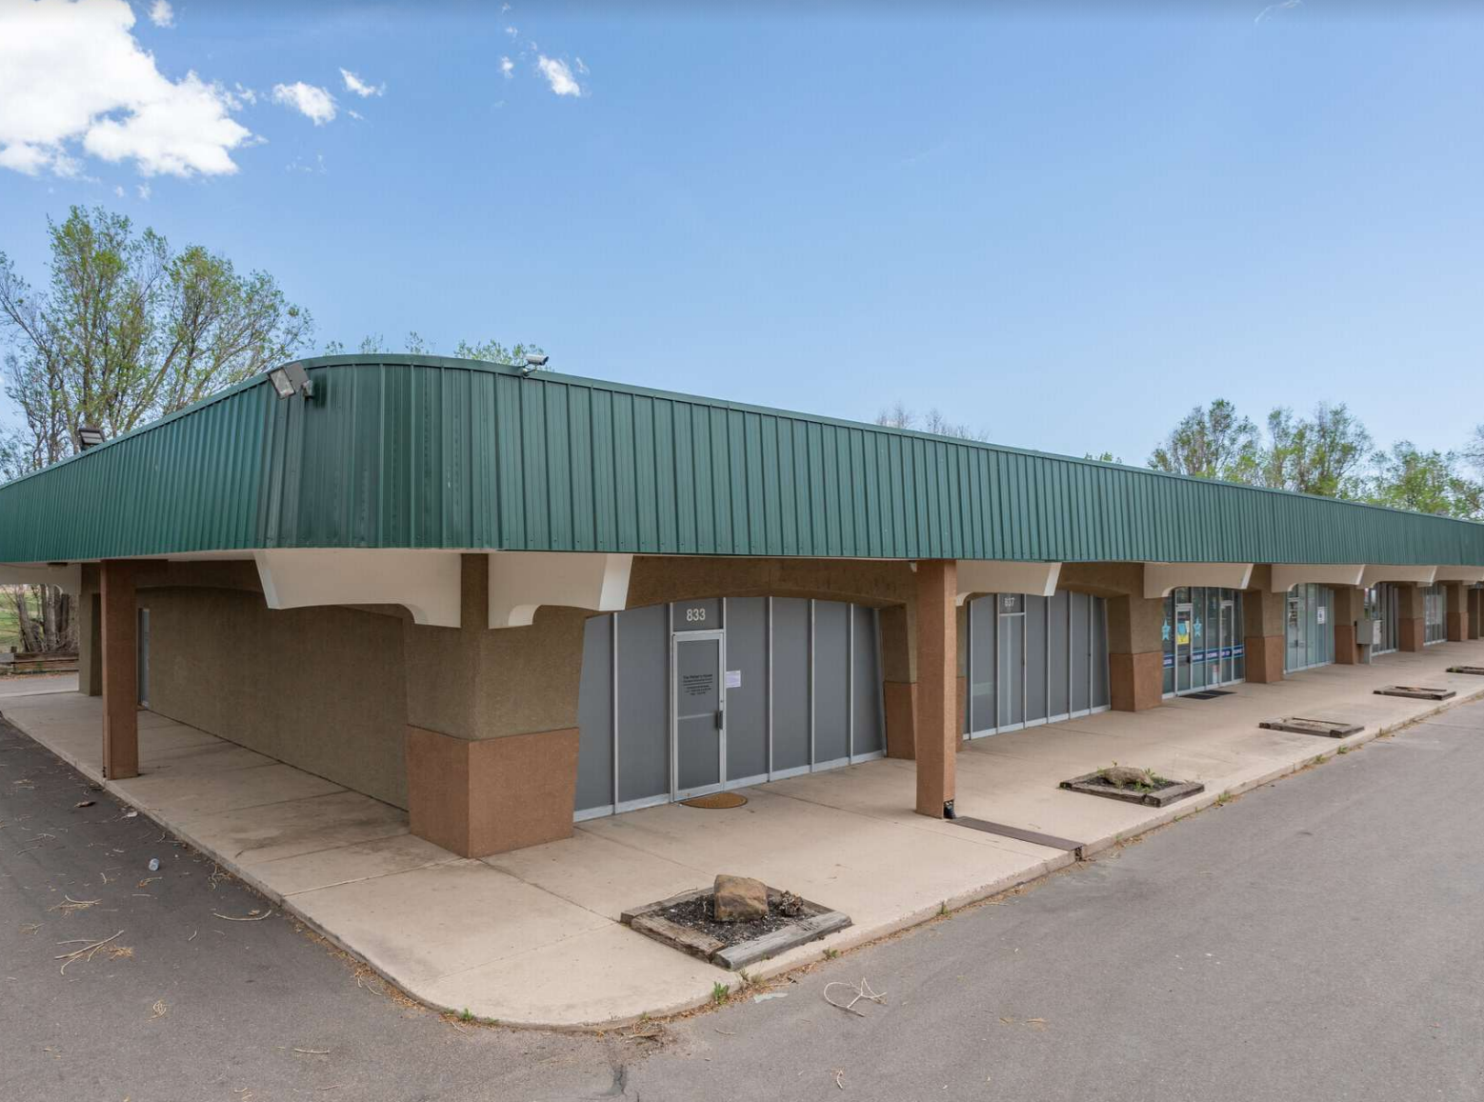

Property Overview
Year Built: 1968
Square Footage: 11058
Land Size: 67953 sq ft.
Tenant mix: For-profit and Nonprofit
The property is currently home to a church, martial arts center, and substance abuse counselor. This is a rare opportunity to purchase a retail building that's perfectly suited for remodeling & repositioning. 1.56 acres originally constructed in 1968, located at 831 South Circle Drive, at the intersection of South Circle and Fountain Boulevard. Solid Rock CDC has planned to occupy the vacant suite with a coffee shop and co-working space to make this area more of a community hub for residents within 80916 and 80910.

Investors
Impact Investors
Impact Investors are a vital part of contributing to the success of Southeast CIT. They invest dollars for the acquisition of the property as well as tenant improvements. A unique social impact aspect of the CIT is to allow for a modest return on investment for impact investors. In talks with foundations and impact investors, a recurring theme was that organizations would like to see a return on investment while also being able to give charitable donations towards operational capacity.
Potential Impact Investors (*committed)
- Solid Rock CDC *
- Calm Foundation
- Dakota Foundation*
- Local philanthropist
- Pikes Peak Community Foundation*
- El Pomar Foundation

Impact Investor Terms Overview
Term: 7 Years: We have a goal of paying back in 3-5 years.
Interest: 4% to be paid quarterly. The interest is paid out of the cash flow of the property
Principal Payment: We pay the principal on the impact investor debt every six months based on the amount the community investors have invested.
Amount: Amount may vary from impact investors but each will receive interest and principal payments. Funds may be used for the down payment on property and or tenant improvements.
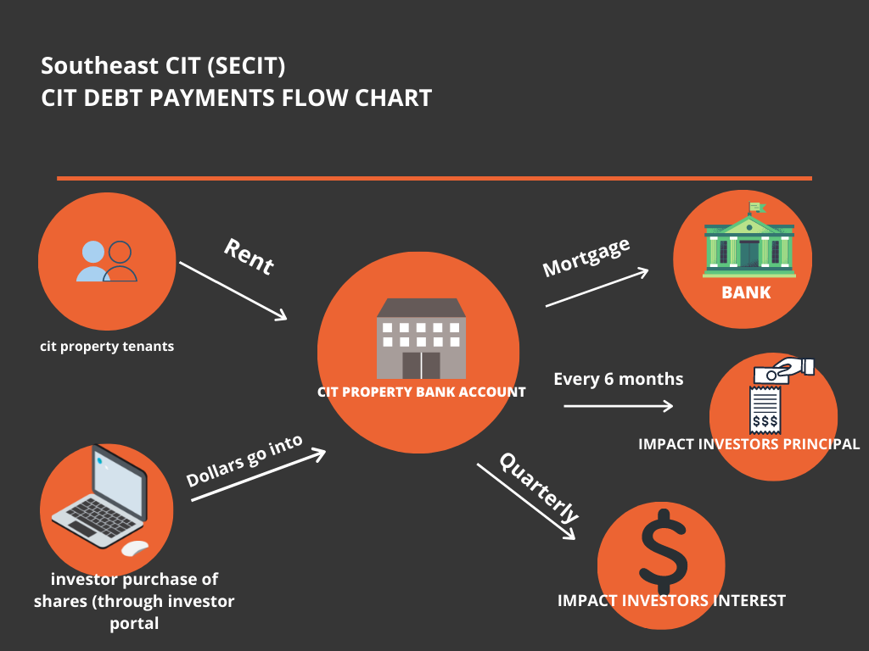

Community Investors (Residents of 80910 and 80916)
The core focus of the SECIT is to reach unaccredited investors who are experiencing asset poverty. Southeast Colorado Springs is one such area and was identified in a feasibility study conducted by Urban Land Institute and Mercy Corp, as an ideal location for implementing a CIT.
Through our conversations with residents of the community, it is apparent that residents are excited about the prospect of owning a property in the community in which they live and can frequent as consumers. The flexibility of the CIT model lowers barriers of entry in which many residents are faced within low and middle-income communities. In teaching, not only financial literacy but also financial action the path to generational wealth can be started.
The community investors will receive an annual dividend payment according to the cash flow total at the end of the year and will also receive an increase in share price when the annual appraisal is performed.
Recently the East Portland CIT announced a 9% shareholder dividend after 3 years of having launched, for a total community distribution of $20,530. These are the kind of returns the Southeast CIT is looking to provide its community investors with.

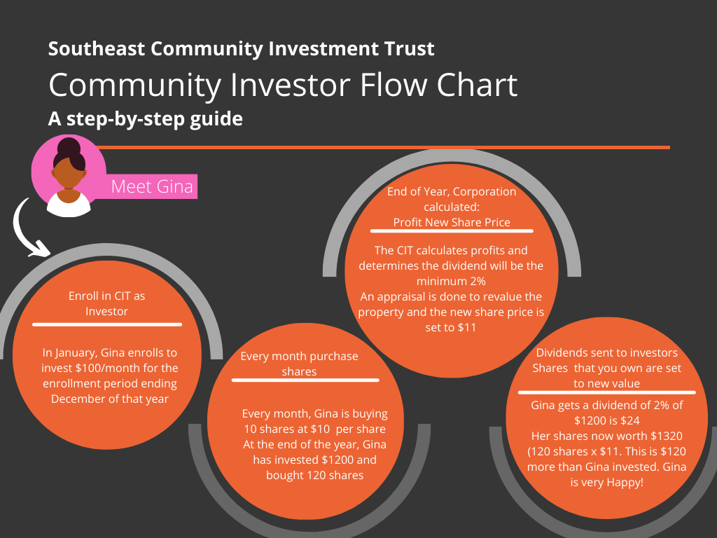
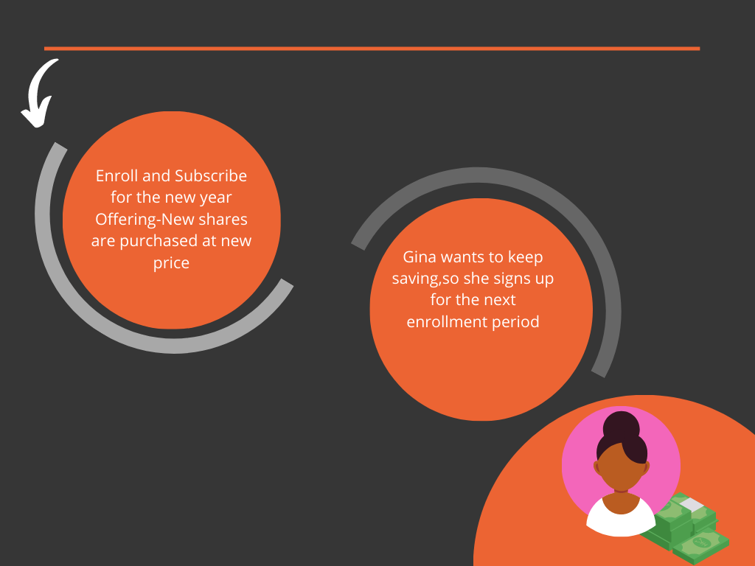

Financial Literacy and Action
A cornerstone of the success of implementing a CIT is the cultivation of an investor mindset. The Owing to Owning course empowers resident investors to create a snapshot of their finances and develop a concrete plan that is unique to their financial situation that will achieve their individual goals. Below you will find our marketing plan created by Anthony Carlson of 6035 Strategies. Anthony is a tremendous asset to the community and project. While SRCDC is in constant communication with East Portland CIT’s team, the unique situation in Southeast Colorado Springs we've taken into consideration that implementing creative solutions will contribute to the project's success.

Owing to Owning Curriculum ( for community/resident investors)
- The curriculum focuses on creating an owner mindset, getting in line with your goals, understanding savings and investment options, and creating a financial investment plan.
- Purpose and vision of curriculum (see Appendix B: “Building an on-ramp to a culture of the financial literacy and financial action)
- Moving from Owing to Owning Course Class schedule and support system - During the investor onboarding period, it is best practice to:
  - Community members (preferably investors) receive a stipend to facilitate Owing to Owing (O2O) classes
  - Schedule one class per month
  - Recruit 8-12 people per class
  - See O2O Replicator Toolkit for specifics

- Train the Trainer course overview:
  - Train the Trainer (TtT) course is the course designed specifically to develop formal and informal community leaders to become CIT Class (Owing to Owning course) facilitators.
  - The course is most effective when it has 6-10 participants.
  - Coaches future facilitators how to manage classroom dynamics, group processes, challenging behavior, and active and collaborative learning.
  - Coaches participants to facilitate the Owing to Owning course with fidelity, empathy, patience, and positive role modeling.

Marketing and Outreach
SRDC’s marketing plan is outlined below. We have brought Anthony Carlson on board to assist with achieving our desired outreach.

Investor Groups

Group | Recruitment Goal
Friends + Family | 125
Professional + Organizational networks | 100
Small Business Owners | 25
Launch Event | 50
Community At Large (not all by launch!) | 250
Total | 550 Investors
Goals are based on raising $1,500,000 over 6 years ($21,000/month) with an average monthly investment of $38.

Key Questions to help us reach our goals
- Who are our friends + family we can ask to join in and help recruit their contacts to become investors?
- Who do I have in my friends + family group that I could ask to join as an investor?
- How much do I think people in my friends + family would be willing to give on a monthly basis?
- Who in our professional and organizational networks can we ask to join and help recruit their contacts to become investors?
- Who do I have in my professional networks that I could ask to join as an investor right now?
- Who do I know that would be willing to volunteer to help spread the word about the CIT?

Community At Large Benchmarking

We need 250 investors from the community at large. These are people who are not friends or family, professional colleagues, small business owners, or attended the launch event. These are individuals that will be reached through grassroots efforts such as through social media, by a canvassing event, from earned media, or through simple word of mouth. This will be the
toughest group to reach as they will likely have no direct affiliation with someone involved in the creation or rollout of the CIT.

Benchmark #1: 6,000 community touchpoints
- These touchpoints are simply points of exposure to the CIT. They can come through a social media post, a canvassing event, reading an article in the news, or through community events that the CIT participates in to spread the word.

Benchmark #2: 900 community sign-ups (15% conversation rate)
- The key to the community signups will be to immediately encourage that individual to commit to a date/time to participate in a financial literacy class. Next steps should be communicated immediately to any individual who signs up to learn more about the CIT.

Benchmark #3: 315 individuals participate in classes (35% conversion from sign ups)
- Participants should receive a notification of commitment to attending the moment they sign up for a class. Additionally, they should receive a reminder 1 week before the class and 1 day before to ensure a higher participation rate in the classes.

Benchmark #4: 250 new investors to the CIT
- The CIT should work to convert class participants to investors before they leave their final class. This will ensure the CIT is maximizing signups and helping mitigate the chance that folks complete the training, but fail to complete the next steps of signing up and becoming an investor.

Launch Timeline:

1 month prior to launch
- Website is launched with the ability for individuals to sign up for the CIT
  - Set schedule for initial classes
- Recruit friends, family, and colleagues to sign up for the CIT
- Set date for the official launch event
  - Recruit food trucks
  - Recruit allied organizations to help recruit individuals to attend
  - Recruit speakers for the event
  - Start social media push and create the event on Facebook
    - Record a video with Latrina and others to educate/spread the word

Three weeks out
- Pitch local media on the story of the CIT to get free media in the press
  - Invite press to attend the launch event
- Print collateral to distribute for canvassing + community events
- Continue to push through social media
  - Recruit allied organizations/press/small businesses/other SE facebook pages to also share the event + sign up forms
- Recruit 15-20 volunteers to canvass neighborhoods the following week
  - Create script and training for volunteers
  - Create packets with streets for each volunteer
  - Prepare canvas packets (clipboards, script, sign up form, paper, collateral)

Two weeks out
- Weekend canvassing event
  - Target neighborhoods immediately surrounding the purchased property
    - (Goal 1000 doors knocked)
- Send out event reminders to anyone who has signed up
- Paid social media post (if necessary)
- All food trucks and any other event vendors finalized
- Recruit 6-8 volunteers to help with launch
  - Sign ups

One week out
- Confirmation calls to anyone who has signed up for the event
  - Push anyone who has signed up, but not registered for a class to register
- Confirm speakers
- Confirm press for event
- Secure tablets/laptops for gathering sign ups at launch
  - Also have sign ups available via clipboard
  - Also a table where people can sign up
- Countdown event reminders on social media

Solid Rock CDC will utilize our network of partners to help with marketing efforts. Each organization and its leadership will be a word-of-mouth marketer for the project by educating their co-workers and leadership on the importance of the CIT, and how collaboration will bring more visibility to each organization.

Replication
Our plan in creating a CIT in Southeast Colorado Springs was, to begin with a smaller property that would need minimal repairs, with very little vacancy, and an existing tenant mix that reflects the needs of the neighborhood and surrounding residents. This line of thought is to minimize the possibility of “false starts” and provides us the opportunity to make mistakes while minimizing risk, as we are working diligently to have Southeast Colorado Springs be home to the second Community Investment Trust in the country.
By carefully documenting our processes, Solid Rock CDC is creating a blueprint that will allow the organization to move efficiently in purchasing future properties and shortening the timeline for acquisition, rehab, and curating the right tenant mix that reflects and services the intended demographic.

CIT Operations/Administration Budget
Income Budget
Project Income
Solid Rock CDC | $700,000.00
Calm Foundation | $100,000.00
Dakota Foundation | $100,000.00
El Pomar Foundation | $100,000.00
PPCF | $10,000.00
Local Philanthropist | $75,000.00
Total | $1,085,000.00

Expense Budget
7/1/2021 | CIT Operations Budget
CIT Expense Budget | FY 2021 |  |  | FY 2022 |  |  | FY 2023
 | 2021 |  |  | FY 2022 |  |  | FY 2023
 | Jan-Jun | Jul-Dec | Total | Jan-Jun | Jul-Dec | Total | Jan-Jun | Jul-Dec | Total
Local CIT Staff (w/o benefits)
Staff Salary |  | $ 75,000 | $ 75,000 | $ - | $ 78,000 | $ 78,000 | $ - | $ 81,120 | $ 81,120
Total Staff Cost |  |  | $ 75,000 |  |  | $ 78,000 |  |  | $ 81,120
Local CIT
Property Purchase- Down Payment |  | $400,000.00 | $400,000.00
CIT Portal and System Upgrades & Evaluation |  | $ 15,000 | $ 15,000 |  | $ 20,000 | $ 20,000 |  | $ 20,000 | $ 20,000
Resident Education Curriculum |  | $ 20,000 | $ 20,000
Legal Framework |  | $ 30,000 | $ 30,000 |  | $ 2,500 | $ 2,500 |  | $ 2,500 | $ 2,500
D&O Insurance |  | $ 250 | $ 250 |  | $ 5,000 | $ 5,000 | $ - | $ 5,000 | $ 5,000
Marketing |  | $ 15,000 | $ 15,000 | $ 1,000 | $ 1,000 | $ 2,000 | $ 1,000 | $ 1,000 | $ 2,000
Board Support |  | $ - | $ - | $ 400 | $ 400 | $ 800 | $ 400 | $ 400 | $ 800
Bank Fees |  | $ 600 | $ 600 | $ 600 | $ 600 | $ 1,200 | $ 600 | $ 600 | $ 1,200
Tax Accounting |  | $ 3,500 | $ 3,500 | $ 2,000 | $ 2,000 | $ 4,000 | $ 2,000 | $ 2,000 | $ 4,000
Property Appraisal |  | $ - | $ - | $ 3,000 | $ - | $ 3,000 | $ 3,000 | $ - | $ 3,000
Consulting |  | $ 3,500 | $ 3,500 | $ 1,500 | $ - | $ 1,500 | $ 1,500 | $ - | $ 1,500
Cinco de Mayo Festival |  | $ 2,000 | $ 2,000
Olympic Day Southeast Field Day |  | $ 500 | $ 500
Fees |  | $ 500 | $ 500 | $ 250 | $ 250 | $ 500 | $ 250 | $ 250 | $ 500
Southeast Fall Festival |  | $ 5,000 | $ 5,000
Southeast Christmas Festival |  | $ 15,000 | $ 15,000
Co-Working Space
Equipment |  | $7,500.00 | $7,500.00 | $1,000.00 | $1,000.00 | $2,000.00 | $1,200.00 | $1,200.00 | $2,400.00
Micro office |  | $10,000.00 | $10,000.00 |  |  | $0.00 |  |  | $0.00
Furnishing |  | $20,000.00 | $20,000.00 | $1,000.00 | $1,000.00 | $2,000.00 | $1,200.00 | $1,200.00 | $2,400.00
Renovation |  | $50,000.00 | $50,000.00 |  |  | $0.00 |  |  | $0.00
Coffee Shop
Build Out |  | $75,000.00 | $75,000.00
Furnishing |  | $25,000.00 | $25,000.00 | $1,000.00 | $1,000.00 | $2,000.00 | $1,200.00 | $1,200.00 | $2,400.00
Total Expenses |  |  | $698,350.00 |  |  | $ 40,500 |  |  | $  40,500
Total Costs |  |  | $ 773,350 |  |  | $ 118,500 |  |  | $ 121,620

Year 1 expected differential: $311,650.00

