HIST 4340 Philosophies of History
Professor David McNally

Mondays and Wednesdays, 4-5:30 PM, Room 203 Agnes Hall

Does history have a meaning? Does it tend toward justice, or is it merely a litany of violence and domination? This course engages these debates in relation to a primary event—the Haitian Revolution of 1791-1804, which saw the abolition of slavery and the creation of the world’s first independent Black republic—and a primary text, C.L.R. James’s classic, The Black Jacobins: Toussaint L’Ouverture and the San Domingo Revolution. We will examine this historic event and James’s text in relation to liberal, Marxist, Feminist, and post-structural philosophies of history. And we will analyze the Haitian struggle for freedom in relation to anti-colonialism, human rights, anti-racism, socialism, feminism, and the meaning of freedom and universal emancipation. Below: CLR James in his study.

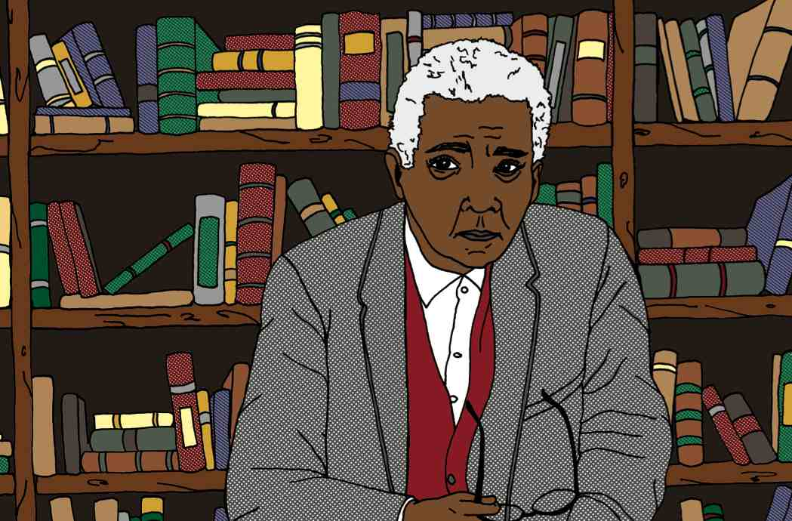

Grading Scheme
- Paper proposal (15%)
- Short research presentation (15%)
- Seminar participation (25%)
- Final essay (45%)
Core Readings
Note: PDFs of many core readings will be provided by the instructor.
- C.L.R. James, The Black Jacobins: Toussaint L’Ouverture and the San Domingo Revolution
- Immanuel Kant, “The Contest of Faculties”
- G.W.F. Hegel, The Philosophy of History (selections). See also: https://philosophynow.org/issues/129/Hegel_on_History
- -----------------, “Lordship and Bondage” from The Phenomenology of Spirit: https://www.marxists.org/reference/archive/hegel/works/ph/phba.htm
- -----------------, The Philosophy of Right (selections)
- Susan Buck-Morss, Hegel, Haiti, and Universal History
- Nick Nesbitt, “Troping Toussaint” Research in African Literatures, v. 35, n. 2 (2004)
- Karl Marx and Friedrich Engels, The German Ideology: Part One-- Feuerbach: Opposition of the Materialist and Idealist Outlooks: https://www.marxists.org/archive/marx/works/1845/german-ideology/ch01.htm
- Friedrich Nietzsche, “On the Uses and Disadvantages of History for Life”
- Michel Foucault, “Nietzsche, Genealogy, History”
- David Scott, “The Re-Enchantment of Humanism: An Interview with Sylvia Wynter,” small axe 8 (September 2000)
- Aaron Kamugisha, “The Hearts of Men? Gender in the Late CLR James,” small axe 34 (March 2011)
- Michel-Rolph Trouillot, Silencing the Past: Power and the Production of History
- Aimé Césaire, Discourse on Colonialism
- Frantz Fanon, The Wretched of the Earth, Ch. 3
- Nick Nesbitt, Universal Emancipation: The Haitian Revolution and Radical Enlightenment

COURSE SCHEDULE

January 19 Course Introduction

January 24, 26 The Haitian Revolution, 1
CLR James, The Black Jacobins, Ch. 1-6

January 31, February 2 The Haitian Revolution, 2
CLR James, The Black Jacobins, Ch. 7-13

February 7 Liberalism and History as Human Progress
Immanuel Kant, “The Contest of Faculties”

February 9, 14 Reason and History in Europe and Africa
GWF Hegel, The Philosophy of History (selections). See also:
https://philosophynow.org/issues/129/Hegel_on_History

February 16 History and the Struggle Between Master and Bondsman
GWF Hegel, “Lordship and Bondage” from The Phenomenology of Spirit:
https://www.marxists.org/reference/archive/hegel/works/ph/phba.htm

February 21, 23 Slavery, Freedom, and Revolution
GWF Hegel, The Philosophy of Right (selections)

Feb 28, Mar. 2 History, Freedom, and Class Struggle
Karl Marx and Friedrich Engels, The German Ideology: Part One--Feuerbach: Opposition of the Materialist and Idealist Outlooks: https://www.marxists.org/archive/marx/works/1845/german-ideology/ch01.htm

March 7, 9 History as Will to Power
Friedrich Nietzsche, “On the Uses and Disadvantages of History for Life”

March 14, 16 MARCH BREAK

March 21, 23 Power Without Progress
Michel Foucault, “Nietzsche, Genealogy, History”

March 28, 30 Colonialism, Gender, and Emancipation
David Scott, “The Re-Enchantment of Humanism: An Interview with Sylvia Wynter,” small axe 8 (September 2000), excerpt pp. 173-207
Aaron Kamugisha, “The Hearts of Men? Gender in the Late CLR James,” small axe 34 (March 2011)

April 5, 7, 12, 14 Colonialism and the Silences of World History
Michel-Rolph Trouillot, Silencing the Past: Power and the Production of History

April 19, 21 History Beyond Colonialism?
Aimé Césaire, Discourse on Colonialism
Frantz Fanon, The Wretched of the Earth, Ch. 3

April 26, 28 Haiti and the Project of Universal Emancipation
Nick Nesbitt, Universal Emancipation: The Haitian Revolution and Radical Enlightenment (selections)

May 2 Concluding Session

