Understanding the Inflation Reduction Act

about us

B
iggins Lacy Shapiro & Co. (BLS & Co.) is one of the largest specialty site selection and incentives advisory consulting firms in North America, helping companies compete and flourish by optimizing location choices. Our team has helped many of the world’s most successful and demanding companies identify the best locations, secure incentives, obtain development approvals, and optimize energy strategies. We site facilities ranging from manufacturing operations to data centers, shared service facilities and corporate headquarters, and frequently partner with the largest, most respected global service providers in real estate brokerage, consulting, accounting, architecture and engineering. Our firm’s trademarked multi-disciplinary approach, Location Economics®, has built a track record of creating value for companies and their communities.

the Inflation Reduction Act AND Site Selection

Signed into law by President Biden in August 2022, the Inflation Reduction Act of 2022 (IRA) provides over $320 billion new and enhanced incentives designed to increase clean energy production in the United States, support energy innovation, and encourage investing in disadvantaged communities and projects that redevelop fossil fuel infrastructure and employ displaced workers. While the IRA took effect on January 1, 2023, some tax credits are available for use currently while others are not available for use until future years. This resource guide is intended to provide an overview of key tax credit provisions and relevant issues, and particularly geographic factors that could – and likely should – be taken into consideration during a site selection process.

IRA SUMMARY

The IRA includes new and expanded tax credits and grant programs spanning a variety of categories. Following is a list of select programs most relevant to private sector companies and project investors:
geographic factors that could – and likely should – be taken into consideration during a site selection process.

- Clean Energy Credits & Financing (including both production and investment credits)

- Fuel Tax Credits
- Clean Vehicle Tax Credits
- Carbon Management Credits
- Energy Innovation
- Offshore Wind and Oil & Gas Systems
- Community Investment & Energy Justice
- Permitting Process Efficiencies
- Programs to support Agriculture and Forestry

For taxpayers without sufficient tax liability to realize the full value of these credits, including most project-specific Special Purpose Entities (SPEs), the IRA permits transfer of most of the credits, providing the ability to monetize the credits by selling them to taxpayers with adequate tax liability to fully utilize the credits. Governmental entities and tax-exempt organizations may also be eligible to receive a direct payment of the credit.

The IRA’s federal income tax credits for production and investment energy projects have designated “base rates” with the opportunity to earn “bonus” rate increases by meeting additional qualifying criteria, several of which are tied to the geographic location of the project.

“Base rate” means different things for different programs. More details can be found in the chart following, but, as an example, the new investment credits provide a base tax credit rate of 6% of qualified investment. If the project meets the prevailing wage and apprenticeship requirements, the project could receive a credit five times greater than the base, i.e., 30%.

The following chart provides an overview of production and investment credits created or extended by the IRA followed by an explanation of bonus enhancement and related requirements. Additional details on these programs-- as well as information on other fuel, vehicle, carbon management and other credits created by the IRA -- can be found on BLS’s website.

Bonus Enhancements

Energy Communities Bonus: As defined in the IRA, the Energy Community Tax Credit Bonus applies a bonus of up to 10% for projects and facilities located in energy communities. The IRA defines energy communities as any one of the following:

- A “brownfield site” (as defined in certain subparagraphs of the Comprehensive Environmental Response, Compensation, and Liability Act of 1980 (CERCLA))
- A “metropolitan statistical area” or “non-metropolitan statistical area” that has (or had at any time after 2009)
  - 0.17% or greater direct employment or 25% or greater local tax revenues related to the extraction, processing, transport, or storage of coal, oil, or natural gas; and
  - has an unemployment rate at or above the national average unemployment rate for the previous year.
- A census tract (or directly adjoining census tract)
  - in which a coal mine has closed after 1999; or
  - in which a coal-fired electric generating unit has been retired after 2009.

There is no current mapping for all qualified brownfield sites; however, the Department of Energy launched a mapping tool that provides geographic eligibility under the other categories except unemployment rate. (See map on following page.) The Treasury Department and the IRS will release a listing of MSAs and non-MSAs qualifying by means of their unemployment rate once unemployment data for 2022 becomes available, expected in May 2023. This listing will apply to the period beginning on January 1, 2023, and will remain effective until the next annual listing.

Domestic Requirements Bonus: To qualify for the domestic content bonus credit (10%), taxpayers must demonstrate sufficient use of domestic iron, steel, and manufactured components.
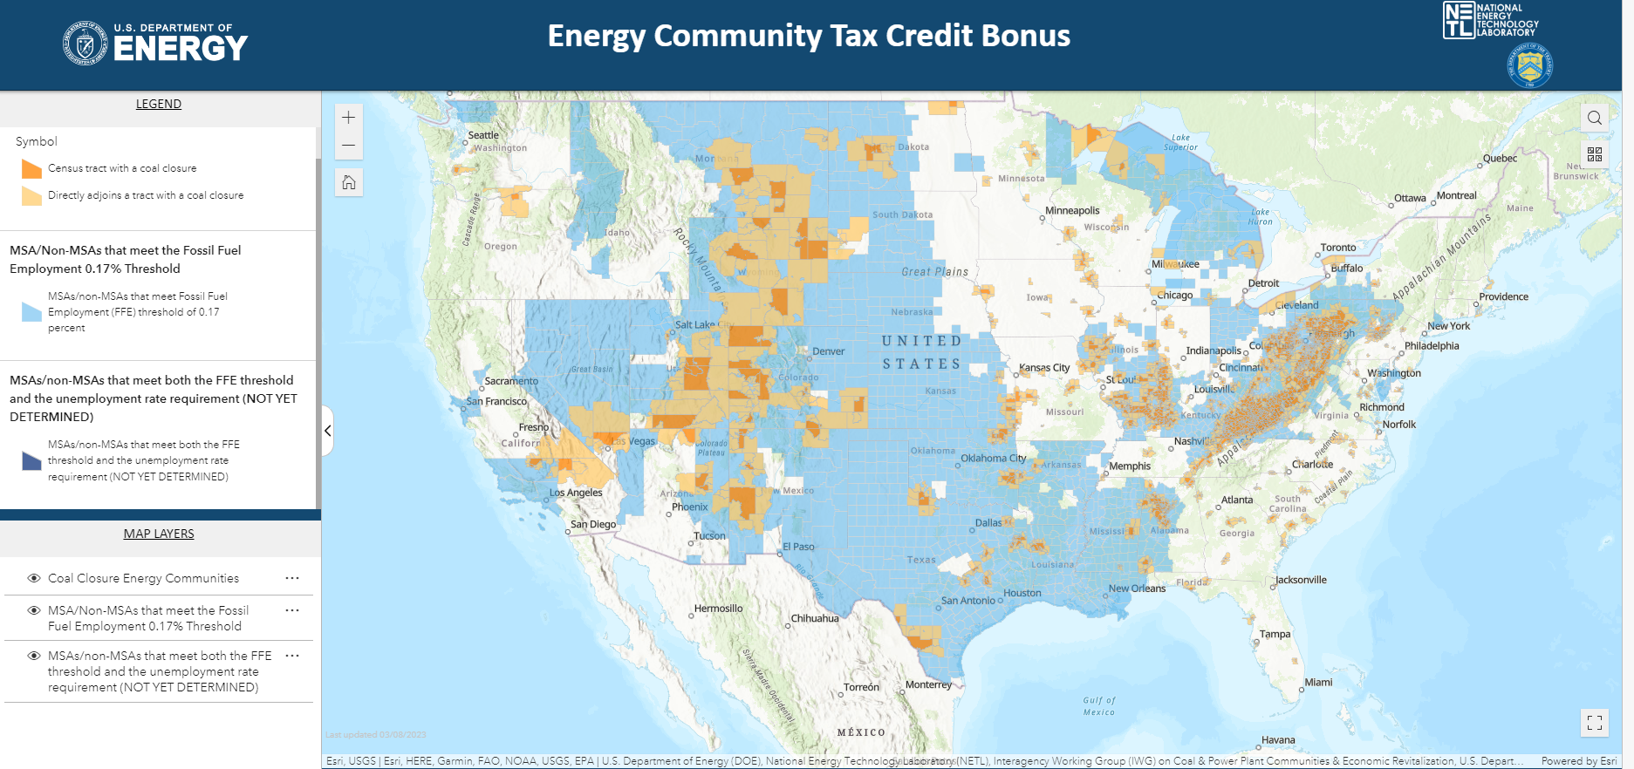
Areas shaded in orange or blue indicate areas deemed eligible for bonus enhancements.
Additional determinations are pending.

Prevailing Wage and Apprentice Bonus: Several tax credits provide enhanced clean energy tax benefits of 5 times the base rate if prevailing wage and apprenticeship requirements are met.
- “Prevailing Wage” refers to aligning a company’s compensation (basic hourly wage plus fringe benefits) with published industry norms for a given occupation/job in a given location. Prevailing wage is determined by the U.S. Secretary of Labor and, applies to all laborers and mechanics for all hours performing construction, and in some cases alteration or repair, on the site of the work of a qualified facility. Companies must undertake specific record-keeping activities to document compliance with prevailing wage requirements.
- To meet apprenticeship requirements, qualified apprentices must be used for a designated percentage of total labor hours for construction, alteration, or repair work on the qualified facility or energy project (10% for projects started before 1/1/23, 12.5% for projects started during 2023 and 15% for projects started after 12/31/23).

Conclusion

The IRA has provided significant tax incentives designed to transition the nation’s reliance on fossil fuels to clean energy production and use. BLS & Co. would be pleased to assist you in pursuing IRA benefits and designing a site selection strategy that optimizes IRA eligibility and other important location considerations. For more information contact:

Jay Biggins Stephanie Mercado Tracey Hyatt Bosman
jcbiggins@BLSstrategies.com smercado@BLSstrategies.com tbosman@BLSstrategies.com
+1-609-613-4275 +1-440-864-3369 +1-312-924-2490
Biggins Lacy Shapiro & Company
www.BLSstrategies.com
Industry/ Project | Credit and Description | Rate, Term & Timing | Energy Community Bonus (10%) | Domestic Bonus (10%) /Domestic Requirement | Prevailing Wage Enhancement (5x)
CLEAN ENERGY TAX CREDITS: PRODUCTION TAX CREDITS (TRANSFERABLE)
Energy Developers | Clean Hydrogen Production Tax Credit: Tax credit for the production of clean hydrogen at a qualified clean hydrogen production facility | The base credit is $0.60/kg (adjusted for inflation) multiplied by the applicable percentage (20% to 100% depending on lifecycle greenhouse gas emissions)  For hydrogen produced after 12/31/22 (for facilities placed in service before 1/1/33 for their first 10 years in service | No | No | Yes
Domestic Manufacturers | Advanced Manufacturing Production Credit:  Production tax credit for manufacturers of components for solar and wind energy, inverters, battery components, and critical minerals | Credit varies by technology  Credit for critical minerals is permanent starting in 2023. For other items, the full credit is available between 2023-2029 and phases down over 2030-2032 | No | Only Domestic Manufacturers are eligible; No additional bonus credit | No
Nuclear | Nuclear Power Production Tax Credit:  Tax credit for electricity produced at a qualified nuclear power facility | Credit is 0.3 cents/kWh, inflation adjusted.  For electricity produced at a qualified nuclear power facility; produced and sold 1/1/24-12/31/32; down depending on the amount of energy produced and the gross receipts of the nuclear power facility | No | No | Yes
Biomass, Geothermal, Hydrokinetic, Landfill and Waste, Hydropower, Marine, Small Irrigation, Solar, Wind | Production Tax Credit for Electricity from Renewables: Tax credit for production of electricity from renewables | Credit is 0.3 cents/kW, inflation adjusted  Construction must start before 1/1/25 | Yes | Yes | Yes
Zero GHG Electricity Generators | Clean Electricity Production Tax Credit:  Technology-neutral tax credit for production of clean electricity. Replaces the production tax credit for electricity generated from renewable sources (extended in Section 13101 through 2024) | Credit amount is 0.3 cents/kW, inflation adjusted  Facilities placed in service after 12/31/24. Phase-out starts the later of (a) 2032 or (b) when U.S. greenhouse gas emissions from electricity are 25% of 2022 emissions or lower. | Yes | Yes | Yes
CLEAN ENERGY TAX CREDITS: INVESTMENT TAX CREDITS (TRANSFERABLE)
Wind and Solar | EXT. Energy Investment Tax Credit (48) in Connection with Low Income Communities:  Additional investment tax credit for small-scale solar and wind facilities in low-income communities; allocated investment credit, capped at 1.8 GW per year (unused capacity carries over to following year); for solar and wind facilities with a maximum net output of less than 5 MW, including associated energy storage technology; | Credit is 6% of qualified investment  The Low-Income Communities Bonus Credit begins in 2023 and is available through 2032 or the year annual GHG emissions from electricity production in the U.S. are equal to or less than 25% of 2022 levels, whichever is later. The bonus requires an application by the taxpayer, with a cumulative total of 1.8 GW of direct current capacity per year available for allocation | No | No | No
Energy Storage, Zero GHG Electricity Generators | Clean Electricity Investment Tax Credit:  Technology-neutral tax credit for investment in facilities that generate clean electricity. Replaces the investment tax credit for facilities generating electricity from renewable sources (extended in Section 13102 through 2024). | Credit is 6% of qualified investment  For facilities placed in service after 12/31/24. Phase-out starts the later of (a) 2032 or (b) when U.S. greenhouse gas emissions from electricity are 25% of 2022 emissions or lower. | Yes | Yes | Yes
Critical Minerals, Industrial Facility, Manufacturing Facility, Manufacturing Retrofit | Advanced Energy Project Credit: Provides a tax credit for investments in advanced energy projects that (1) re-equips, expands, or establishes an industrial or manufacturing facility for the production or recycling of a range of clean energy equipment and vehicles; (2) re-equips an industrial or manufacturing facility with equipment designed to reduce greenhouse gas emissions by at least 20 percent; or (3) re-equips, expands, or establishes an industrial facility for the processing, refining, or recycling of critical materials. | Credit is 6% of qualified investment  Competitive application process beginning on 5/31/23; DOE will consider greatest job creation, greatest reduction in greenhouse gas emissions, shortest time to completion, greatest potential for innovation, geographic diversity, commercial viability and regional economic development potential when awarding credits | No | No | Yes

