Here’s a list of books that Anaïs recommends:

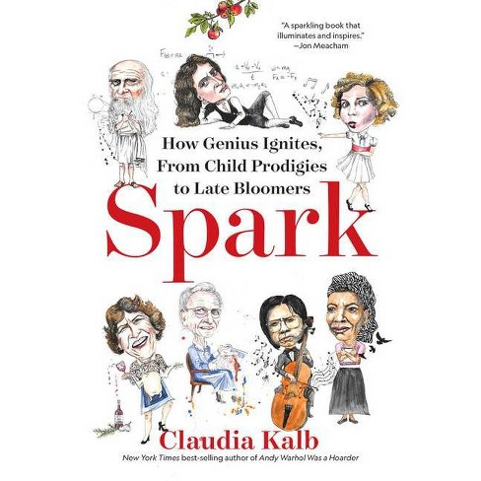 | Spark, by Claudia Kalb
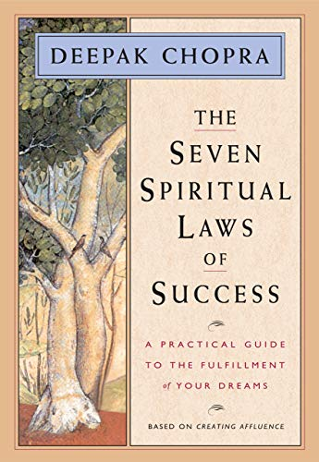 | The Seven Spiritual Laws of Success, by Deepak Chopra
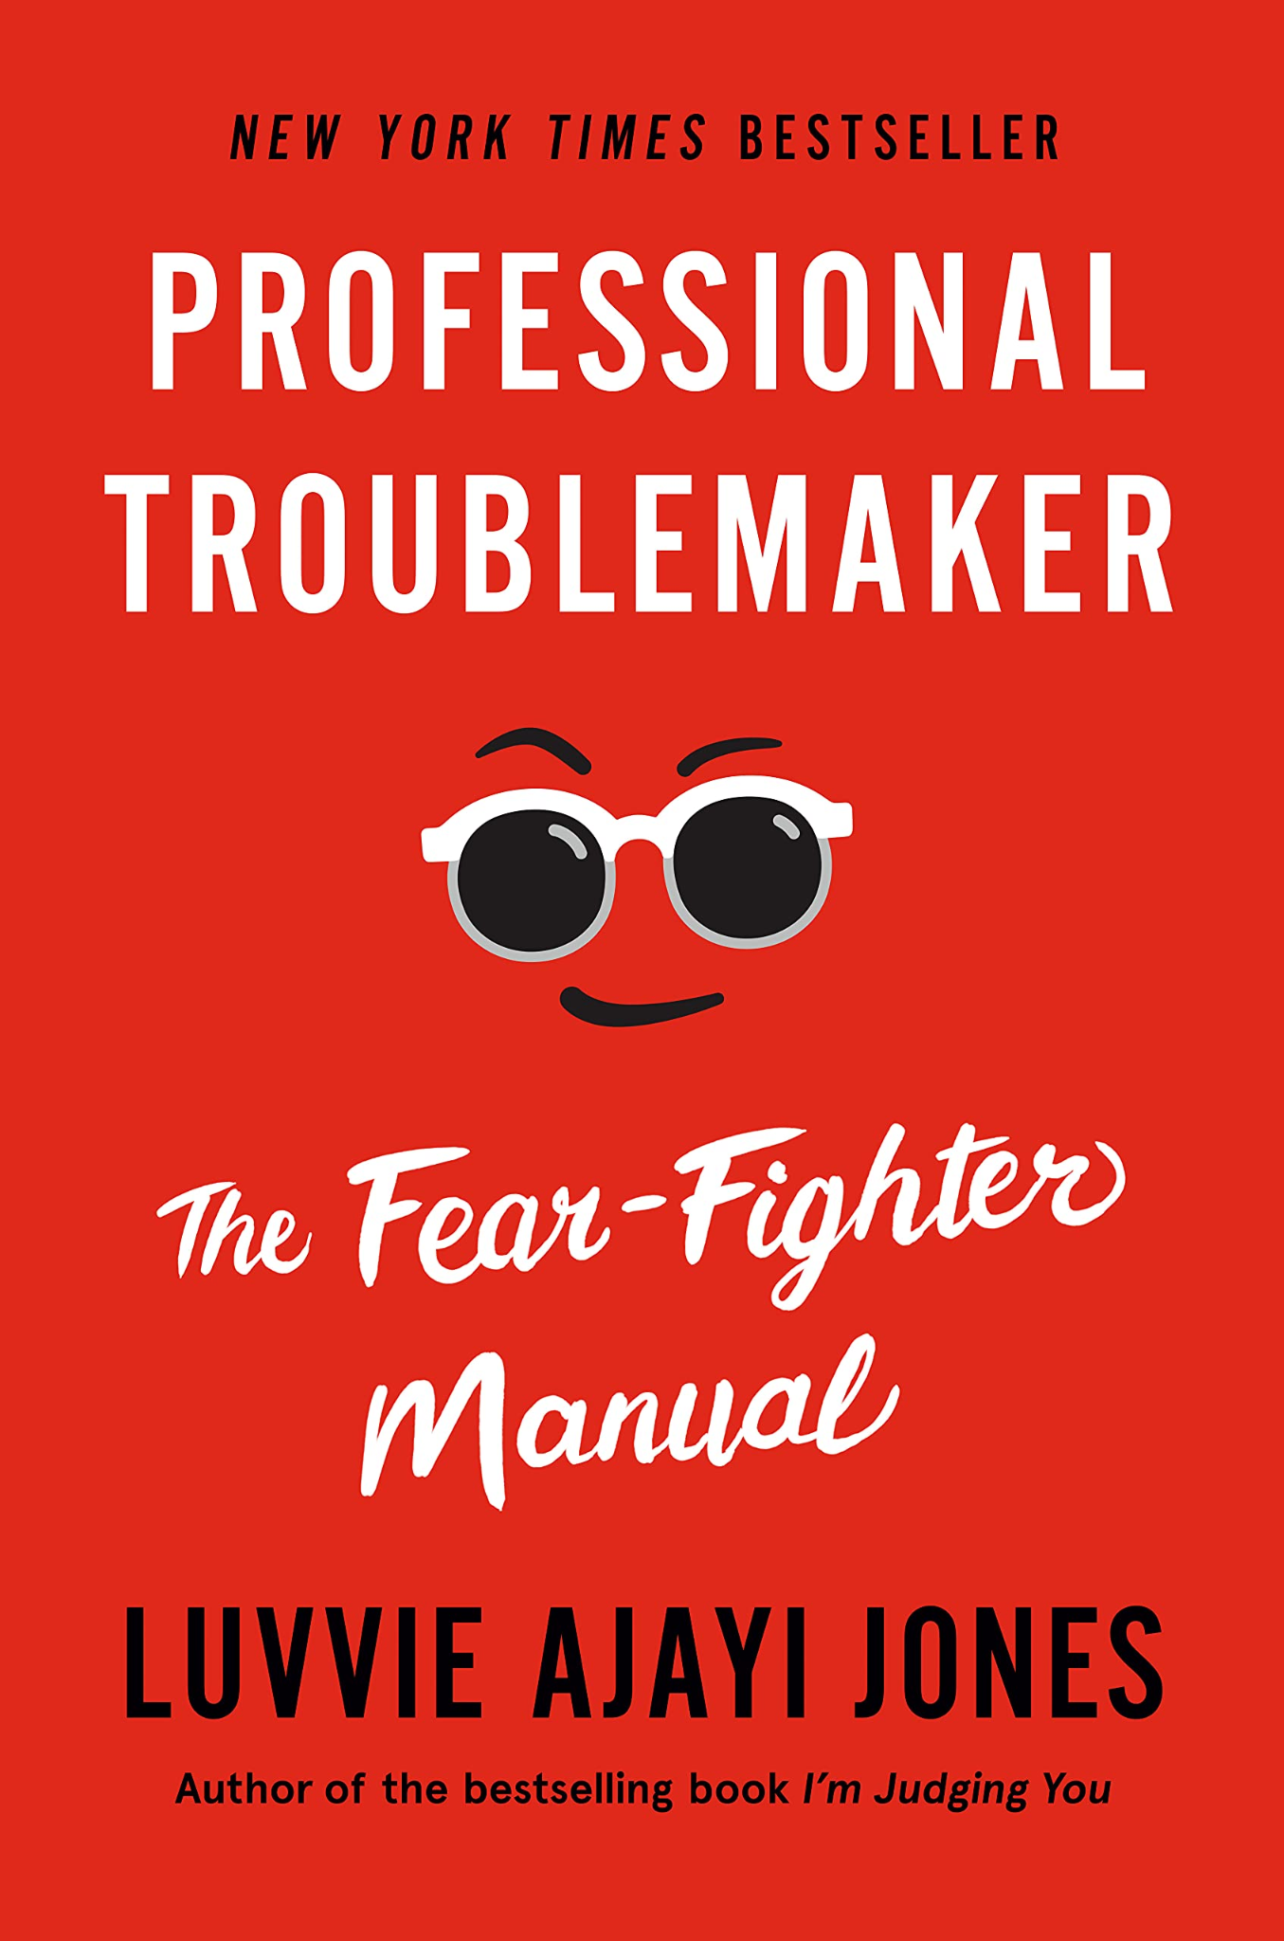 | Professional Troublemaker, by Luvvie Ajayi Jones
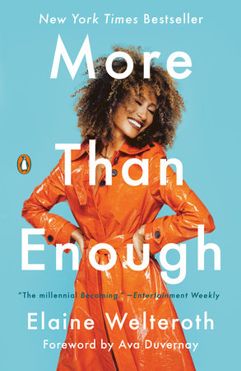 | More Than Enough, by Elaine Welteroth.
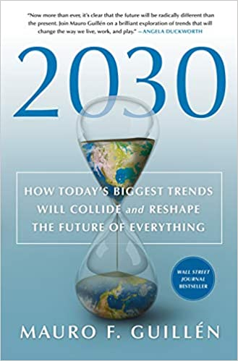 | 2030 by Mauro F. Guillen

