  - VOLUNTARY STEWARDSHIP PROGRAM

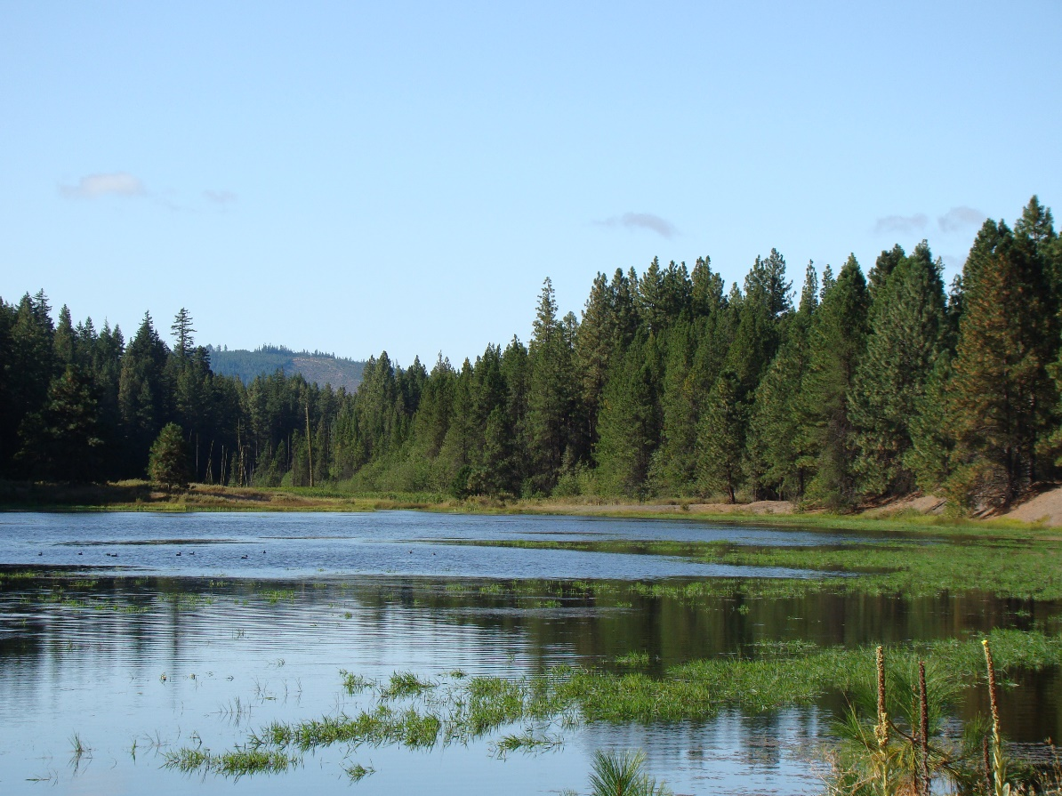

  - COUNTY WORK PLAN FIVE-YEAR
  - REPORTING GUIDANCE

  - September 2020

Voluntary Stewardship Program:
County Work Plan Five-Year Reporting Guidance

Washington State Conservation Commission
Carol Smith, Executive Director

Ron Shultz, Director of Policy and Inter-governmental Relations
Brian Cochrane, Habitat and Monitoring Coordinator
Bill Eller, VSP Coordinator

September 2020
- Introduction

The Voluntary Stewardship Program (VSP) requires each county watershed work group (work group) to report to the Executive Director (Director) of the Conservation Commission (Commission) and the county on whether it has met the work plan's protection and enhancement goals and benchmarks.

Reports are to be submitted at five-year intervals from the date of receipt of funding, and sent to the Director of the Commission and to each county legislative authority by each county work group. The Director must decide to concur, or not, with each county work group’s determination.

- Report Submission

Important: The date each work group must submit its five-year report (report) is set out below in Section V. Please allow time prior to the submittal due date for your work group to approve both the content and the submittal of the report using the Template referenced below.

To submit a report, work groups must use the database provided by the Commission.

In the database, each county work group must

- Assert whether or not it is meeting its goals and benchmarks in its work plan, and

- Provide evidence supporting the assertion for each goal and benchmark.

Additional materials, documents, or information a work group would like to make available to support its assertions in the database should be retained at the county or work group, and a link to those materials provided within the database when submitted. All information necessary for the Director to decide if they concur, or not, with the work group’s determination should be documented and explained in the database.

If, as part of an answer in the database, a reference is made to a work plan, appendix of a work plan, or other document, please provide a link to that document, the document title, and the page number as part of that reference. Nothing in this guidance shall require the Commission to review and/or evaluate the additional materials beyond what has been submitted in the database.

Answers submitted in the database should be brief, succinct, and directly answer the question posed. In completing the database, please use clearly identified units of measurement (i.e. feet, acres, miles, etc.) with all data.

When the report is submitted to the Commission in the database, it should be in final form. The database will require verification that the report has been approved by the work group. The report provided in the database should be submitted on or before each five year interval from the date the county first received VSP funding (see Section V, below).

Special Note: FOR ANY COUNTY THAT USES A “REGULATORY BACKSTOP,” REGULATION OR REGULATIONS TO PROTECT ONE OR MORE CRITICAL AREAS: VSP serves as an alternative to protecting critical areas in areas used for agricultural activities through development regulations. However, VSP allows for flexibility on how critical areas are protected. Some counties have chosen, in the work plans, to rely on a “regulatory backstop,” involving regulation or regulations to protect a critical areas or areas.

During the five-year report review and evaluation, the director of the Commission is tasked by statute to concur, or not, with the assertion of the county VSP work group, that they are meeting the protection and enhancement goals in their work plan. Protecting critical areas under VSP means protecting their functions and values.

For a county that is relying on a regulatory backstop to protect one or more critical areas, to fulfill her task of agreeing, or not, with the assertion of the work group, the director will need to know if the regulatory backstop is protecting the critical area. Protection is defined in the statute to mean “means to prevent the degradation of functions and values existing as of July 22, 2011.”

As a result, the Commission, in its five-year report template, needs proof that the regulatory backstop is working to protect a critical areas or areas if the county work plan has chosen that route for one or more of the critical areas. That proof or evidence goes beyond reference to the regulatory backstop / regulation that it is protecting the critical areas. That proof should be sufficient for the Commission’s director to concur with the assessment of the work group that they are protecting critical areas from degradation of functions and values as of July 22, 2011.

Any and supporting evidence should be described, explained, and/or referenced, including, but not limited to: scientific monitoring of the critical area functions and values, documentation of violations (or absence of) of the regulation, documentation of permit application and review, documentation of complaints related to the regulatory provision, etc.

Examples of supporting evidence include
- No new construction, structures, agricultural activities or permit violations in frequently flooded areas
- No new construction, structures, agricultural activities or permit violations in geologically hazardous areas
- No groundwater contamination in CARAs
- A description and number of projects that protect fish and wildlife habitat conservation areas

During the review and evaluation process, counties should continue to implement their work plan
IMPORTANT!

- Review and Evaluation

The information in the database is first reviewed and evaluated by the VSP Technical Panel (TP) to assist the Director in the decision to concur or not with assertion of the work group.

The Director then consults with the VSP Statewide Advisory Committee (SAC) in deciding whether to concur with the work group, and the SAC assists in deciding if the Director should approve an adaptive management plan, if one is required. If the work group asserts it is not meeting its plan goals and benchmarks, an adaptive management plan is required to be submitted along with the report.

There is no timeline for completion of the review and evaluation process set in statute. The Commission will work diligently to complete the process in a timely manner.

Figure 1 illustrates the review and evaluation process when the work plan is meeting its goals and benchmarks.

Figure 2 illustrates the process when the work plan is not meeting its goals and objectives.

- Definitions
The following definitions should be considered throughout the five-year report process. The TP and SAC provide the following uniform definitions for reference throughout their review process. These terms are not defined in statute, but the Commission wants to provide guidance on the following concepts:

- Goal: the end toward which effort is directed. Goals should identify what the project is trying to accomplish – what the end product will be (e.g., what functions you want to protect). If objectives were used to clarify your goals, they may be included in your goals.

- Benchmark: something that serves as a standard by which others may be measured or judged; a point of reference from which measurements may be made. Benchmarks typically contain numbers for measurement, not action verbs, unless the action is in reference to a number. Benchmarks are specific conditions used to determine whether the work plan is achieving its objectives. If indicators were used to obtain your benchmarks, they must be included in your benchmarks.

- Submittal Dates

SCHEDULE FOR SUBMITTAL OF THE FIVE-YEAR REPORT†#
COUNTY | RECEIPT OF FUNDING DATE | 5 YEAR | 10 YEAR | 15 YEAR | 20 YEAR
Chelan* | 1.20.14 | 7.20.19 | 7.20.24 | 7.20.29 | 7.20.34
Thurston* | 1.20.14 | 7.20.19 | 7.20.24 | 7.20.29 | 7.20.34
Kittitas | 11.17.15 | 11.17.20 | 11.17.25 | 11.17.30 | 11.17.35
Mason | 11.24.15 | 11.24.20 | 11.24.25 | 11.24.30 | 11.24.35
Garfield | 11.30.15 | 11.30.20 | 11.30.25 | 11.30.30 | 11.30.35
Asotin | 12.14.15 | 12.14.20 | 12.14.25 | 12.14.30 | 12.14.35
Grant | 12.14.15 | 12.14.20 | 12.14.25 | 12.14.30 | 12.14.35
San Juan | 12.21.15 | 12.21.20 | 12.21.25 | 12.21.30 | 12.21.35
Cowlitz | 12.22.15 | 12.22.20 | 12.22.25 | 12.22.30 | 12.22.35
Pacific | 12.22.15 | 12.22.20 | 12.22.25 | 12.22.30 | 12.22.35
Okanogan | 12.28.15 | 12.28.20 | 12.28.25 | 12.28.30 | 12.28.35
Benton | 1.12.16 | 1.12.21 | 1.12.26 | 1.12.31 | 1.12.36
Skagit | 1.19.16 | 1.19.21 | 1.19.26 | 1.19.31 | 1.19.36
Whitman | 1.19.16 | 1.19.21 | 1.19.26 | 1.19.31 | 1.19.36
Columbia | 1.20.16 | 1.20.21 | 1.20.26 | 1.20.31 | 1.20.36
Yakima | 1.21.16 | 1.21.21 | 1.21.26 | 1.21.31 | 1.21.36
Douglas | 1.22.16 | 1.22.21 | 1.22.26 | 1.22.31 | 1.22.36
Pend Oreille | 2.2.16 | 2.2.21 | 2.2.26 | 2.2.31 | 2.2.36
Franklin | 2.24.16 | 2.24.21 | 2.24.26 | 2.24.31 | 2.24.36
Walla Walla | 3.7.16 | 3.7.21 | 3.7.26 | 3.7.31 | 3.7.36
Stevens | 3.10.16 | 3.10.21 | 3.10.26 | 3.10.31 | 3.10.36
Ferry | 3.14.16 | 3.14.21 | 3.14.26 | 3.14.31 | 3.14.36
Grays Harbor | 3.21.16 | 3.21.21 | 3.21.26 | 3.21.31 | 3.21.36
Lincoln | 3.21.16 | 3.21.21 | 3.21.26 | 3.21.31 | 3.21.36
Lewis | 4.18.16 | 4.18.21 | 4.18.26 | 4.18.31 | 4.18.36
Spokane | 4.22.16 | 4.22.21 | 4.22.26 | 4.22.31 | 4.22.36
Adams | 5.23.16 | 5.23.21 | 5.23.26 | 5.23.31 | 5.23.36
† All timelines subject to continued legislative funding.
# Each county work group must approve of the information in the report before it is submitted. Please allow enough time prior to the submittal due date for your work group to approve both the content and the submittal of the report.
* Special note on Chelan and Thurston County: Both Chelan and Thurston County were pilot projects that received funding much earlier than all the rest of the counties that opted-into VSP. As such, their timelines are substantially different. Other counties have later deadlines based on when additional funding was made available to them.

Figure 1: Process for Submittal and Review of VSP Five-Year Report: Work group asserts it is meeting the work plan goals and benchmarks

Approval obtained from Work Group of content and submittal of report
After six months, watershed fails to meet goals and benchmarks
Director determines likely to meet goals and benchmarks with six more months of planning and implementation; extension granted
Director determines not likely to meet goals and benchmarks with six more months of planning and implementation
Commission consults with Statewide Advisory Committee for recommendation
Director does not concur with work group
After six months, watershed meeting goals and benchmarks
Work Group continues implementation
Director concurs with Work Group
Commission consults with Statewide Advisory Committee
Review by Commission and Technical Panel
Submittal to Commission

Watershed subject to RCW 36.70A.735; within 18 months, a county must choose an option outside of VSP

Figure 2: Process for Submittal and Review of VSP Five-Year Report: Work group asserts it is not meeting the work plan goals and benchmarks

Approval obtained from Work Group of content and submittal of report
NOTE: An adaptive management plan for those goals and benchmarks not met must be submitted with the report

Report and adaptive management plan submitted to Commission

Work Group continues implementation
Review by Commission

After six months, watershed meeting goals and benchmarks
Director determines likely to meet goals and benchmarks with six more months of planning and implementation; extension granted
Director determines not likely to meet goals and benchmarks with six more months of planning and implementation
Commission consults with Statewide Advisory Committee for recommendation

Watershed subject to RCW 36.70A.735; within 18 months, a county must choose an option outside of VSP

After six months, watershed fails to meet goals and benchmarks

Appendix A: Suggested Procedure for Filling out the Five-Year Report

The five-year report will be submitted using an online database that the user fills out and then transmits to the Commission over the internet. The database will accommodate the storage of data, information and answers to database questions before final submittal to the Commission. Once the report is ready for submittal to the Commission, the submitter would simply click on the submittal button to transmit the report to the Commission. An illustration is below:

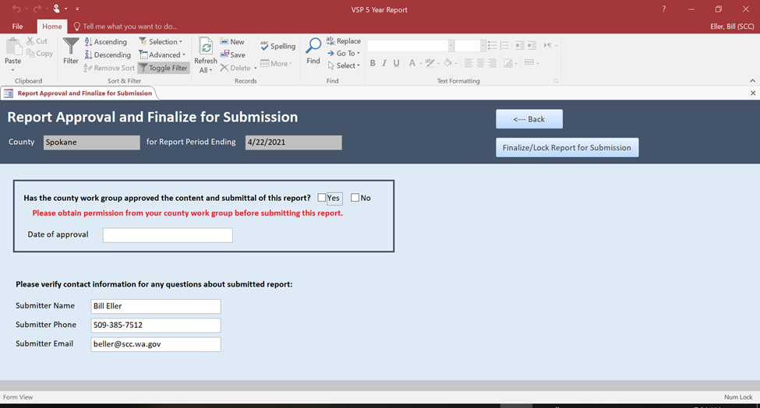

Appendix B: Steps in the Five-Year Report Review Process

- Upon receipt of a five-year report (report) from a county through the submittal of the report in the database, the Commission will provide the report to the Technical Panel (TP) and Statewide Advisory Committee (SAC).

- TP review and evaluation. The TP will review and evaluate the report to assist the Director in the decision to concur or not with assertion of the work group on whether it has met the work plan's protection and enhancement goals and benchmarks. Whether a work group is meeting a work plan’s enhancement goals and benchmarks depends on if the work plan includes enhancement goals and benchmarks and funding being made available for them.

  - After their review and evaluation, TP members can provide comments to the director using the database or other suitable form provided by the Commission. Each TP member will be provided an opportunity to review other TP member comments before finalizing their own. Through the database or other suitable form provided by the Commission, in addition to comments about the report, each TP member will be given the opportunity to provide a short summary (2-3 sentences) of their recommendations for inclusion in the director’s decision letter to the county. Counties will also be allowed access to the full comments from each TP member.

  - The director will review TP comments and consider them during the Director’s decision-making process.

- Consultation with the SAC. After considering the TP comments, the Director will then consult with the SAC during an open, public meeting with the TP.

  - The SAC will assist the Director in deciding whether to concur with the work group, and if the Director should approve an adaptive management plan, if one was required.

  - The TP shall be given the opportunity to explain their comments at the meeting, and the SAC and Director (or Director’s designee) will solicit information, ask questions, and otherwise seek further explanation from the TP, as needed, during the meeting.

  - At the end of the meeting, the SAC will provide a recommendation to the director on whether the Director should concur with the work group. If the SAC needs more time or additional meetings to make a recommendation, more time or meetings will be available.

- The Director’s decision. The Director’s decision will be communicated to each county in writing. The writing will include a brief summary of the recommendation made from each TP member about whether to concur with the five-year report.

  - If the Director concurs with the county work group that the work plan meets the protection goals and benchmarks, the Director will inform the county in writing and the watershed group shall continue to implement the work plan.

  - If the Director does not concur with the county work group that the work plan meets the protection goals and benchmarks, the Director will inform the county in writing of that determination and provide the reasons for that determination. The Director must then consult with the SAC to determine whether or not the watershed group can meet the goals within six months. If not, then the watershed group shall be notified in writing that they have failed out of VSP for the watershed.

  - If, after a six-month time extension is granted, the Director, in consultation with the SAC determines that the watershed has failed to meet its goals and benchmarks for protection, the watershed is subject to RCW 36.70A.735 and the Director shall notify the county watershed group in writing of that determination.

  - If the watershed group, in its five year report, has determined that the protection goals and benchmarks of the work plan have not been met, then it must propose and submit to the Director an adaptive management plan to achieve the goals and benchmarks that were not met. The adaptive management plan must be submitted at the same time as the five-year report. If the Director, after consultation with the SAC, does not approve the adaptive management plan, the watershed is subject to RCW 36.70A.735 and the Director will notify the county watershed group of that determination.

Appendix C: Roles of the Technical Panel and Statewide Advisory Committee

ROLE OF THE TECHNICAL PANEL

The TP assists in the review and evaluation of five-year report (report) by participating in meetings on the merits of the report. The TP reviews and evaluates the report and provides comments to the Director at each agency’s discretion. The TP will review and evaluate the report to assist the director in the decision to concur or not with assertion of the work group on whether it has met the work plan's protection and enhancement goals and benchmarks. Whether a work group is meeting a work plan’s enhancement goals and benchmarks depends on if the work plan includes enhancement goals and benchmarks and funding being made available for them.

Each member of the TP assists the watershed work group in identifying any issues from their agency identified during its review and evaluation of the report. The TP ensures that the data, information, analysis, and documentation contained in the report is scientifically sound, technically reliable, and ecologically appropriate.

ROLE OF THE STATEWIDE ADVISORY COMMITTEE

The SAC assists the Director in the review and evaluation of the report by participating in meetings on the merits of the report, in deciding if the Director will concur with the watershed work group’s determination that the protection goals and benchmarks of the work plan have been met, and in deciding if the Director will approve of the adaptive management plan if one is needed.

Appendix D: Standard

REVIEW AND EVALUATION STANDARD

VSP is designed to protect and enhance critical areas on lands used for agricultural activities through voluntary actions by agricultural operators. The Commission will review and evaluate the five-year report to determine whether the work plan’s protection and enhancement goals and benchmarks have been met, and to meet the policy objectives and requirements of chapters 36.70A.700-760 RCW pertaining to the VSP.

Each goal and benchmark under each critical area must be listed in the database as stated in the work plan. Any critical area that relies on a “regulatory backstop”, a regulation, or combination of regulations for their protection or enhancement as described in the work plan, must be supported by evidence showing that the critical area was protected and / or enhanced.

CONVENING THE TECHNICAL PANEL AND STATEWIDE ADVISORY COMMITTEE

The Commission shall convene the TP and SAC as appropriate throughout the five year report review and evaluation process.

RCW 36.70A.720 (2) (b) (i) and (c) (i)
RCW 36.70A.730
RCW 36.70A.705 (2) (e) (ii)
RCW 36.70A.705
RCW 36.70A.705 (1)

