  - VOLUNTARY STEWARDSHIP PROGRAM

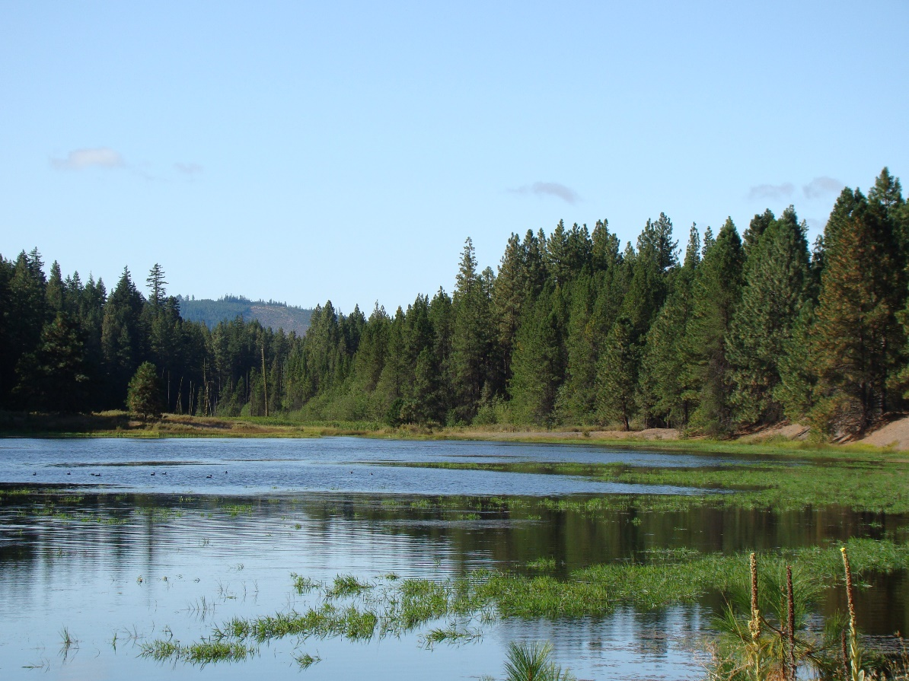

  - COUNTY WORK PLAN FIVE-YEAR
  - REPORTING GUIDANCE

  - July 2020

Voluntary Stewardship Program:
County Work Plan Five-Year Reporting Guidance

Washington State Conservation Commission
Carol Smith, Executive Director

Ron Shultz, Director of Policy and Inter-governmental Relations
Brian Cochrane, Habitat and Monitoring Coordinator
Bill Eller, VSP Coordinator

July 2020
- Introduction

The Voluntary Stewardship Program (VSP) requires each county watershed work group (work group) to report to the Executive Director (Director) of the Conservation Commission (Commission) and the county on whether it has met the work plan's protection and enhancement goals and benchmarks.

Reports are to be submitted at five-year intervals from the date of receipt of funding, and sent to the Director of the Commission and to each county legislative authority by each county work group. The Director must decide to concur, or not, with each county work group’s determination.

- Report Submission

Important: The date each work group must submit its five-year report (report) is set out below in Section V. Please allow time prior to the submittal due date for your work group to approve both the content and the submittal of the report.

To submit a report, work groups must use this link:

https://www.formstack.com/forms/?3728205-Dn0ll6FOVL

In the template, each county work group must

- Assert whether or not it is meeting its goals and benchmarks in its work plan, and

- Provide evidence supporting the assertion for each goal and benchmark.

Additional materials, documents, or information a work group would like to make available to support its report should be retained at the county or work group, and a link to those materials provided within the report when it is submitted to the Commission. All information necessary for the Director to decide if they concur, or not, with the work group’s determination should be documented and explained in the report.

If, as part of an answer in the report, a reference is made to a work plan, appendix of a work plan, or other document, please provide a link to that document, the document title, and the page number as part of that reference. Nothing in this guidance shall require the Commission to review and/or evaluate the additional materials beyond what has been submitted in the report.

Answers submitted in the report should be brief, succinct, and directly answer the question posed. In completing the report, please use clearly identified units of measurement (i.e. feet, acres, miles, etc.) with all data.

When the report is submitted, it should be in final form. The report will require verification that the submittal has been approved by the work group. The report should be submitted on or before each five year interval from the date the county first received VSP funding (see Section V, below).

During the review and evaluation process, please continue to implement your work plan
IMPORTANT!

- Review and Evaluation

The report is first reviewed and evaluated by the VSP Technical Panel to assist the Director in the decision to concur or not with assertion of the work group.

The Director then consults with the VSP Statewide Advisory Committee (SAC) in deciding whether to concur with the work group, and the SAC assists in deciding if the Director should approve an adaptive management plan, if one is required. If the work group asserts it is not meeting its plan goals and benchmarks, an adaptive management plan is required to be submitted along with the report.

There is no timeline for completion of the review and evaluation process set in statute. The Commission will work diligently to complete the process in a timely manner.

Figure 1 illustrates the review and evaluation process when the work plan is meeting its goals and benchmarks.

Figure 2 illustrates the process when the work plan is not meeting its goals and objectives.

- Definitions
The following definitions should be considered throughout the five-year report process. The Technical Panel and SAC provide the following uniform definitions for reference throughout their review process. These terms are not defined in statute, but the Commission wants to provide guidance on the following concepts:

- Goal: the end toward which effort is directed. Goals should identify what the project is trying to accomplish – what the end product will be (e.g., what functions you want to protect). If objectives were used to clarify your goals, they may be included in your goals.

- Benchmark: something that serves as a standard by which others may be measured or judged; a point of reference from which measurements may be made. Benchmarks typically contain numbers for measurement, not action verbs, unless the action is in reference to a number. Benchmarks are specific conditions used to determine whether the work plan is achieving its objectives. If indicators were used to obtain your benchmarks, they must be included in your benchmarks.

- Submittal Dates

SCHEDULE FOR SUBMITTAL OF FIVE-YEAR REPORTS†#
COUNTY | RECEIPT OF FUNDING DATE | 5 YEAR | 10 YEAR | 15 YEAR | 20 YEAR
Chelan* | 1.20.14 | 7.20.19 | 7.20.24 | 7.20.29 | 7.20.34
Thurston* | 1.20.14 | 7.20.19 | 7.20.24 | 7.20.29 | 7.20.34
Kittitas | 11.17.15 | 11.17.20 | 11.17.25 | 11.17.30 | 11.17.35
Mason | 11.24.15 | 11.24.20 | 11.24.25 | 11.24.30 | 11.24.35
Garfield | 11.30.15 | 11.30.20 | 11.30.25 | 11.30.30 | 11.30.35
Asotin | 12.14.15 | 12.14.20 | 12.14.25 | 12.14.30 | 12.14.35
Grant | 12.14.15 | 12.14.20 | 12.14.25 | 12.14.30 | 12.14.35
San Juan | 12.21.15 | 12.21.20 | 12.21.25 | 12.21.30 | 12.21.35
Cowlitz | 12.22.15 | 12.22.20 | 12.22.25 | 12.22.30 | 12.22.35
Pacific | 12.22.15 | 12.22.20 | 12.22.25 | 12.22.30 | 12.22.35
Okanogan | 12.28.15 | 12.28.20 | 12.28.25 | 12.28.30 | 12.28.35
Benton | 1.12.16 | 1.12.21 | 1.12.26 | 1.12.31 | 1.12.36
Skagit | 1.19.16 | 1.19.21 | 1.19.26 | 1.19.31 | 1.19.36
Whitman | 1.19.16 | 1.19.21 | 1.19.26 | 1.19.31 | 1.19.36
Columbia | 1.20.16 | 1.20.21 | 1.20.26 | 1.20.31 | 1.20.36
Yakima | 1.21.16 | 1.21.21 | 1.21.26 | 1.21.31 | 1.21.36
Douglas | 1.22.16 | 1.22.21 | 1.22.26 | 1.22.31 | 1.22.36
Pend Oreille | 2.2.16 | 2.2.21 | 2.2.26 | 2.2.31 | 2.2.36
Franklin | 2.24.16 | 2.24.21 | 2.24.26 | 2.24.31 | 2.24.36
Walla Walla | 3.7.16 | 3.7.21 | 3.7.26 | 3.7.31 | 3.7.36
Stevens | 3.10.16 | 3.10.21 | 3.10.26 | 3.10.31 | 3.10.36
Ferry | 3.14.16 | 3.14.21 | 3.14.26 | 3.14.31 | 3.14.36
Grays Harbor | 3.21.16 | 3.21.21 | 3.21.26 | 3.21.31 | 3.21.36
Lincoln | 3.21.16 | 3.21.21 | 3.21.26 | 3.21.31 | 3.21.36
Lewis | 4.18.16 | 4.18.21 | 4.18.26 | 4.18.31 | 4.18.36
Spokane | 4.22.16 | 4.22.21 | 4.22.26 | 4.22.31 | 4.22.36
† All timelines subject to continued legislative funding.
# Each county work group must approve of the report before it is submitted. Please allow enough time prior to the submittal due date for your work group to approve both the content and the submittal of the report.
* Special note on Chelan and Thurston County: Both Chelan and Thurston County were pilot projects that received funding much earlier than all the rest of the counties that opted-into VSP. As such, their timelines are substantially different. Other counties have later deadlines based on when additional funding was made available to them.

Figure 1: Process for Submittal and Review of VSP Five-Year Report: Work group asserts it is meeting the work plan goals and benchmarks

Approval obtained from Work Group of content and submittal of report
After six months, watershed fails to meet goals and benchmarks
Director determines likely to meet goals and benchmarks with six more months of planning and implementation; extension granted
Watershed subject to RCW 36.70A.735; within 18 months, a county must choose an option outside of VSP
Director determines not likely to meet goals and benchmarks with six more months of planning and implementation
Commission consults with Statewide Advisory Committee for recommendation
Director does not concur with work group
After six months, watershed meeting goals and benchmarks
Work Group continues implementation
Director concurs with Work Group
Commission consults with Statewide Advisory Committee
Review by Commission and Technical Panel
Submittal to Commission

Figure 2: Process for Submittal and Review of VSP Five-Year Report: Work group asserts it is not meeting the work plan goals and benchmarks

Approval obtained from Work Group of content and submittal of report
NOTE: An adaptive management plan for those goals and benchmarks not met must be submitted with the report

Report and adaptive management plan submitted to Commission

Work Group continues implementation
Review by Commission

After six months, watershed meeting goals and benchmarks
Director determines likely to meet goals and benchmarks with six more months of planning and implementation; extension granted
Director determines not likely to meet goals and benchmarks with six more months of planning and implementation
Commission consults with Statewide Advisory Committee for recommendation

Watershed subject to RCW 36.70A.735; within 18 months, a county must choose an option outside of VSP

After six months, watershed fails to meet goals and benchmarks

Appendix A: Suggested Procedure for Filling out the Five-Year Report

The five-year report is a web-based, online form that the user fills out over the internet. The Commission suggests copying the form into a Microsoft Word format so that the answers to the questions can be stored and presented to your work group for approval prior to submittal. Once the Microsoft Word document is ready, the submitter would cut and paste the answers from the Word document into the online form. Instructions are set out below:

Appendix B: Steps in the Five-Year Report Review Process

- Upon receipt of a five-year report (report) from a county, the Commission will forward the report to the Technical Panel (TP) and Statewide Advisory Committee (SAC), and will provide an email containing all the submitted data back to the submitting county.

- TP review and evaluation. The TP will review and evaluate the report to assist the Director in the decision to concur or not with assertion of the work group.

  - After their review and evaluation, TP members can provide comments to the director using the template. Through the template, in addition to comments about the report, each TP member will be given the opportunity to provide a short summary (2-3 sentences) of their recommendations for inclusion in the director’s decision letter to the county. Counties will also be provided with the full comments from each TP member by email.

  - The director will review TP comments and consider them during the director’s decision-making process.

- Consultation with the SAC. After considering the TP comments, the director will then consult with the SAC during an open, public meeting with the TP.

  - The SAC will assist the director in deciding whether to concur with the work group, and if the director should approve an adaptive management plan, if one was required.

  - The TP shall be given the opportunity to explain their comments at the meeting, and the SAC and director (or director’s designee) will solicit information, ask questions, and otherwise seek further explanation from the TP, as needed, during the meeting.

  - At the end of the meeting, the SAC will provide a recommendation to the director on whether the director should concur with the work group. If the SAC needs more time or additional meetings to make a recommendation, more time or meetings will be available.

- The director’s decision. The director’s decision will be communicated to each county in writing. The letter will include a brief summary of the recommendation made from each TP member about whether to concur with the five-year report.

  - If the director concurs with the county work group that the work plan meets the protection goals and benchmarks, the director will inform the county in writing and the watershed group shall continue to implement the work plan.

  - If the director does not concur with the county work group that the work plan meets the protection goals and benchmarks, the director will inform the county in writing of that determination and provide the reasons for that determination. The director must then consult with the SAC to determine whether or not the watershed group can meet the goals within six months. If not, then the watershed group shall be notified in writing that they have failed out of VSP for the watershed.

  - If, after a six-month time extension is granted, the director, in consultation with the SAC determines that the watershed has failed to meet its goals and benchmarks for protection, the watershed is subject to RCW 36.70A.735 and the director shall notify the county watershed group in writing of that determination.

  - If the watershed group, in its five year report, has determined that the protection goals and benchmarks of the work plan have not been met, then it must propose and submit to the director an adaptive management plan to achieve the goals and benchmarks that were not met. The adaptive management plan must be submitted at the same time as the five-year report. If the director, after consultation with the SAC, does not approve the adaptive management plan, the watershed is subject to RCW 36.70A.735 and the director will notify the county watershed group of that determination.

Appendix C: Roles of the Technical Panel and Statewide Advisory Committee

ROLE OF THE TECHNICAL PANEL

The Technical Panel assists in the review and evaluation of five-year report (report) by participating in meetings on the merits of the report. The Technical Panel reviews and evaluates the report and provides comments to the director at each agency’s discretion.

Each member of the Technical Panel assists the watershed work group in identifying any issues from their agency identified during its review and evaluation of the report. The Technical Panel ensures that the data, information, analysis, and documentation contained in the report is scientifically sound, technically reliable, and ecologically appropriate.

ROLE OF THE STATEWIDE ADVISORY COMMITTEE

The Statewide Advisory Committee assists the director in the review and evaluation of the report by participating in meetings on the merits of the report, in deciding if the director will concur with the watershed work group’s determination that the protection goals and benchmarks of the work plan have been met, and in deciding if the Director will approve of the adaptive management plan if one is needed.

Appendix D: Standards

REVIEW AND EVALUATION STANDARD

The primary objectives of the VSP are to protect and enhance critical area functions and values on lands used for agricultural activities through voluntary actions by agricultural operators. RCW 36.70A.705. The Commission will review and evaluate the five-year report to determine whether the work plan’s protection goals and benchmarks have been met, and to meet the policy objectives and requirements of chapters 36.70A.700-760 RCW pertaining to the VSP.

CONVENING THE TECHNICAL PANEL AND STATEWIDE ADVISORY COMMITTEE

The Commission shall convene the Technical Panel and Statewide Advisory Committee as appropriate throughout the five year report review and evaluation process.

RCW 36.70A.720 (2) (b) (i) and (c) (i)
RCW 36.70A.730
RCW 36.70A.705 (2) (e) (ii)
RCW 36.70A.705

