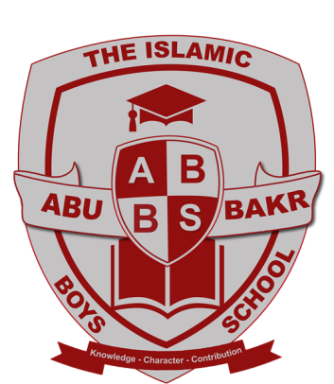

GCSE Results 2021
We are delighted to report outstanding success in this years’ examination results. Over the last two years our Year 11 pupils faced a very unprecedented and challenging time. Despite this, they have worked with resilience, fortitude and perseverance. Congratulations to all our Year 11 pupils in what has been an excellent set of results. Our pupils have truly performed at the very highest level.
Although our pupils did not sit public examinations this summer, with grades determined by teacher assessments, the results they have received are, we believe, an accurate reflection of what they deserve. These results are the outcome of a detailed and rigorous process which has taken into account teacher assessments, tests, amongst other evidence. These results reflect the position of the school which is one of continuous improvement on our way to becoming an outstanding school for our local and wider community.
Across the majority of subjects, there have been significant increases in grades awarded at 7 and above, as well as substantial increases in the number of students achieving a grade 5 or above in almost all subjects.
We are extremely proud of all our Year 11 pupils. Although it is not the end of a five year journey we expected for them, we are so pleased to be sharing such an excellent set of results today.
I would also like to thank my outstanding team of staff who through their tremendous dedication, effort and support throughout two lockdowns and several periods of isolation have ensured the pupils were awarded the GCSE grades that truly reflected their abilities and potential.

Mrs H. Varachia
Executive Head Teacher

