

Shift Date: Click here to enter a date.

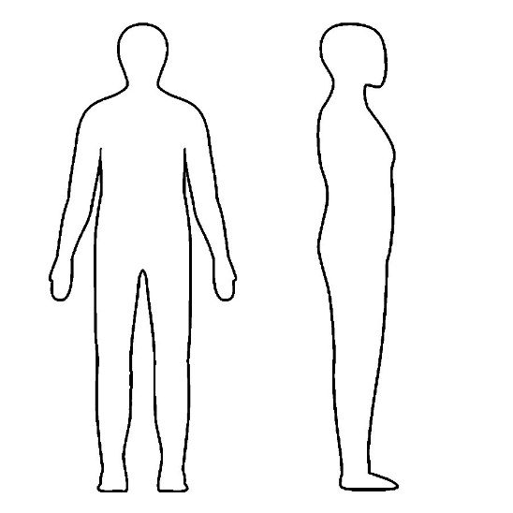

**Reactive Feeling Name**

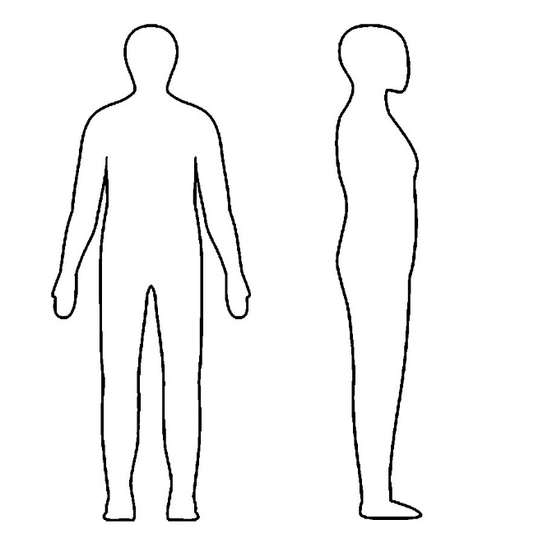

**Restored Feeling Name**

**NOTES**

Click here to enter text.