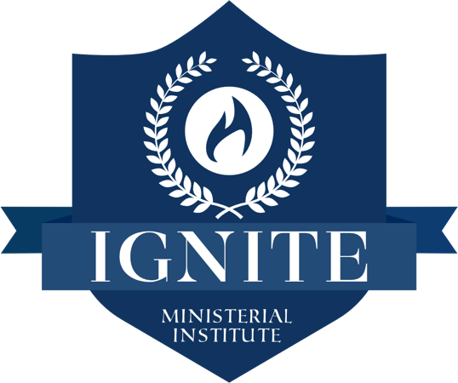

SCHOOL CALENDAR
2022 - 2021

PHASE 3
OPERATIONAL DAYS: TUESDAY: 7 PM – 9:30 PM | THURSDAY: 7 PM – 9:30 PM

COURSE & NAME | DATE
1. MINISTERIAL INTERNSHIP 3 | 09/06/22 – 09/22/22
2. PASTORAL MINISTRY | 09/27/22 – 10/13/22
3. CORINTHIANS CORRESPONDENCE | 10/18/22 – 11/03/22
4. POETIC BOOKS | 11/08/22 – 11/22/22
5. PRAYER & WORSHIP | 11/29/22 – 12/ 15/ 22
6. CHURCH ADMINISTRATION | 01/05/23 - 01/24/23
7. PENTATEUCH | 01/26/23 - 02/09/23
8. APOLOGETICS | 02/14/23 - 03/02/23
9. CHURCH LEADERSHIP | 03/07/23 - 03/23/23

Note: If five days before the course begins, the number of students is less than three, we will cancel the course and refund any payments previously made for that specific course.

