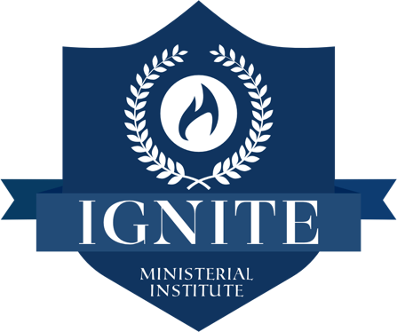

SCHOOL CALENDAR
2022 – 2023

PHASE 1
OPERATIONAL DAYS: TUESDAY: 7 PM – 9:30 PM | THURSDAY: 7 PM – 9:30 PM

COURSE & NAME | DATE
1. CHRIST IN THE SYNOPTIC GOSPEL | 09/06/22 – 09/22/22
2. INTRODUCTION TO HERMENEUTICS | 09/27/22 – 10/13/22
3. RELATIONSHIP AND ETHICS IN MINISTRY | 10/18/22 – 11/03/22
4. MINISTERIAL INTERNSHIP 1 | 11/08/22 – 11/22/22
5. INTRODUCTION TO PENTECOSTAL DOCTRINE | 11/29/22 – 12/ 15/ 22
6. A SPIRIT EMPOWERED CHURCH | 01/05/23 - 01/24/23
7. ASSEMBLIES OF GOD, HISTORY, MISSIONS, AND GOVERNANCE | 01/26/23 - 02/09/23
8. INTRODUCTION TO THEOLOGY: A PENTECOSTAL PERSPECTIVE | 02/14/23 - 03/02/23
9. NEW TESTAMENT | 03/07/23 - 03/23/23
10. OLD TESTAMENT | 03/28/23 - 04/13/23

Note: If five days before the course begins, the number of students is less than three, we will cancel the course and refund any payments previously made for that specific course.

