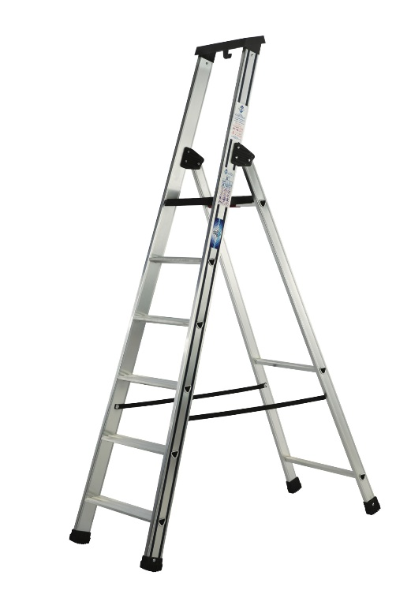
The Product

- Introducing the Issima platform step by Murdoch international
- Tested to 50,000 cycles to withstand the most vigorous usage
- From 3 Tread – 12 Tread
- 275 x 260mm platform area for safe footing made out of composite material of nylon and fibreglass for ultimate strength
- 10 year warranty
- Made in Italy

Specification
- Large 80mm anti-slip treads
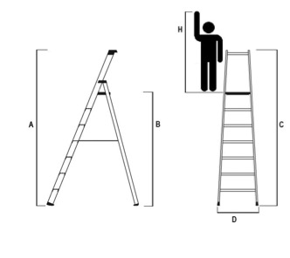
- Treads connected like rungs for massive strength
- Simple to use platform lock
- Large 70x20mm box section stiles
- Two anti-splay straps
- Large, anti-slip, all round moulded feet
- 150KG load rated
- EN131 Professional
- Comes with user friendly bucket hook and tool tray
- Handrails available as an accessory
Code | Description | Open Height m  A | Platform Height m  B | Closed Length m  C | Base Width m  D | Max Working Height m  H | Weight  KG
A07IS150 | 3 Tread Issima Platform Step | 1.28 | 0.66 | 1.36 | 0.44 | 2.66 | 5.0
A07IS175 | 4 Tread Issima Platform Step | 1.51 | 0.89 | 1.61 | 0.46 | 2.89 | 5.9
A07IS200 | 5 Tread Issima Platform Step | 1.74 | 1.12 | 1.86 | 0.49 | 3.12 | 6.8
A07IS225 | 6 Tread Issima Platform Step | 1.97 | 1.35 | 2.11 | 0.51 | 3.35 | 7.7
A07IS275 | 8 Tread Issima Platform Step | 2.43 | 1.81 | 2.61 | 0.56 | 3.81 | 9.5
A07IS325 | 10 Tread Issima Platform Step | 2.89 | 2.27 | 3.11 | 0.61 | 4.27 | 12.5
A07IS375 | 12 Tread Issima Platform Step | 3.35 | 2.73 | 3.61 | 0.66 | 4.73 | 14.9
A50CORR67 | Single Handrail for Issima Step |  |  | 0.8 |  |  | 1.2

