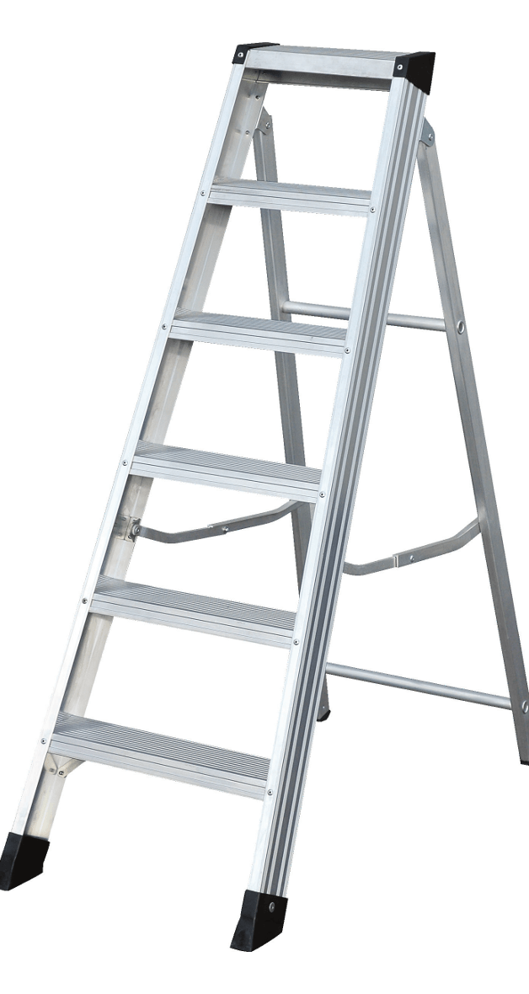
The Product

- Introducing the aluminium swingback / builders step from Murdoch International
- Tested to 50,000 cycles to withstand the most vigorous usage
- From 4 Tread – 12 Tread
- Two aluminium locking arms for security
- Steel fittings/hinges for strength and rigidity
- 10 year warranty

Specification
- Large 85mm anti-slip treads
- Large 82mm front profile for easy climbing
- Two aluminium locking arms
- Large, anti-slip, all round moulded feet
- 150KG load rated
- EN131 Professional
Code | Description | Open Depth m  A | Open Height m  B | Base Width m  C | Closed Length m  D | Max Working Height m  V | Weight  KG
SHR804 | 4 Tread Aluminium Builders / Swingback Stepladder | 0.69 | 0.86 | 0.43 | 0.99 | 2.11 | 3.9
SHR805 | 5 Tread Aluminium Builders / Swingback Stepladder | 0.85 | 1.06 | 0.45 | 1.22 | 2.31 | 5.0
SHR806 | 6 Tread Aluminium Builders / Swingback Stepladder | 0.99 | 1.27 | 0.48 | 1.45 | 2.52 | 5.5
SHR808 | 8 Tread Aluminium Builders / Swingback Stepladder | 1.31 | 1.69 | 0.54 | 1.91 | 2.94 | 7.3
SHR810 | 10 Tread Aluminium Builders / Swingback Stepladder | 1.62 | 2.11 | 0.59 | 2.37 | 3.36 | 9.5
SHR812 | 12 Tread Aluminium Builders / Swingback Stepladder | 1.92 | 2.53 | 0.64 | 2.83 | 3.78 | 12.0

