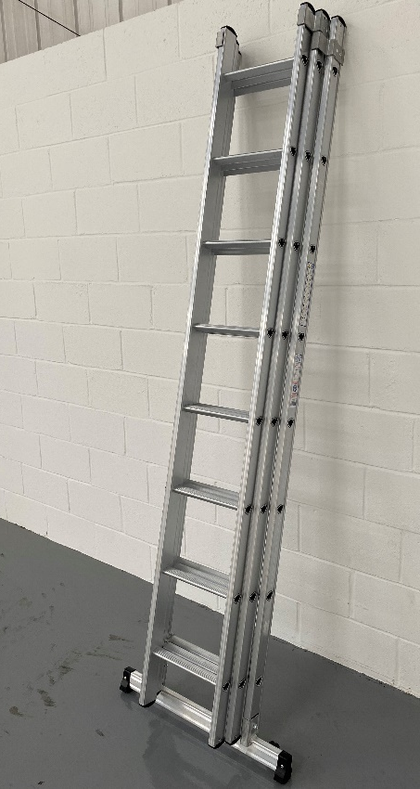
The Product

- Introducing the new Dmax extension ladder from Murdoch International
- Deployable stabiliser bar makes transportation and storage easier than traditional ladders with fixed stabiliser bar
- Comfortable working with a deep 39mm D shaped rung
- Strong ridged profile design helps to prevent dents to stiles
- 10 year warranty
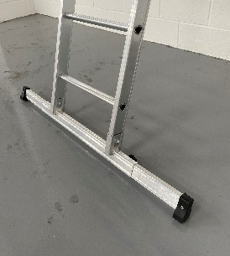
Specification
- Deep 39mm D shaped rung
- 1200mm deployable stabiliser bar
- 300mm rung spacing
- Heavy duty, manual rung lock
- Max folded width 700mm and folded depth 300mm
- EN131 Professional

Code | Description | Closed Length m | Extended Length m | Base Width mm (closed/  open) | Stile Dims mm | Weight  KG
Double Extension
A10059082255 | 2 x 8 Dmax Double Extension Ladder | 2.55 | 4.06 | 780/1200 | 58/25 | 11.0
A10069102315 | 2 x 10 Dmax Double Extension Ladder | 3.15 | 5.26 | 780/1200 | 68/25 | 15.0
A10069112345 | 2 x 11 Dmax Double Extension Ladder | 3.45 | 5.86 | 780/1200 | 68/25 | 16.0
A10069132405 | 2 x 13 Dmax Double Extension Ladder | 4.15 | 6.36 | 780/1200 | 68/25 | 20.0
A10100152465 | 2 x 15 Dmax Double Extension Ladder | 4.65 | 8.76 | 780/1200 | 100/25 | 26.0
Triple Extension
A10069083255 | 3 x 8 Dmax Triple Extension Ladder | 2.55 | 5.56 | 780/1200 | 58/25 | 18.0
A10069103315 | 3 x 10 Dmax Triple Extension Ladder | 3.15 | 7.36 | 780/1200 | 68/25 | 21.5
A10084113345 | 3 x 11 Dmax Triple Extension Ladder | 3.45 | 8.26 | 780/1200 | 85/25 | 24.0
A10100133405 | 3 x 13 Dmax Triple Extension Ladder | 4.15 | 10.06 | 780/1200 | 100/25 | 30.0

