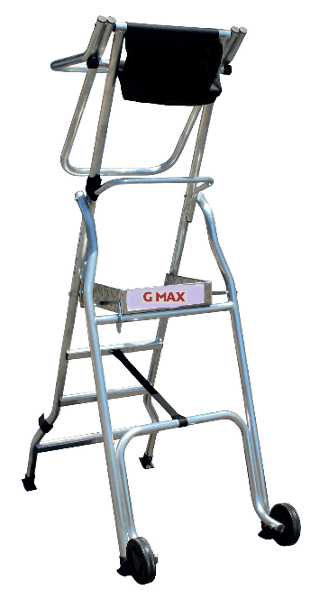
The Product
- New platform with “halo”-type automatic closing overhead barrier
- Work platform designed for all work up to 3.68 m height.
- Ideal for finishing work such as carpentry, dry lining and general maintenance
- Safe, enclosed working with generous 410x436mm platform area
- Lightweight – No fatigue when transporting/moving around site
- 2-year warranty.
Specification
- Deep tool pocket
- Stabilisers legs with millimetric adjustment (4 Tread models and up)
- 10 cm height toe boards
- Heavy duty platform lock hook when in use
- 150 mm tilt wheels for easy transportation
- Max folded width 700mm and folded depth 360mm
- EN131-7 – 150KG weight loading
 |  | A | B | C | D | E | F
Code | Description | Platform Height m | Working Height m | Base Width m | Base Projection m | Closed Depth m | Closed Length  m | Weight  (KG)
GMAX2 | 2 Tread Gmax | 0.48 | 2.48 | 0.70 | 0.98 | 0.36 | 1.74 | 12.0
GMAX3 | 3 Tread Gmax | 0.72 | 2.72 | 0.70 | 1.16 | 0.36 | 2.00 | 13.0
GMAX4 | 4 Tread Gmax | 0.96 | 2.96 | 0.70 /1.43 | 1.34 | 0.36 | 2.28 | 15.5
GMAX5 | 5 Tread Gmax | 1.20 | 3.20 | 0.70 / 1.43 | 1.52 | 0.36 | 2.54 | 18.0
GMAX6 | 6 Tread Gmax | 1.44 | 3.44 | 0.70 / 1.43 | 1.70 | 0.366 | 2.82 | 19.0
GMAX7 | 7 Tread Gmax | 1.68 | 3.68 | 0.70 / 1.43 | 1.88 | 0.36 | 3.10 | 20.0

