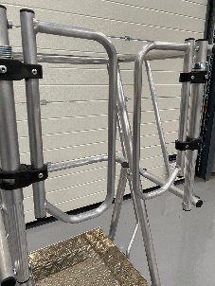
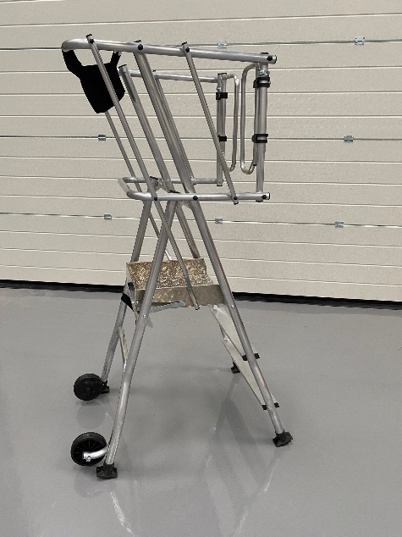
The Product
- New platform with “saloon”-type automatic closing door.
- Work platform designed for all work up to 3.44 m height.
- Ideal for finishing work such as carpentry, dry lining and general maintenance
- Safe, enclosed working with generous 410x436mm platform area
- Lightweight – No fatigue when transporting/moving around site
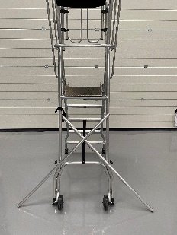
- 2-year warranty.
Specification
- Deep tool pocket
- Stabilisers legs with millimetric adjustment (4 Tread models and up)
- 10 cm height toe boards
- Heavy duty platform lock hook when in use
- 150 mm tilt wheels for easy transportation
- Max folded width 700mm and folded depth 300mm
- EN131-7 – 150KG weight loading
 |  | A | B | C | D | E | F
Code | Description | Platform Height m | Working Height m | Base Width m | Base Projection m | Closed Depth m | Closed Length  m | Weight  (KG)
GMAXP2 | 2 Tread Gmax + | 0.48 | 2.48 | 0.70 | 0.89 | 0.3 | 1.82 | 12.8
GMAXP3 | 3 Tread Gmax + | 0.72 | 2.72 | 0.70 | 1.04 | 0.3 | 2.08 | 13.5
GMAXP4 | 4 Tread Gmax + | 0.96 | 2.96 | 0.70 / 1.43 | 1.19 | 0.3 | 2.33 | 15.5
GMAXP5 | 5 Tread Gmax + | 1.20 | 3.20 | 0.70 / 1.43 | 1.35 | 0.3 | 2.58 | 18.5
GMAXP6 | 6 Tread Gmax + | 1.44 | 3.44 | 0.70 / 1.43 | 1.50 | 0.3 | 2.85 | 19.0

