Contact: Name, Title
(PLACE YOUR DISTRICT LOGO OR NAME HERE)
Tel. xxx.xxx.xxxx
Email: john@district.com
Address

Date:

FOR IMMEDIATE RELEASE

Media Release

Main Title, keep it as short as possible
Subtitle Goes Here - should include hook or major selling point of the event

LOCATION – Body of press release begins here. Get to the point immediately. What is the take-away message from the story?

Second paragraph: provide details / facts that explain why the reader should care and continue reading (e.g. notable statistics/figures, tie to local issues).

Third – Last paragraphs: As concisely as possible, tell the remainder of your story, highlighting how this story impacts/benefits the audience, any ties to relevant community issues/topics, and include quotes.

About Random Conservation District

[Include a 3-4 line description of your conservation district and the unique services you provide. The last line should be: To learn more, visit www.randomcd.com, or call us at XXX.XXX.XXXX.]

###
[Three hash tags symbol the end of the release]

(EXAMPLE)

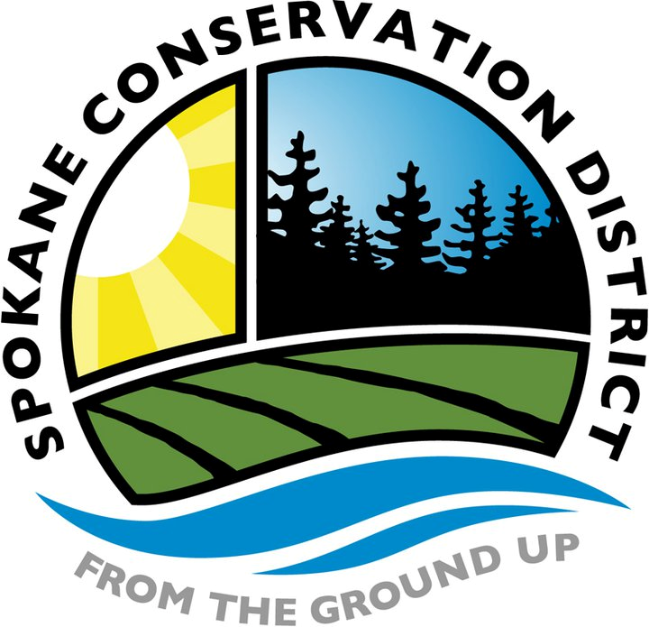
Contact: Erica VanNatta, Outreach Specialist
Tel. 509.535.7274
Email: erica-vannatta@sccd.org
210 N Havana
Spokane WA 99202

Date: November 5, 2014

FOR IMMEDIATE RELEASE

Press Release

Looking back on 32 years of conservation
Jim Armstrong retires from Spokane Conservation District

SPOKANE – Jim Armstrong has defined conservation for Spokane County and developed programs that will protect and enhance natural resources for generations to come. After 32 years of employment at the Spokane Conservation District (SCD), he looks back on his work and prepares to retire.

Armstrong was the first full-time employee of the Spokane Conservation District. His initial achievement was in developing the forestry program. Armstrong created a firewood thinning program that helped landowners make their forested property healthier and more fire resistant through thinning. He cleverly utilized the firewood seeking public to help complete and pay for the work. Today, SCD implements forest thinning as part of a nationwide program called Firewise, but only licensed contractors complete the work.

After growing the forestry department, Armstrong turned his focus to water quality in 1987 with projects on Eloika Lake. The water resources department now employs five people and includes ongoing programs like Livestock & Land technical assistance and cost-share opportunities, and On-Site Septic System Financial Assistance Program.

The department that Armstrong has become most passionate about is Production Agriculture, and the Direct Seed Loan Program. Low interest loans are provided to qualifying farmers to purchase no-till or direct seed farming equipment. With these loans, farmers have reduced soil erosion to almost nil on an estimated 750,000 acres across 19 Washington counties and four counties in North Idaho. The best part is, the tax payers get the money back with interest. Armstrong has developed several radio and video productions to support the Direct Seed movement.
“The changes I have witnessed in the quantity and quality of natural resource conservation and advancements in environmental quality are quite impressive by any measure,” Armstrong said.

Aside from helping develop Armstrong has actively served on the Farm Forum Committee, AgriBusiness Council, Northwest Natural Resources Institute board, Pacific Northwest Direct Seed Association Conference committee, and has written for various local publications.

Vicki Carter, SCD Director, stated “Jim was instrumental in the adoption of the assessment legislation back in 1991. Quite simply, our district wouldn’t have the capacity to do the scale of projects we do without Jim’s vision and hard work for stable funding. For that, SCD and 14 other districts across Washington will be forever indebted to him.”

What’s next? Armstrong retires to spend more time with his wife, children and grandchildren, and practice conservation in small farming and gardening.

To celebrate Armstrong’s 32 years of accomplishments, the Spokane Conservation District will hold an open house on November 12 from 3pm-5pm at the SCD office, 210 N Havana, Spokane WA 99202. For more information, call 509.535.7274 or email erica-vannatta@sccd.org.

About Spokane Conservation District

The mission of Spokane Conservation District is to promote the sustainable use of natural resources within Spokane County. We offer a range of voluntary services to help people responsibly and efficiently manage their land. To learn more, visit www.sccd.org, or call us at 509.535.7274.

###

