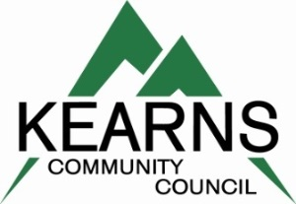
Kearns Hometown Night Celebration—“We Are Kearns”
Booth/Table Entry Form
Friday--August 5, 2022
Event Start Time: 6:00 pm

Kearns Community Council would like to invite your school, organization, political booth, business, etc… to participate in this year’s Kearns Hometown Night Celebration by setting up your organization’s booth/table.
Typically, we have approx. 1100 people attend this event through the evening. There is no fee to participate, just complete this form and return it by the deadline date. Booth/table set up time 4 pm--6 pm.

Booth/table area can only by 10’ x 10’, no selling anything, no solicitations for donations, must bring own power (if needed), table, chairs, canopy, etc.., booth/table must meet the standards of the community as determined by the Kearns Community Council

Deadline To Return Form: August 1, 2022

Organization/Company____________________________________________________________________

Contact Person________________________________Phone________________Cell__________________

Address____________________________________Email_______________________________________

City_________________________________________State_________________Zip__________________

Booth Type (circle which applies) Business Political Non Profit Family

Other (describe)______________________________________________________________________________

_________________________________________________________________

Comments______________________________________________________________________________

_______________________________________________________________________________________

Mail or Email Entry To:
Paula Larsen, Kearns Community Council
5134 South 4180 West Kearns, Utah 84118
Phone: Home 801-963-9150 Cell/Text 801-651-5371 Email: robertandpaula90@msn.com
or any
Kearns Community Council Member
Roger Snow—Sue Willis—Edward Aguirre—Carmen Ramirez
Emma Hansen--Bridget McQueen—Joel Trujillo
or Associate Aaron Nickle

