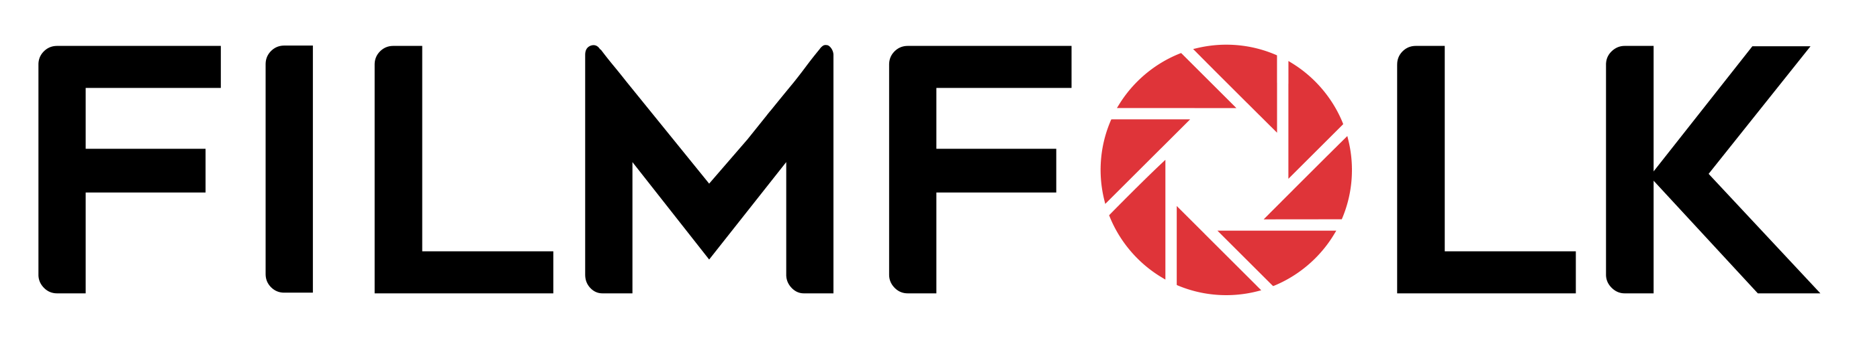

Applicant Questionnaire

Thank you for your interest in joining our team! To help us learn about you and your suitability for our work opportunities, please complete this application and email it to us at info@filmfolk.com.

Please briefly complete every section and ensure samples are your own work. Rest assured, there are no right or wrong answers, we are flexible and will take everything into account!

Your Role
Please tell us your main skill for which you are applying

Camera Person | My main skill is filming with a video or cine camera/s
Drone Operator | My main skill is flying and filming with a drone/s
Video Editor | My main skill is video editing
Filmmaker | I am equally proficient at both filming and editing
Photographer | My main skill is photography and I edit my own pics
Photo Editor | My main skill is photo editing, I’m not a shooter
If you have a secondary skill for which you wish to apply, please tell us here

Your Details
Name
Please tell us your full name
Date of Birth
Please tell us your DoB
Nationality
What is your nationality?
Location
What is your nearest train or underground station?
Work Permit
Do you have the right to work in the UK? For how long?
Tax Status
Are you registered self-employed?
If so, please provide UTR number
VAT Status
Are you registered for VAT?
If so, please provide VAT number
Drivers Licence
Do you have a driver’s licence? If so, how long have you held it?
Professional Profile
Please provide a link to your LinkedIn or social media profile.
Website
If you have a website, please provide a link here

Training & Education
Higher Education
Please tell us what and where you studied including results/grade
Vocational Training
Please tell us about any relevant vocational training
Accreditations
Please tell about any professional qualifications or accreditations
Employment
What is your current employment status?

Equipment & Facilities
Camera/s
What camera kit do you currently own? Why did you choose it?
Lenses
What lenses do you currently own. What’s your favourite?
Sound Kit
What microphones & sound recording equipment do you own?
Tripod & Grip
What tripod and grip kit do you own?
Lights & Accessories
What three accessories do you most use and why?
Drones
What drone kit do you own? Why did you choose it?
Studio Set-Up
What computer set-up do you own? Provide basic specifications
Vehicle
Please provide the make/model of any vehicle you own.

Production Experience
Corporate Projects
Have you previously worked on any corporate projects or events? If so, please link a video or image gallery and specify your role/s.
Provide up to 3 links.
Private Projects
Have you worked on any private projects or events? If so, please link a video or image gallery and specify your role/s.
Provide up to 3 links.
Weddings
Have you worked on any weddings? If so, please link a video or image gallery and specify your role/s.
Provide up to 3 links.
Other Videography Work
Please provide examples of any other film work. Please specify what equipment you used.
Provide 3 video links.
Other Photography Work
Please provide examples of any other photography. Please specify what equipment you used.
Provide 3 gallery links.
Drone Operating
Please provide examples of any other drone operating work. Please specify what equipment you used.
Provide 3 links here.
Video Editing
Please provide examples of any other video editing work. Please specify what equipment you used.
Provide up to 3 video links.
Photo Editing
Please provide examples of any other photo editing work. Please specify what equipment you used.
Provide up to 3 links.

Professional Skills
Client Management
What experience do you have in managing and corresponding with clients
Skills Development
What aspect of your professional skills do you want to develop?
Favourite Activities
What aspects of your profession do you most enjoy and why?
Least Favourite Activities
What aspects of your profession do you least enjoy and why?
Flexibility
This role includes evening & weekend work and some travel. Do you have any restrictions?
Special Needs
Do you need any special support from us for your employment?
Other Comments
Is there anything you’d like to tell us that you feel we might have overlooked?

Declaration

I confirm that all the above statements are true and correct. All samples provided are my own
work and where collaboration has occurred, I have stated my involvement. I understand that
failure to properly disclose information will result in disqualification.
Signed | Date

© FilmFolk Updated June 2022

