CALL FOR PAPER ISSUE III, JudicateMe

[ISSN 2582-7324]
It gives us immense pleasure in announcing that the journal has received a great response from scholars, teachers and academicians from all over the country. We here at JudicateMe duly acknowledge the contribution of each and every person from the legal, scientific and management fraternity. JudicateMe will provide assistance to every Author in rectifying their small errors which are necessary for publishing the Research paper and polishing their skills further. Our team is well versed with the fact of importance of CV in a student’s life therefore we pledge to assist and publish your original content of Daily Notes, College Projects, Case Analysis, Memorials or any other college research work into a well analysed paper for publication in our journal.
To visit our website, kindly check www.judicateme.com or scan the code:

INSTRUCTIONS FOR PAPER SUBMISSIONS
We, here at JudicateMe focus on in-depth research and original content of the Author so as to encourage creativity and extensive study of the topic, that’s why we do not believe in the concept of “First Come, First Serve”. Our team works day and night to make sure that the Authors who have worked spectacularly in their papers are given preference over others which will encourage others as well to improve and do an extensive research in their work. Our aim is not to exclude other authors but to choose best amongst the best.
The submission should be on any theme related to Law, Science, and Management.
- The Manuscript should be in Word Format along with an appropriate Title.
- The quality-based selected papers will be published in the form of International Standards Serial Number, ISSN 2582-7324
- The content of the Papers should be original and unpublished.
- Only full manuscripts submitted on or before the deadline shall be considered for Publication.
- Authors are requested to adhere the following word limit:
  - Long Articles: 4000 to 6000 words (excluding footnotes).
  - Short Articles: 2000 to 3000 words (excluding footnotes).
  - Case Analysis: 500 to 2000 words (excluding footnotes).
  - Book Review: 1000 to 2000 words (excluding footnotes).
  - Memorials: Arguments Advance should not exceed 25 pages.
- The Articles must be in Times New roman, Font Size for headings 14 and for side headings & content 12, line spacing 1.5, on an A4 sheet with 1’ margin on all sides.
- A uniform style of the citation must be strictly adhered to while submitting the paper (prefer 20th edition Blue Book or OSCOLA).
- Submission Deadline: 30th November 2020.
Note: Certificates will be given in both Physical and Electronic form.

All manuscripts submitted shall accompany
- A cover letter with the Name(s) of the Author(s), Institution/Affiliation, the Title of the Manuscript and Contact information which should include Email Address and Mobile Number.
- An undertaking as to the work submitted is genuine and the author is the original owner of the work, and the same is not published anywhere before. (Separate Word File Mandatory).
- Email to this ID: journal.judicateme@gmail.com

REWARDS:
- First Prize (Best Research Paper): Certificate of Merit + Certificate of Publication + Interview opportunity for Member of Editorial Board + Internship Opportunity with Senior Editor.
- Second Prize: Certificate of Merit + Certificate of Publication+ Internship Opportunity with Senior Editor.
- Third Prize: Certificate of Merit + Certificate of Publication + Internship Opportunity with Senior Editor.
- Top 10 Entries will receive the consolation Prize (Certificate of Merit and Certificate of Publication).
Failure to payment of publication fees leads to disqualification/removal of paper from both publication and competitions. Any Registration fee paid be the Author(s) will be acknowledged by the Email.
The last date of submission is 30th November, 2020.

Confirmation and acknowledgement of receiving paper will be sent within 48 hours and Confirmation regarding selection of paper will be given within the span of 7 days.
All submissions must be sent to journal.judicateme@gmail.com and must be attached with a covering letter mentioning the name of the authors, Title of the manuscript, Occupation, Email address and phone number.
Note: Only when the paper is selected by the Editorial Team of JudicateMe, the student will be asked to pay the required amount.

PAYMENT MODE:
- Bank Name: Bank of India
- Account Number: 682110110003007
- Account Holder Name: Saumya Tripathi
- Branch Name: Terhi Pulia (Madion)
- IFSC Code: BKID0006821
- Paytm/Google pay number: 9044382618
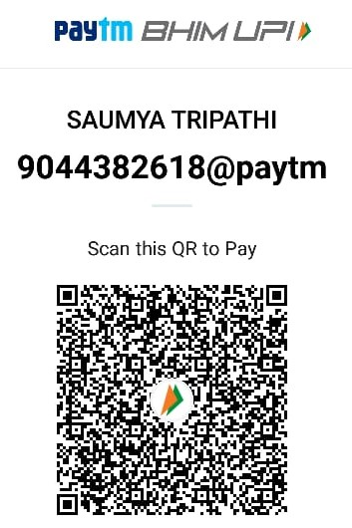
The publication will be available at www.judicateme.com

For Further Assistance :
Saumya Tripathi (Founder and Editor-in-chief)
WhatsApp no: 9044382618
Email: saumya.judicateme@gmail.com
G Brahmakrit Rao (Co-Founder and CTO)
WhatsApp no: 9810709121
Email: brahmakrit.judicateme@gmail.com

