Rochester Black Nurses Association Inc.

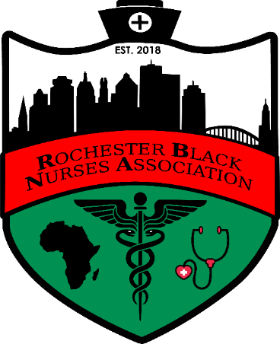

Open to all RNs, LPNs, Nursing Students, Retirees and those whom support the mission of NBNA
NBNA’s mission: To serve as the voice for Black nurses and diverse populations ensuring equal access to professional development, promoting educational opportunities and improving health
RBNA motto: “The Heart of Community Health: Bridging the Gap”
Chapter Meeting Tuesday March 30th, 2021
Sponsored by University of Rochester, School of Nursing
Guest Speaker: Tommye Hinton
Healthcare Consultant Brown ePoints @7pm

Location: Via zoom
When: Tuesday March 30th, 2021
Time: 6-8pm
Meeting ID: 972 600 7930
Password: waiting room enabled

Join our FB and Instagram @RochesterBNA
Email:Nbna.rochester@gmail.com
Website: rocbna.org
Call/Text:585.210.8374

