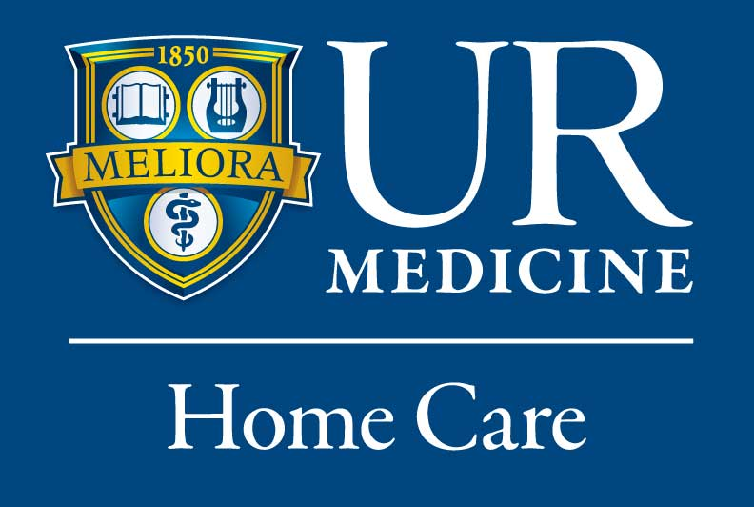

Job Title: Home Care RN
Link to Apply: https://careers.pageuppeople.com/979/cw/en-us/job/492748/home-care-rn
Work type: Full-time
Location: Monroe County
Are you interested in working 1:1 with patients in their home? UR Medicine Home Care is growing! Our RN Case Manager's work weekdays. No overnights, no weekends, and no shift work.
The Registered Nurse makes the initial evaluation visit, and regularly reevaluates the patient's nursing needs. They initiate the plan of care and any necessary revisions while counseling the patient and family to meet any nursing or other medically related needs.
RESPONSIBILITIES:
- Develops and revises plan of treatments and discharge plan in conjunction with patient, family, physician, care delivery team and third party payors including obtaining medical orders and approval of medical services.
- Initiates appropriate preventive and rehabilitative strategies.
- Consults with and educates the patient, family and other team members regarding disease process, self-care techniques and preventive strategies.
- Provides supervision of LPN to ensure patient health, safety, and compliance with plan of care.
- Assist with the training of newly hired staff
- Directs, coordinates, evaluates and supervises the quality of patient care services provided by the Home Health Agency.
- Assures the completion of all appropriate clinical records needed for compliance with state and federal legislation and the delivery of seamless service within established time-frames.
QUALIFICATIONS:
- New York State Licensed RN.
- One year of experience as a clinical nurse in a hospital or home care agency preferred,
- Strong interviewing, assessment and communication skills.
- Current NYS driver’s license

