FY2021 (7/1/20 – 6/30/21) Annual Work Plan
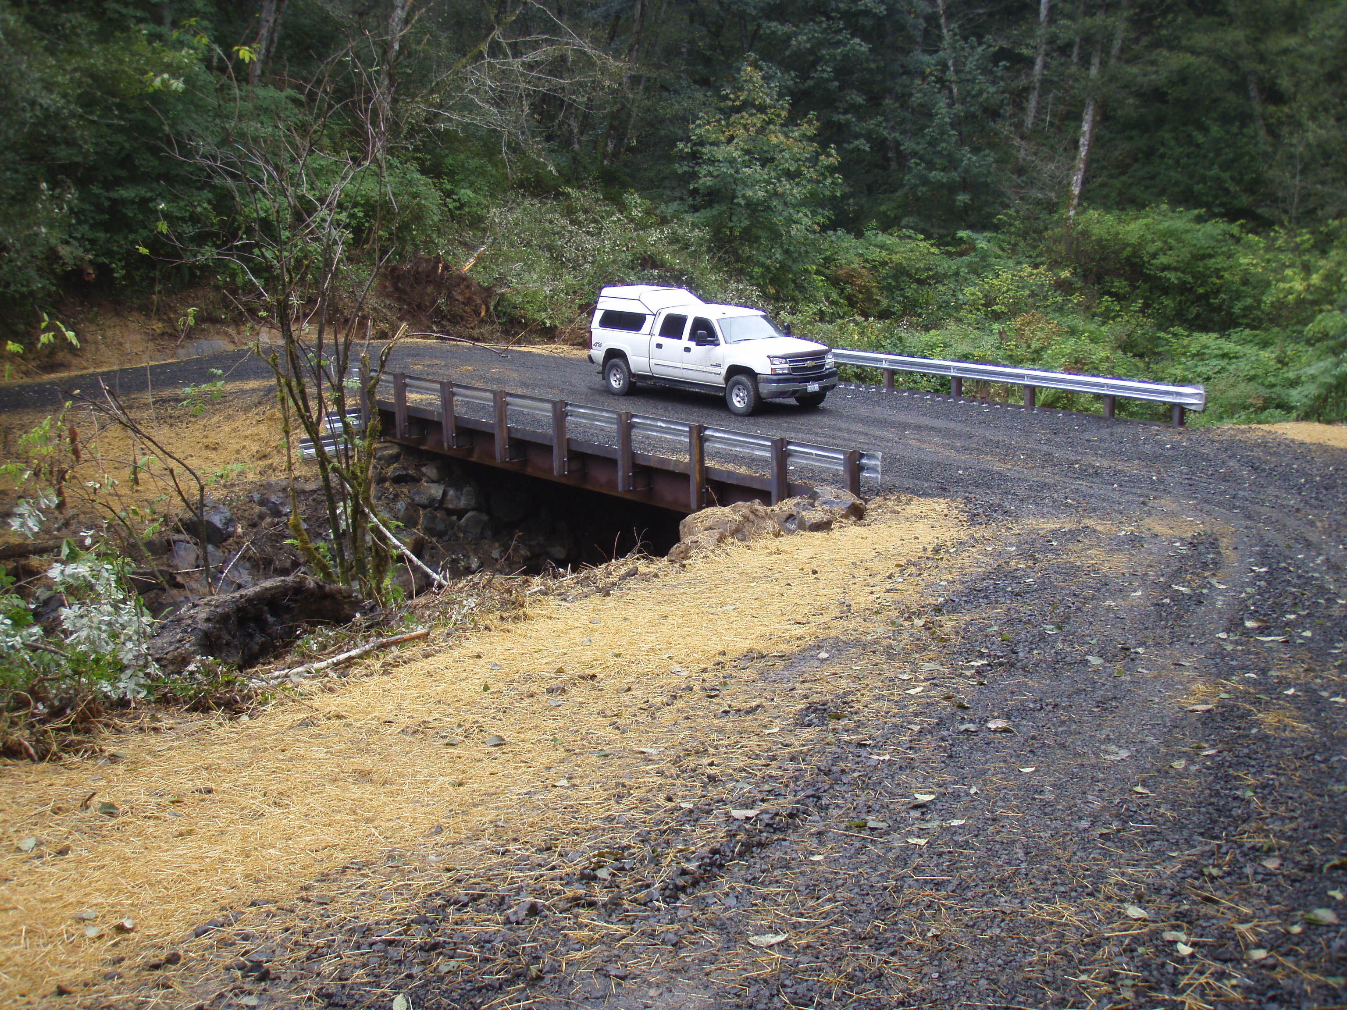

Grays Harbor Conservation District
For More Information Contact: Mike Nordin, 360-208-4451, plutroll@willapabay.org

- Mission of the Grays Harbor Conservation District To sustain and enhance the quality of and preservation of natural resources while providing for their use by current and future citizens of Grays Harbor County through locally led conservation practices.

Natural Resource Priorities
- Water Quality
- Improve the water quality in the Grayland Ditch so that it is removed from the 303(d) list.
- Work to reduce the water bodies on the 303(d) list.
- Design and plan of action on the outfall for the Cosmo Specialty Fibers mill.
- In partnership with the county.
- Implement an ambient water quality monitoring program.
- Immediately start working with partners to develop an oil spill prevention plan.
- Immediately work on implementation practices developed by the ocean acidification blue ribbon panel recommendations.
- Develop and implement a program on storm water management practices for landowners.
- Reduction in TMDL listings within the WRIA’s #22, 23, and 24
- Eliminate pesticide contaminant of surface water from applications
- Continue to provide technical assistance to cranberry producers to install BMP to reduce pesticides in surface waters

- Stream Restoration
- Fish Passage and instream habitat
- Riparian Restoration

- Agricultural, Forestry and aquaculture land
    - Promote and maintain long term forest health and productivity on non-industrial private forest land.
    - Improve water quality on forest land by addressing potential erosion and sediment delivery issues.
    - Develop a program for small-size livestock operations that is capable of serving 10 landowners per year.
    - Immediately be engaged in the development of a VSP plan.
    - Write farm plans.
    - Complete Phase 2 of the sediment study for Grays Harbor.
    - Increase the number of acres available for shellfish farming.
- Assist in upgrading shellfish grounds.

- Soil Quality
- By 2020 develop a program to educate landowners on best practices to maintain soil quality.
- District will work to increase soil quality in Grays Harbor Conservation District.
- Vegetation management
- Work to control of knotweed in the Wynoochee, Hoquiam, Williams, and Rock Creek.
- In cooperation with partners, develop a strategy and education plan for managing invasive plant species
- Work to complete a joint operation with Grays Harbor Noxious Weed Board to identify areas and impacted infestations of noxious water weeds, and assist to eradicate key noxious weeds
- Establish a working relationship with Noxious Weed Board for identification or eradication of noxious weeds

- Food security public education
- Explore opportunities for local foods, community gardens and other programs to address food security in Grays Harbor County.

- Energy – conservation and education
    - Work with Grays Harbor County PUD to explore ways to partner.
    - Work with NRCS to implement energy audits.
- Reduce usage of non-renewable energy.

- Air

FY2011 (FY2018 (7/1/20– 6/30/21) Annual Work Plan

Grays Harbor Conservation District

Picture of Natural Resource Project

Natural Resource Priority Program Area: Water Quality
Natural Resource Goal(s): Reduction in TMDL listings within the WRIA’s #22, 23, and 24
Natural Resource Measurable Result Objective: No new TMDL listings
Programmatic Measurable Result Objective:
Funding Source(s): Conservation Commission
Activities for FY2020 | Target Dates | Person  Responsible | Time(Days) Required | Estimated Funding | Notes
Investigate a path to develop a PIC plan to work on water quality hot spots | July 2020 – June 2021 | Mike Nordin | 40 | See Budget
Work on implementation practices developed by the ocean acidification blue ribbon panel recommendations. | ongoing | Anthony Waldrop | 400 | See Budget
Provide technical assistance for and cost share to non-dairy livestock producers to install needed BMP’s | ongoing | VSP Coordinator | 1500 | See Budget
provide technical assistance to cranberry producers to install BMP to reduce pesticides in surface waters | ongoing | Natalie Osowaski | 350 | See Budget

Natural Resource Priority Program Area: Stream Restoration
Natural Resource Goal(s): Reduction of riparian habitat degradation and increased salmonid passage within the WRIA’s #22, 23, and 24.
Natural Resource Measurable Result Objective: Improve riparian habitat and remove salmonid barriers.
Programmatic Measurable Result Objective:
Funding Source(s): Conservation Commission
Activities for FY2020 | Target Dates | Person  Responsible | Time(Days) Required | Estimated Funding | Notes
Implement 2-10 new CREP projects. | July 2021 – June 2021 | Jim Getchman | 900 | See Budget
Implement 1-2 miles of flood mitigation projects. | July 2020 – June 2021 | Tom K./A. Waldrop | 1200 | See Budget
Complete 5 culvert barrier correction projects. | July 2020– June 2021 | David Marcell & Tom Kollasch | 800 | See Budget
Complete 2 miles of instream habitat projects. | July 2020 – June 2021 | David Marcell, Tom K. & A. Waldrop | 800 | See Budget

Natural Resource Priority Program Area: Agricultural, Forestry and aquaculture land
Natural Resource Goal(s): Increased productivity of working lands with improved ecological practices
Natural Resource Measurable Result Objective:
Programmatic Measurable Result Objective:
Funding Source(s): Conservation Commission
Activities for FY2020 | Target Dates | Person  Responsible | Time(Days) Required | Estimated Funding | Notes
completing 12 forest stewardship plans | July 2020 – June 2021 | Dave Houk & Jim Getchman | 1200 | See Budget
12 landowners per year with forestry technical assistance and/or BMPs. | July 2020 – June 2021 | Dave Houk & Jim Getchman | 800 | See Budget
Improve water quality on forest land by addressing potential erosion and sediment delivery issues by inventorying and planning on forest roads. | ongoing | Dave Houk & Jim Getchman | 240 | See Budget
Immediately be engaged in the development of a VSP plan | Immediately | Anthony Waldrop | 240 | See Budget
Complete the writing of 5 farm plans. | By June 2021 | VSPCoordinator,Jim Getchman | 580 | See Budget
Complete Phase 2 of the sediment study for Grays Harbor. | By June 2021 | Mike Nordin | 40 | See Budget

Natural Resource Priority Program Area: Soil Quality
Natural Resource Goal(s):
Natural Resource Measurable Result Objective:
Programmatic Measurable Result Objective:
Funding Source(s): Conservation Commission
Activities for FY2020 | Target Dates | Person  Responsible | Time(Days) Required | Estimated Funding | Notes
Educate landowners on best practices to maintain soil quality. | ongoing | All Staff
Work to increase soil quality in Grays Harbor Conservation District. | ongoing | All Staff

Natural Resource Priority Program Area: Vegetation management
Natural Resource Goal(s):
Natural Resource Measurable Result Objective:
Programmatic Measurable Result Objective:
Funding Source(s): Conservation Commission
Activities for FY2020 | Target Dates | Person  Responsible | Time(Days) Required | Estimated Funding | Notes
Establish a working relationship with Noxious Weed Board for identification or eradication of noxious weeds | ongoing | Mike Nordin |  | See Budget

Natural Resource Priority Program Area: Food security public education.
Natural Resource Goal(s):
Natural Resource Measurable Result Objective:
Programmatic Measurable Result Objective:
Funding Source(s): Conservation Commission
Activities for FY2020 | Target Dates | Person  Responsible | Time(Days) Required | Estimated Funding | Notes
Explore opportunities for local foods, community gardens and other programs to address food security in Grays Harbor County. | ongoing | VSP Coordinator

Natural Resource Priority Program Area: Energy – conservation and education
Natural Resource Goal(s):
Natural Resource Measurable Result Objective:
Programmatic Measurable Result Objective:
Funding Source(s): Conservation Commission
Activities for FY2020 | Target Dates | Person  Responsible | Time(Days) Required | Estimated Funding | Notes
Work with Grays Harbor County PUD to explore ways to partner. | ongoing | VSP Coordinator
Work with NRCS to implement energy audits. | ongoing | VSP Coordinator

Natural Resource Priority Program Area: Air
Natural Resource Goal(s):
Natural Resource Measurable Result Objective:
Programmatic Measurable Result Objective:
Funding Source(s): Conservation Commission
Activities for FY2020 | Target Dates | Person  Responsible | Time(Days) Required | Estimated Funding | Notes
Promote and educate about air quality | ongoing | All Staff

FY2020 Annual Budget

Grays Harbor Conservation District (shared staff with PCD)

