#### FY2021 (7/1/20 – 6/30/21) Annual Work Plan

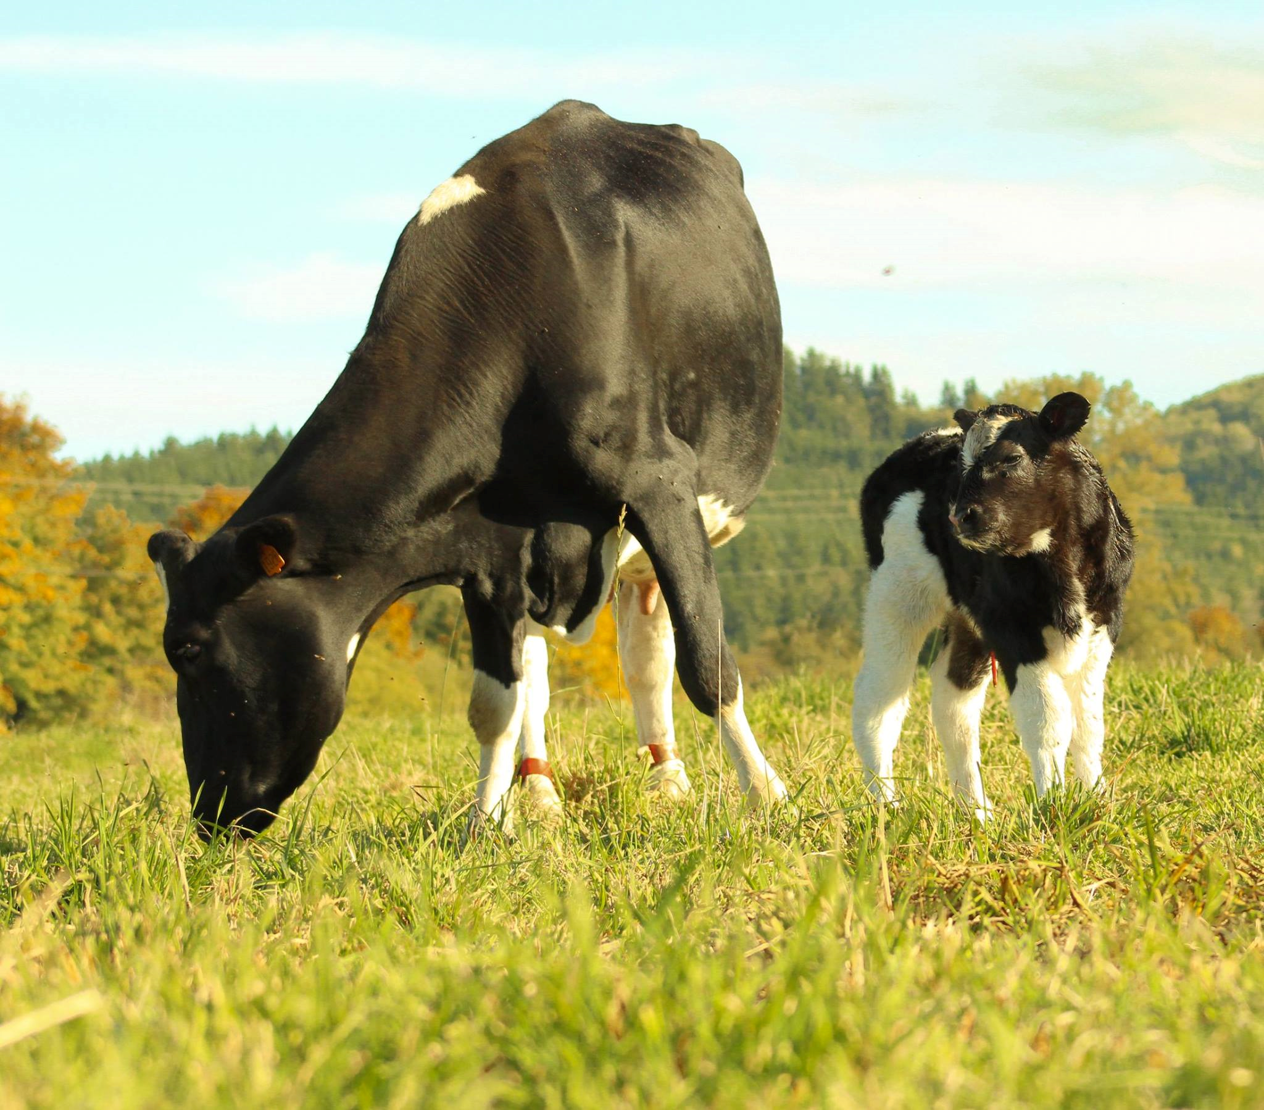



#### Pacific Conservation District

For More Information Contact: Mike Nordin, 360-208-4451, plutroll@willapabay.org

**Mission of the Pacific Conservation District**

* *The Pacific Conservation District promotes sound; volunteer conservation programs and provides technical assistance to foster a healthy relationship between people and the environment through non-regulatory, voluntary, and incentive-based programs.*

**Natural Resource Priorities**

* Watershed health
* Reduction in TMDL listings within the WRIA’s # 24 and 25
* Increase Salmonid habitat throughout Pacific Conservation District
* Cropland/unimproved land, tidelands and forest health
* Improve forest health for Pacific Conservation District’s non-industrial private forest landowners (NIPF)
* *Minimize pesticide contaminant of surface water from applications*
* *Assist in upgrading shellfish grounds*
* *Improve cropland/unimproved land/small AG operations farms*
* *Energy efficiency and conservation; Stormwater*
* *Reduce usage of non-renewable energy*
* *Educate about Low Impact Development and implement Low Impact Development*

**Information – Education & District Operations Priorities, Measures of Success, and Goals:**

*Education (continued goals):*

* *Goal 1 – Have an established education program for K-12 through adult. Envirothon*
* *Goal 2 – A video that shows the relationship between conservation and natural resources*
* *Goal 3 – Create an education program that connects with state STEM requirements*
* *Goal 4 – Connect schools with Envirothon opportunities and natural resource career paths*
* *Goal 5 – Put together a scholarship fund for local kids to raise the profile of conservation and natural resources*
* *Goal 6 – Education and outreach program for the district*

#### FY2011 (FY2020 (7/1/20 – 6/30/21) Annual Work Plan

#### Pacific Conservation District



Natural Resource Priority Program Area: Watershed Health

Goal(s): Reduction in TMDL listings within the WRIA’s # 24 and 25

Increase Salmonid habitat throughout Pacific Conservation District

Natural Resource Measurable Result Objective: No new TMDL listings & Improve riparian habitat

Programmatic Measurable Result Objective: provide TA to a minimum of 10 cranberry, 10 non-dairy livestock producers, & 19 Salmonid Projects

Funding Source(s): Conservation Commission Grant Programs, CREP funds, RCO, WDFW, Pacific County

|  |  |  |  |  |  |
| --- | --- | --- | --- | --- | --- |
| **Activities for FY2020** | Target Dates | **Person**  **Responsible** | **Time(Days) Required** | **Estimated Funding** | **Notes** |
| riparian forest buffer Plantings by 10 acres | End of FY 20’ | D. Houk/J. Getchman | 200 | See Budget |  |
| T/A for 5 NMP’s and/or ISP’s or farm plans | End of FY 20’ | C. Hagain/ M. Martin-Aust | 418 | See Budget |  |
| Expand water quality testing program | End of FY 20’ | M. Nordin | 40 | See Budget |  |
| correct 2 salmonid barriers | End of FY 20’ | D. Marcell/T. Kollasch | 775 | See Budget |  |
| 2-5 CREP contracted to go on the ground or renewed | End of FY 20’ | C. Hagain | 600 | See Budget |  |
| 3 LWD project designed & permitted | End of FY 20’ | D. Marcell/T. Kollasch | 960 | See Budget |  |
| Complete Phase 2 of the North Cove Dynamic Revetment Project | End of FY 20’ | M. Nordin | 400 | See Budget |  |
| Continue to coordinate the PC VSP Program | On Going | M Martin-Aust | 1420 |  |  |
| Continue to coordinate the Pacific County Marine Resources Comm. | On Going | C. Hagain | 436 | See Budget |  |
| Continue to coordinate the Willapa Lead Entity Program | On Going | T. Kollasch | 700 | See Budget |  |
| Complete 2 Salmonid Assessment projects | End of FY 20’ | T. Kollasch/D. Marcell | 240 | See Budget |  |
| Complete/implement 12 Fish Screen replacements for irrigation sites | End of FY 19’ | D. Marcell/M. Martin-Aust | 70 | See Budget |  |

Natural Resource Priority Program Area: Cropland/unimproved land, tidelands and forest health

Natural Resource Goal(s):

Improve forest health for Pacific Conservation District’s non-industrial private forest landowners (NIPF)

Minimize pesticide contaminant of surface water from applications

Assist in upgrading shellfish grounds

Improve cropland/unimproved land/small AG operations farms

Natural Resource Measurable Result Objective: Improved Water quality for agricultural & Forestry production

Programmatic Measurable Result Objective: provide technical assistance for 10 non-industrial private forest landowners (NIPF) & 2 agricultural operations

Funding Source(s): WSCC, RCPP, FFFPP, VSP, WSDA, Pacific County

|  |  |  |  |  |  |
| --- | --- | --- | --- | --- | --- |
| **Activities for FY2020** | Target Dates | **Person**  **Responsible** | **Time(Days) Required** | **Estimated Funding** | **Notes** |
| technical assistance and/or financial assistance to 10 non-industrial private forest landowners (NIPF) | End of FY 20’ | D. Houk/ J. Getchman | 200 | See Budget |  |
| correct 1 salmonid barriers using funding from FFFPP | End of FY 20’ | B. Carman | 120 | See Budget |  |
| Establish a district Fuels Reduction Program in Pacific County | End of FY 20’ | M. Nordin | 40 | See Budget |  |
| covered ditches in cranberry bogs properly and actively maintained | On Going | C. Hagain | 80 | See Budget |  |
| T/A to cranberry producers to install 5 BMP | End of FY 20’ | C. Hagain | 80 | See Budget |  |
| Work with Shellfish Producers NPDS and Invasives Control Program | On Going | M. Nordin | 40 | See Budget |  |
| technical assistance to 2 small agricultural operations | End of FY 20’ | C. Hagain/M. Martin-Aust | 240 | See Budget |  |
| acquire a no-till drill and make it available for landowners | End of FY 20’ | All Staff | 40 | See Budget |  |
| Continue to work on goal and deliverables for the VSP program | On Going | M. Martin-Aust | 1420 | See Budget |  |

Natural Resource Priority Program Area: Energy efficiency and conservation; Stormwater

Goal(s):

Reduce usage of non-renewable energy

Educate about Low Impact Development and implement Low Impact Development

Natural Resource Measurable Result Objective:

Programmatic Measurable Result Objective:

Funding Source(s): Conservation Commission, ECY, NRCS

|  |  |  |  |  |  |
| --- | --- | --- | --- | --- | --- |
| Activities for FY2020 | Target Dates | Person  Responsible | Time(Days) Required | Estimated Funding | Notes |
| Partner with NRCS to provide energy audits to 2 AG producers | End of FY 20’ | C. Hagain | 180 | See Budget |  |
| begin to provided information about Low Impact Development to a wide network of stakeholders | End of FY 20’ | All Staff | 120 | See Budget |  |

#### FY2020 Annual Budget



#### Pacific Conservation District



PCD Continued next page



 



