Quick Guide
The Concept: ViZZ is a new way of visualizing and organizing information 3-dimensionally including relationships between pieces of data- making storage and retrieval an intuitive process. A unique aspect of ViZZ is that we use characteristics to search for information. ViZZ’ secure project hubs can contain all information about a project, no matter what program files are involved, allowing you to access and view all details in one place.
All of this creates a single source of truth, ensuring all players are updated and working from the same information. Architects, Engineers, Contractors and Owners can now collaborate inside or outside of a building model, improving efficiency and speed while also saving resources.
ViZZ uses the way we think to make organization so simple and powerful that there is no need for file naming or remembering where things were stored. Files can be located based on the type of information they contain, and their relationships with other information is easily visualized, leading to improved understanding and decision making.

This document will help you to understand the icons and functionality of ViZZ.

ViZZ HOMEPAGE
The ViZZ home page is your menu of areas to begin working. We refer to this as The Burst. Each icon represents a characteristic or category to find, store, access, or filter a wide variety of information.
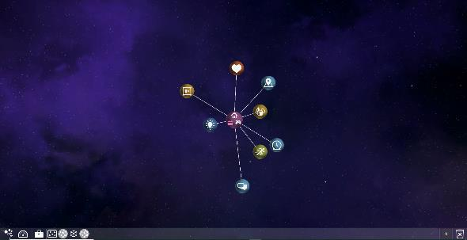
Ghost Bar- along the bottom The Burst- center of screen

Let’s review each area:
Living: People, Contacts or Anything Living
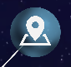 Places: Location information (Coming Soon)
Things: Any non-living things, like objects or building models
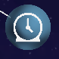 Time: Schedules or Calendars (Coming Soon)
Action: Tasks & Entire Projects
Communication: Emails & Notes
Knowledge: Files & Documents from almost any program
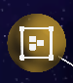 Groups: Companies, Project Teams or a Community
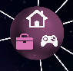 Environments: Work, Live (Home) & Play

USER SETTINGS
Ghost Bar
ViZZ Settings: Power Off, About ViZZ, Settings and Feedback
ViZZ Power Off
About ViZZ
Settings- Controls, User Details & Preferences
Feedback

Dashboards: There are a few different dashboards
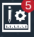 Projects: A list of your various projects and their status
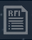 Requests For Information: Questions which need to be answered
Communications: A list of your notes and emails
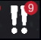 Outstanding: Items which have been assigned to you and need your attention

Trash is in the bottom right corner. Drag or double click to remove items from your screen. Nothing is “deleted” only removed from view.
Double click on the trash and your screen will be cleared taking you back to the home page displaying the burst.
THE BASICS
There are several basic functions which are repeated throughout ViZZ.
Mouse Clicks:
- Single Left Click – opens menu items and interacts with buttons
- Double Left Click – opens specific objects or spaces
- Single Right Click – Open options and menus for objects, sessions, etc.
Terminology:
Sessions – when you are viewing items within the transparent circle. For example, when you open multiple contacts and their relationships, that is a session.
Environments – you have options to view your information. Are you at work, home or at play?
You may start within the Environment you prefer OR as you are entering in details, choose the appropriate Environment from the current screen.
Common icons:
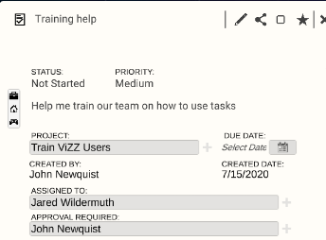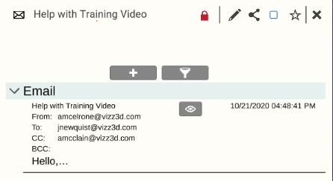
Lock- to control privacty settings
Edit- to make changes
Share- to control or change access to the information
Read/Unread- blue = read
Make Favorite- or
Alert- To receive notification of changes to the item

To Add a new piece of information, Right click on the icon, click on the “+” and fill in the form.

Relationships: To establish or view relationships, right click on an item and choose Create Relationship which will create a line to attach to another item. When finished, right click on original object to Finish Selecting Objects.
To view all relationships within a session, right click on the hand.

Filtering Information: There are several ways to find and filter information. Easiest is to Right Click on a characteristic and choose the funnel to filter the data in that area.

Importing Contacts/Enabling Email
Go to the bottom left corner and select the ViZZ Settings button.
Then choose the second icon down, the “Settings” button. Choose the User Account button. Select the plus sign next to Linked Accounts and you will be directed to MS Outlook login page. Once you log in, you’ll return to ViZZ. Select the radio button beside the email you choose to sync. Select the “Business Card” icon on the left to complete the email sync process.
Currently only Outlook contacts can be loaded into ViZZ. Other email providers will be added soon.
Building Models
Currently, ViZZ will create the model file and transfer to you for uploading. Self-service model uploading is Coming Soon.
Model Menu: Appears on the right within a model. See definitions and location in model.
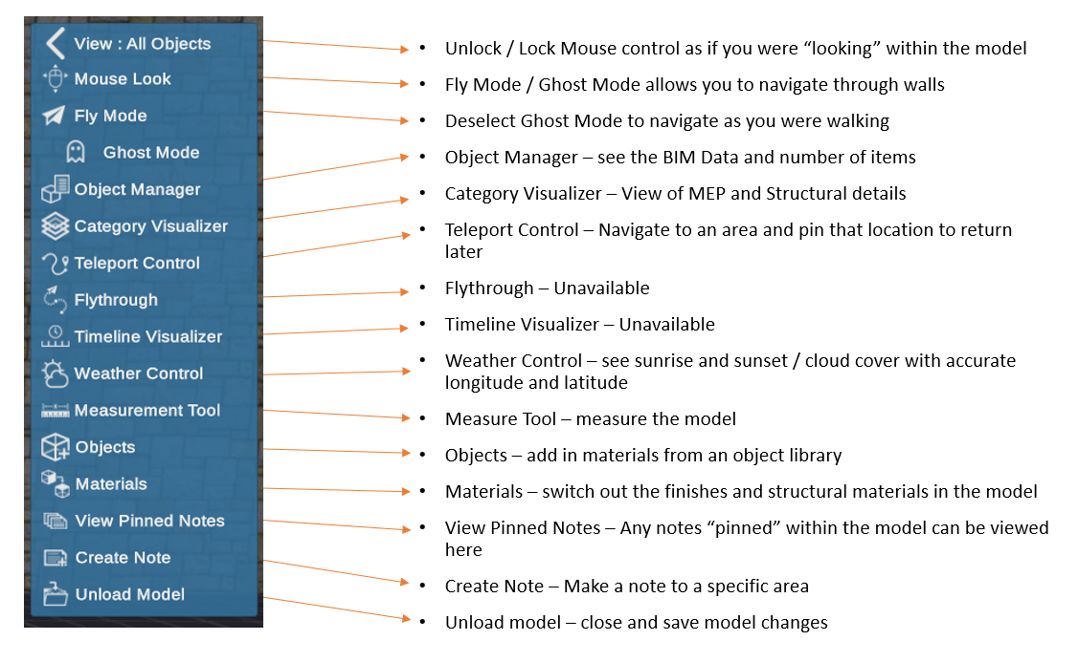

Model Navigation:
A = moves left
S = moves back
D = moves right
W = moves forward
E = moves up
Q = moves down
View control or Camera control may be used by selecting “Lock Mouse” to unlock or lock the mouse camera view. Another way is to choose F2 to lock or unlock the mouse.
You can also move using your keyboard arrow keys to look up, down, left or right.
Navigate using the keys AND the mouse for smooth fly through capabilities.

We have a training page on our website which includes a variety of specific training videos and a more detailed User Guide.
You can find it here: http://www.vizz3d.com/training.

For any questions or to secure more training, please contact your Account Partner at ViZZ or email: Admin@ViZZ3d.com.

If you have feedback, questions or issues with ViZZ, please report them to: Admin@ViZZ3d.com or detail them on the feedback button under ViZZ Menu in lower left corner.

