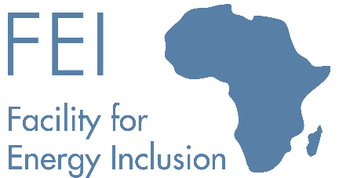 | 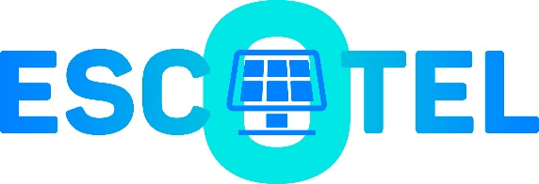
The Facility for Energy Inclusion (“FEI”) signs a transaction to act as sole lender for a USD22.5 million senior debt facility to finance ESCOTEL Mauritius’s subsidiaries in Sierra Leone and Liberia

On December 8th, 2021, the Facility for Energy Inclusion (“FEI”) signed a transaction to act as the sole lender for a USD 22.5 million senior debt facility for ESCOTEL Mauritius’s subsidiaries in Sierra Leone and Liberia.
ESCOTEL Mauritius (“ESCOTEL”) is an Energy Services Company (“ESCO”) set up in December 2020 by (i) Inspired Evolution via its Evolution II Fund, (ii) Norfund and (iii) Sagemcom Energy and Telecom SAS. ESCOTEL provides energy services to mobile tower owners and operators, owning and operating decentralised renewable energy infrastructure across Africa and thereby replacing polluting diesel generators. The telecom clients benefit from outsourcing a substantial part of their infrastructure while improving their service uptime and reducing their carbon footprint.
ESCOTEL currently supplies, installs, operates and maintains decentralised solar and storage hybrid power systems provided by Sagemcom, for a portfolio of around 800 telecom sites in Sierra Leone and Liberia, owned by subsidiaries of France-based telecommunications company, Orange S.A. The transaction structured by FEI follows an innovative telecom ESCO financing which allows ESCOTEL to finance its individual African operating companies directly without a parent company guarantee.
FEI is designed to support small-scale Independent Power Producers (“IPPs”) delivering power to the grid, mini-grids, C&I and captive power projects. The Fund is managed by Lion’s Head Asset Management. FEI was set up by the African Development Bank as part of its New Deal for Africa initiative. In addition to the investment by the AfDB, FEI received equity funding from KfW and Norfund and a loan commitment from the Austrian Development Bank. The AfDB also invested on behalf of the Clean Technology Fund and the European Commission.
“This transaction continues to demonstrate the innovative approach of the FEI team and its expertise in structuring transactions for the ESCO sector in Africa. This loan will allow ESCOTEL to provide clean energy to telecom towers located in some of the most remote areas in Sierra Leone and Liberia”, said Orli Arav, Managing Director of FEI.
“Securing this financing within 12 months of establishing Escotel is testament to the team and its partners’ ability to execute the business plan. We thank FEI for their support and commitment to the ESCO model, which we believe has a bright future in Africa. Besides funding our Liberian and Sierra Leonese operations, this financing frees up capital to grow our business in other countries” said Michel Hubert, CEO of ESCOTEL.

