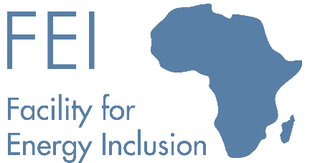 | 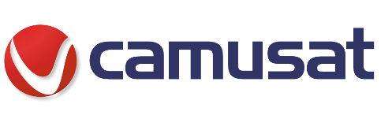
The Facility for Energy Inclusion (FEI) signs its First Transaction and acts as arranger for a EUR60 million multi country facility for AktivCo SAS

On August 13, 2021, the Facility for Energy Inclusion (FEI) signed its first transaction. In this inaugural transaction, FEI acted as lead arranger for a EUR 60m multi-country facility for AktivCo SAS’ subsidiaries in Chad, Niger, Cameroon, Ivory Coast, and Burkina Faso. FEI will provide EUR27m of the total amount and is being joined by Proparco (EUR16m), Norfund (EUR9m) and AfricaGoGreen (AGG, EUR 8m).
AktivCo SAS is an Energy Services Company (ESCO) and fully owned subsidiary of Camusat Group, a global player for the roll-out of telecom networks. AktivCo provides energy solutions to telecom network operators in Africa, including the construction of renewable energy power plants for telecom towers, replacing polluting diesel generators. The telecom clients benefit from outsourcing a substantial part of their infrastructure while improving their service uptime and reducing their carbon footprint. Aktivco is a leading African ESCO with 3,000 sites in its portfolio and aims to operate 10,000 sites by 2025.
The transaction structured by FEI is innovative, and one of the first multi-country telecom ESCO financings in Africa which allows AktivCo to finance its individual African operating companies directly without a parent company guarantee. The AktivCo financing was made possible through the support of FEI as lead arranger, Proparco, the private sector subsidiary of the French development agency Agence Française de Développement (AFD), Norfund, the Norwegian Investment Fund for developing countries as well as AfricaGoGreen, a new fund focused on energy efficiency and launched by KFW with funding from the German Ministry for Economic Cooperation and Development.
FEI is designed to support small-scale Independent Power Producers (IPPs) delivering power to the grid, mini-grids, C&I and captive power projects. The Fund is managed by Lion’s Head Asset Management.
FEI was set up by the African Development Bank as part of its New Deal for Africa initiative. In addition to the investment by the AFDB, FEI received equity funding from KFW and Norfund and a loan commitment from the Austrian Development Bank. The AFDB also invested on behalf of the Clean Technology Fund and the European Commission.
“This transaction demonstrates the innovative and client-oriented ethos of FEI. The FEI team Led by Orli Arav, offered AktivCo a solution which was not readily available in the market. This multi-country loan will allow AktivCo to achieve its growth target and provide clean energy to telecom towers located in some of the most remote areas in West Africa”, said Clemens Calice, Co-CEO of LHGP Asset Management, FEI’s Fund Manager.
“ We are very happy to set up this multi-country Facility, which reflects the level of maturity reached by our ESCO activities and will be a stepping stone in the development of Aktivco. It reinforces our ability to meet the Telecom Operators’ demand for green and efficient energy to secure their networks. I would like to personally congratulate our Lenders’ and LHGP Asset management teams, as well as Camusat Group’s financial team for their hard work in making this innovative agreement possible”, said Richard Thomas, CEO of Camusat Group.

