AKUANA Regulator Order Form
Order No.： ________________ Dealer： _______________
Contacts： _______________ Phone： _______________
Email： _______________ Order Date： _________/_____/ _____
Memo： ______________________________________
Please Mark with color “□” at specific position “□”

- Second stage
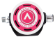Pink0201 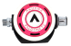Pink0203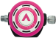Pink0204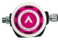Pink0205
Red0101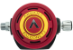Red0102 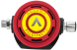Red0104
Blue0401 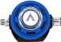Blue0402 Blue0403 Blue0405
Orange501Orange0502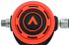Orange0503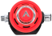Orange0504
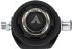□Black0601 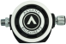□Black0603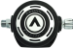□Black0605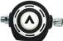□Black0609
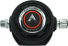□Black0701 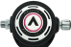□Black0702
□Yellow0801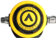□Yellow0802□Yellow0803□Yellow0805
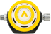□Yellow1302
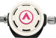□White0301White0303□White0305□White0306
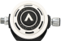□White0606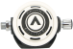□White0607
□Green1101□Green1102□Green1103
Marvel0902Marvel0903Marvel0904Marvel0905

