2nd Annual CASINO NIGHT FUNDRAISER

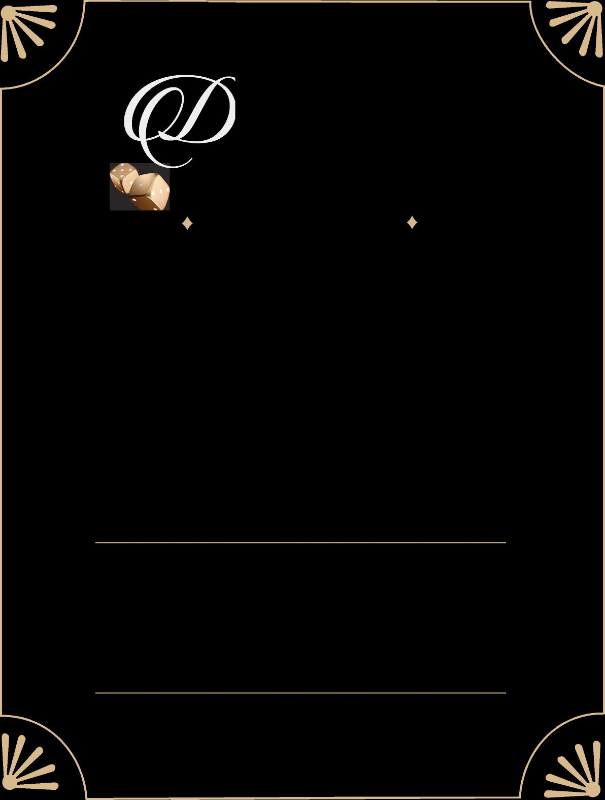

The Therapeutic Riding Center of Huntington Beach presents:

**iamonds**

*&*

**DICE**

Join us for a night of live music by The Emperors, drinks, silent auction, hors d’oeuvres and casino games!

SATURDAY, October 3, 2020

5:00 – 10:00 PM

Senior Center in Central Park  
18041 Goldenwest St,  
Huntington Beach, CA 92648

**$75 per ticket**

**Includes $200 Playing Chips and 1 Drink Ticket**

**Sponsorship**

**Table of 8 – $500**

Includes 2 bottles of wine at table

Ages 21+

**Game Table – $350**

Includes entrance for 2 guests and name of the sponsor on the table

To purchase tickets please visit: [**www.trchb.org**](http://www.trchb.org)

501(c)3 # 33-0519376

[www.trchb.org](http://www.trchb.org) | 714.313.0922 | [info@trchb.org](mailto:info@trchb.org) P.O. Box 2298, Huntington Beach, CA 92647