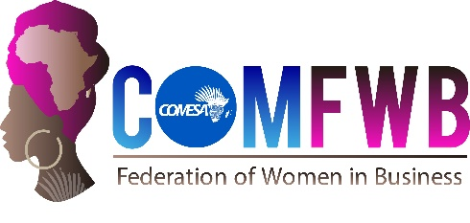

COMESA FEDERATION OF NATIONAL ASSOCIATIONS OF
WOMEN IN BUSINESS
COMFWB

MALAWI Chapter Report
QUARTER 1, 2021
January – March

Developing African Women Entrepreneurship for Trade and Economic Integration
prepared by COMFWB – Secretariat, Lilongwe, Malawi
- Name of Chapter:
- Name of Chapter Chairperson:
- Name of Liaison Officer:
- Date of submission:
- Reporting Period:
- Reports from the chapters align with the strategic priorities below:
GOAL 1: To Strengthen the Institutional Capacity of COMFWB
To Strengthen the HR capacity of COMFWB
Provide a detailed description of the major activities undertaken such as recruitment of digital communication and resource mobilization officers; Conduct TNA of the Secretariat and National Chapters; Identify training service providers; Organize training programs and evaluation of the training programs

GOAL 2: To Strengthen the Resource Mobilization Capacity of COMFWB
To increase fund raised from partners
Provide a detailed description of the major activities undertaken such as prepare proposals and submit to partners and monitor the status of the submitted proposals.

To increase fund raised from members contribution
Provide a detailed description of the major activities undertaken such as activities aimed at promoting promote membership at national level and provide update on payment of subscription fees.

GOAL 3: To Strengthen Development Programs for Women in Business
To enhance the support in Trade and investment facilitation
Provide a detailed description of the major activities undertaken such as activities as conduct needs assessment of the National Chapter on Trade and investment facilitation; support establish cooperatives and organize trade fairs.

To enhance access to credit and capital
Provide a detailed description of the major activities undertaken such as establish strategic alliances with existing women's financial institutions including micro finance; conduct needs assessment on access to credit and capital; establish SACCO; establish credit guarantee scheme and access services of exiting credit guarantee schemes and establishment of women's banks building on the WISE mode.

To strengthen business development services
Provide a detailed description of the major activities undertaken such as conduct needs assessment on business development services, Business Plans, Strategic Plans, etc.
GOAL 4: To Enhance the Advocacy, Public Image and Branding of COMFWB
Strengthen the advocacy capacity of COMFWB

- COMFWB Funds Summary
  - Inflows
  - Cash outflows
  - Other
- Challenges/Ideas:
- Recommendations/ Solutions
- Conclusion
- Annexes

