In the beginning of the lockdown period, Padup initiated BootUp Lockathon to help idea stage start-ups. The world was & still is facing an unprecedent crisis, and in such times, Entrepreneurs are one of the most deeply impacted as they are low on resources and the general environment is bad for business since the world continues to be in LOCKDOWN.

In keeping with Padup’s mission of nation building, Padup found an innovative way of making start-ups and entrepreneurs utilise their time on hand by engaging them through an interactive online mentoring & educational Bootcamp, called the BootUp Lockathon. Padup has completed the first iteration of the BootUp Lockathon with sterling success rate as 40% participants got funded.

* 200 start-ups applied
* 20 selected for BootUp Lockathon
* 8 have received investor nod

## Introducing BootUp Lockathon 2.0

The world economy is under great stress because of the pandemic and various countries are still at different stages of recovery. Governments and business houses are limping back to normalcy but with great caution. The start-up community is also showing signs of resilience, and is using this time to rethink, reshape, and restart.

Padup is now starting BootUp Lockathon 2.0.

Under BootUp Lockathon 2.0, we invite start-ups at PoC stage and looking for funding upto INR 1 Crore. The focus this time will be “Mentoring to Accelerate”.

## About Padup Ventures

Padup Ventures is a knowledge ﬁrm that helps entrepreneurs with a structured process to

build disruptive & innovative start-ups.

Entrepreneurship education has traditionally limited itself to ‘story telling’! Padup has developed a customised methodology to help acquire entrepreneurship skills at all levels which is beyond ‘story telling’. The key elements such as user centric approach, lean Start-up philosophy, learning while doing, models to build innovative solution to real, emerging and futuristic problems, are at the core of teaching entrepreneurship. The process is simple but comprehensive, practical and proven, and has well-defined outcomes.

Padup programs have been widely accepted and acclaimed as we have conducted several such bootcamps in the country in recent past and they have been very successful in creating investible startup. In the current situation, we have specially created a new version that is completely online to help Start-ups and Entrepreneurs unable to travel in these diﬃcult times.

**Through BootUp Lockathon 2.0, PadUp will methodically address the two main challenges: solve a real problem that potential customers are willing and able to pay for, and accelerate through customer acceptance of their product or services for building sustainable & investible venture.**

Padup has designed BootUp Lockathon 2.0 to help and push founders to think or rethink their startup, answer vital questions and get a grip on what their focus should be. Post attending this program, all participating entrepreneurs will be able to take their innovation into a sustainable and scalable business.

The participants will practice applying the learning in real time through interactive assignments, and receive live coaching sessions with Padup mentors. As we work to develop new ventures from start to ﬁnish, the course will culminate into a comprehensive pitch-ready business plan. This is an intensive program for highly motivated individuals and teams who want to put their idea to the test and answer this question: **What is the real market potential of the product or services offered? Is it worth it? If so, how can we win?**

**BootUp Lockathon 2.0 combines Entrepreneurial Education, long term Mentoring and assured Funding in a structured & proven process.**

**As they say, whatever you do, do it for 999 days as success may strike on the 999th day!**

The journey with Padup doesn’t end at BootUp Lockathon 2.0 as Padup is extending 24-month mentoring to the qualifying startups. Padup Mentors will handhold the startups to take them through various stages of the “Start-up Lifecycle” by helping them with

* education masterclasses-cum-workshops to build customised business plan
* personalised mentoring by 'been there done it' mentors
* business & ecosystem development
* network access to build personal network
* legal and financial advice
* introduction to investors at various stages of investment

The BootUp Lockathon 2.0 helps a start-up at PoC stage to validate its potential through customer interaction by demonstrating a well-quantified value proposition, acceptable

pricing and innovative business model.

## Expectations from BootUp Lockathon

Mentoring: Be part of the 10% of start-ups that survive their ﬁrst 3 years through a structured Mentoring process that would help build Innovative product plus Biz Model & bounce back during setbacks, thus improving a start-up’s chances of survival.

Build Business: At BootUp Lockathon 2.0, we provide a framework for starting where entrepreneurs can

build customer-centric products and services through a framework that guides them to work with stakeholders to build new products or discover new markets.

Funding is Assured: At BootUp Lockathon 2.0, Mentors handhold the startups through their Idea or Early stage journey to present them as investible venture to pick up their ﬁrst cheque from the BootUp Lockathon Investment Committee.

Challenge yourself! We help identify and deﬁne problems that lead to solutions. It is easy to say “I believe in the idea,” but reality is that it is not all about the idea. It is about the process to build a sustainable and scalable business based on the idea.

Team-based approach! Building a startup is team play. The team identifies and deﬁnes problems to solve, where the idea becomes the focal point for the team.

Presentations! It is storytelling time! All the hard work to collect solid evidence on viability of the business is established. Solutions are presented working closely in teams, leveraging each person’s unique skills, delivered by the Team Leader. Teams receive speciﬁc and actionable feedback.

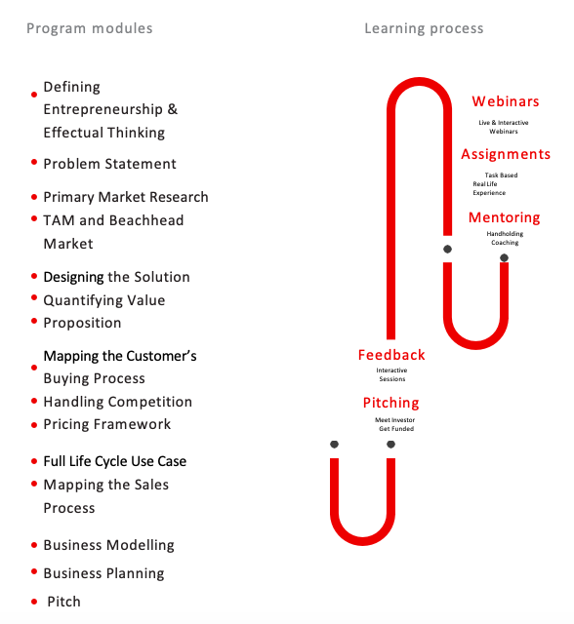

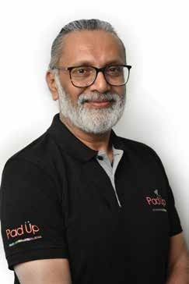Pankaj Thakar, Founder & Chief Mentor is a serial entrepreneur with 35 years of corporate and start-up experience. In his various C-level role and founder of multiple global start-ups, he has built, advised and transformed, both corporate and start-up companies to become highly successful. He has worked with many reputed companies like HCL Limited, India Telecom Ltd, Atlas Telecom Ltd, Value First Media Ltd. etc.

He has attended Harvard Business School & MIT’s Executive Education programs in Entrepreneurship, Digital Media, Digital Marketing, Big Data Analysis, Blockchain, IoT, AI and Cybersecurity.

Rajat Jain A Postgraduate from IIM, Ahmedabad and B Tech from IIT, Delhi, is a Founder Director of PadUp Ventures, a Tech Start- ups Incubator, focusing on providing deep mentoring and incubation services to early stage tech companies as well as other incubators in India and helping them grow successfully to the next level and to Series A funding.

Rajat is a Non-Executive Director on the Boards of TIM Delhi Airport Advertising (TIMDAA), a JV between TIM and the GMR group, Securenow TechServices Pvt Ltd, a PE funded InsureTech company and Kaleidoscope Events Pvt Ltd, a pureplay marketing recently, he was on the Board of Xerox India and was also its Managing Director.

Divyendu Kumar has had more than three decades of experience in the Indian and international business world. He was the Managing Director of a multi-billion Dollar, 3500 employee-strong automotive retailing business with a multi-country footprint in the Middle East. Prior to that, for over two decades, he was closely associated with the Tata Group of India, and was the Head, International Business for Passenger Cars at Tata Motors for a number of years before relocating to the Middle East.

A B.Tech. from Indian Institute of Technology (IIT-ISM), Dhanbad and a post graduate PGDM from Indian Institute of Management (IIM, Kolkata), he has also held leadership positions in companies in the commodities, real estate and telecom industry related services markets. He has become actively involved in the business start-up scene, having contributed, among other things, to the formation of an incubation and accelerator space, called the ASPIRE, at Kent Business School in the United Kingdom.

Saumyajit Guha holds an MBA in Entrepreneurship & Innovation from Exeter University and has over 18+ years of experience with recognized proﬁciency in: Startup Ecosystem Development, Invest- ment management, Angel Investing, Startup Acceleration & Incuba- tion, Incubator Management, Research & Analysis, Team Manage-ment, Process Migration, Operations, Business Analysis.

He is currently working for PadUp ventures as Vice President. Before that he was a faculty at IMT Ghaziabad in the area of Strategy Innovation and Entrepreneurship and was responsible for the Incubator and E Cell of IMT Ghaziabad.

Vikas Goel has more than 3 decades of experience in variety of roles across multiple domains. Vikas is a science graduate, and have added certiﬁcation from IIMA on Business Leadership and General Management.

Starting his own venture by name of Comm-sys Information system P Ltd, he was at the helm of aﬀairs managing business development, product management & ﬁnances for 16 years. During these 16 years CISPL grew to about 40 Cr revenues and a team size of 200.

In 2019, he joined E&Y as an external/independent consultant and SME for “ Make in India “ program. In this role he is helping E&Y team to understand the relevance of technology proposed by applicants, market feasibility, and GTM strategy.

Vivek Chandel is an Electronics Engineer and an MBA from IIM Ahmedabad. Vivek has more than 25 years of experience in Tech- nology (Telecom, IT and Power) sector. He has been involved in building brands, transforming operations and turnaround opera- tions at early stage organisations as well as mature set-ups. Start- ing his career with Bharat Heavy Electricals Limited (BHEL), Vivek Moved over to Telecom in 1995. After his corporate stints as Gen- eral Manager Marketing at Escotel Mobile Communications (Now Idea-Vodafone), Vice President – Transformation Projects in Airtel, Chief Operating Oﬃcer at Tata Teleservices and Executive Director

- Marketing at Xerox India, Vivek is now pursuing his passion of creating impact though Education and Innovations

Padup Mentors



## Consociates



Syndicate



+91 124 4235450

[info@padup.in](mailto:info@padup.in)

v e n t u r e s c all rights reserved PadUp Pvt Ltd. 2020

Padup Ventures Private Limited,

609, Star Towers, Sector 30, Gurugram, Haryana-122001 India

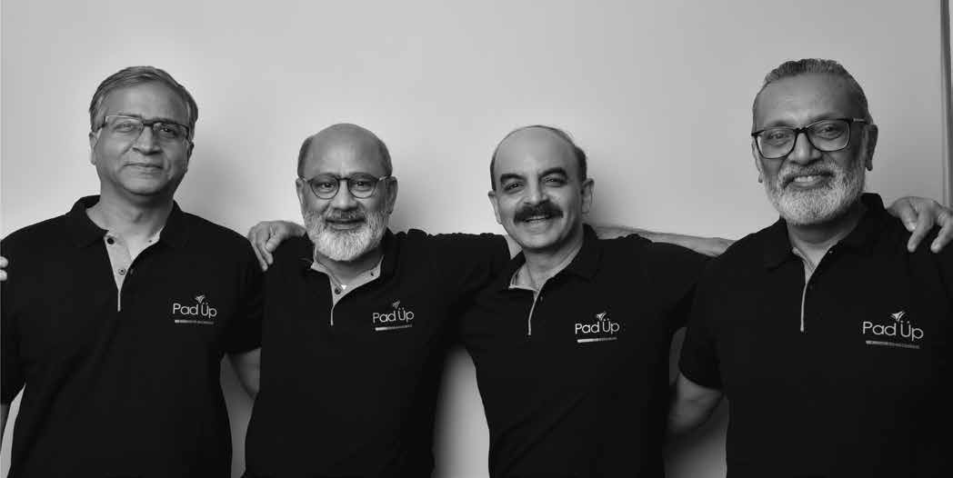

Become a part of the PadUp family!

Join the BootUp Lockathon