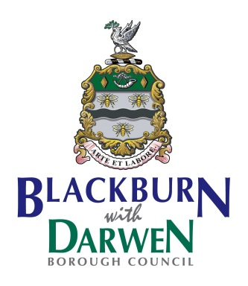

Blackburn with Darwen Borough Council

Home to School Transport Services

Coronavirus (Covid-19) Emergency

Guidance for Home to School Transport from

Updated March 2021

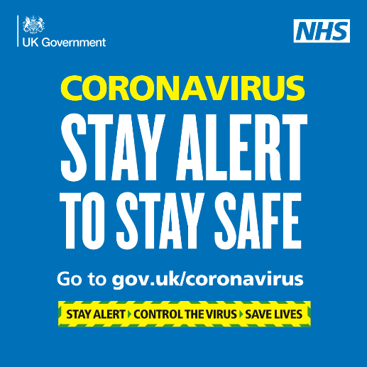

**Introduction**

As the Coronavirus (Covid-19) emergency continues, Blackburn with Darwen Borough Council is working to re-activate all its home to school transport for entitled pupils from March 2021.

Government has decided that all schools will re-open in March 2021 and all pupils will return to school. They have issued advice (e.g. Department for Education Transport to School and other places of education) about how this will be achieved, and the Council is following this guidance for the school transport network.

To keep everyone as safe as possible, we will rely on stakeholders’ full cooperation in following this guidance – this includes operators, staff, parents, pupils and schools. Only by all of us working together will we keep everyone safe as they can be. This offer of Covid-19 safe school transport is made by the local authority to parents/pupils, but if parents/pupils do not wish to accept the offer, they can make their own alternative arrangements for transport to and from school.

All sections of the guidance below are relevant to all stakeholders and should be read by everyone – the different sections are intended to better group the guidance and provide a focus for different stakeholders, and are as per:

* Government Safer Travel – Key Points
* General Covid-19 Guidance - Prevention
* Operators
* Parents/Pupils
* Schools
* SEND Transport
* Local Bus Services (Public Buses)
* Summary

The guidance sets out how provided school transport in Blackburn with Darwen is to resume and these plans will be updated as the Coronavirus (Covid-19) emergency develops and changes (locally and nationally), and as Government advice is updated or altered.

This guidance should be followed by all Council passenger transport contractors/operators, schools and parents/pupils.

**Government Safer Travel – Key Points**

For information, a quick reference to key Government travel guidance is shown below and these points are amplified further into this guidance document:

* Pupils should not travel if feeling unwell or if they have any Covid-19 symptoms
* Face coverings – must be worn
* Providing the most on-bus ventilation possible, consistent with a comfortable journey
* Enhanced bus/taxi cleaning regimes, particularly for regular touch points
* Keeping any physical contact to the minimum
* Cashless system operated
* Avoid touching your face where practical
* Covering mouth and nose with a tissue or the inside of the elbow when coughing or sneezing
* Travelling side by side or behind other people, rather than facing them, where seating arrangements allow
* Touching as few surfaces as possible
* Minimising the time spent close to other people, where possible
* Avoiding loud talking, shouting or singing
* Facing away from others
* Wash hands for at least 20 seconds or sanitise hands before and after the end of your journey
* Self Isolation

**General Covid-19 Guidance - Prevention**

*Principles*

1. Safety of staff, pupils and the public will be paramount.
2. Government Covid-19 advice for passengers is at this link:

<https://www.gov.uk/government/collections/coronavirus-covid-19-list-of-guidance#transport>

[Transport to school and other places of education: 2020 to 2021 academic year - GOV.UK (www.gov.uk)](https://www.gov.uk/government/publications/transport-to-school-and-other-places-of-education-autumn-term-2020/transport-to-school-and-other-places-of-education-autumn-term-2020)

1. And Government advice for operators is at this link:

<https://www.gov.uk/government/publications/coronavirus-covid-19-safer-transport-guidance-for-operators/coronavirus-covid-19-safer-transport-guidance-for-operators>

[Coronavirus (COVID-19): safer transport guidance for operators - GOV.UK (www.gov.uk)](https://www.gov.uk/government/publications/coronavirus-covid-19-safer-transport-guidance-for-operators/coronavirus-covid-19-safer-transport-guidance-for-operators)

*Illness/Shielding*

1. Drivers, Passenger Assistants and pupils should not travel on transport if they are feeling unwell, particularly if they have symptoms of coronavirus (COVID-19) which include a new, continuous cough, high temperature, or loss of taste or smell, or if they live in a household with someone showing any of these symptoms – they should self-isolate and stay at home.
2. Any pupils becoming ill at school should be taken home by their parents (NB parents should have transport contingency arrangements in place to do this).
3. Guidance on shielding and people/pupils who are high risk (clinically extremely vulnerable) can be found at the Government web link below:
4. Peoples Risk Assessments have been carried out for BWD staff whose characteristics fall within clinically extremely vulnerable.

<https://www.gov.uk/government/publications/guidance-on-shielding-and-protecting-extremely-vulnerable-persons-from-covid-19/guidance-on-shielding-and-protecting-extremely-vulnerable-persons-from-covid-19>

*NHS Test and Trace*

1. Drivers and passenger assistants should book a Covid-19 test if they display symptoms (as described above) and families should do likewise if their children display symptoms.
2. They should also provide details of anyone they have been in close contact with if they were to test positive for coronavirus (COVID-19) or if asked by NHS Test & Trace.
3. A person should [self-isolate](https://www.gov.uk/government/publications/covid-19-stay-at-home-guidance/stay-at-home-guidance-for-households-with-possible-coronavirus-covid-19-infection) if they have been in close contact with someone who develops Covid-19 symptoms or someone who tests positive for Covid-19.

<https://www.gov.uk/government/publications/covid-19-stay-at-home-guidance/stay-at-home-guidance-for-households-with-possible-coronavirus-covid-19-infection>

*Contact and Self - Isolation*

1. If pupils have any symptoms of Coronavirus Covid-19 they should self-isolate at home and [arrange to have a test to see if they have coronavirus](https://www.nhs.uk/conditions/coronavirus-covid-19/testing-for-coronavirus/).  If anyone in their household or [support bubble](https://www.gov.uk/guidance/meeting-people-from-outside-your-household#making-a-support-bubble-with-another-household) has symptoms of Coronavirus Covid-19 they should self-isolate.
2. **Drivers and Passenger Assistants** who have been in **‘contact’** with someone who has developed symptoms whilst at school or on home to school transport do not need to go home to self-isolate unless:

* they develop symptoms themselves (in which case, they should arrange a test), or
* **the symptomatic person subsequently tests positive**, or
* if they have been requested to do so by NHS Test and Trace.

*Contact*

Contact is someone testing positive for COVID-19, the definition of a close ‘Contact’ is considered as:

* being coughed on,or
* having a face to face conversation within 1 metre, or
* having unprotected skin to skin physical contact, or
* travelling in a small vehicle with the case, or
* any contact within 1 metre for 1 minute or longer without face-to-face contact
* extended close contact (between 1 and 2 metres for more than 15 minutes) with a case

**N.B. This is irrespective of whether PPE was worn at the time of contact.**

Further information can be found in the Government link below:

<https://www.gov.uk/government/publications/guidance-for-contacts-of-people-with-possible-or-confirmed-coronavirus-covid-19-infection-who-do-not-live-with-the-person/guidance-for-contacts-of-people-with-possible-or-confirmed-coronavirus-covid-19-infection-who-do-not-live-with-the-person>

<https://www.gov.uk/government/publications/guidance-for-contacts-of-people-with-possible-or-confirmed-coronavirus-covid-19-infection-who-do-not-live-with-the-person/guidance-for-contacts-of-people-with-possible-or-confirmed-coronavirus-covid-19-infection-who-do-not-live-with-the-person#what-is-meant-by-a-contact>

*Loading Capacities*

1. Whilst provided school transport will operate to full loading capacities from March 2021, public transport (local bus services and trains) will remain at less than 50% capacity. The government is urging parents to arrange for pupils not entitled to free transport who normally use public buses to get to school to walk or cycle instead, if they can, or to use alternative means of getting to school. This will ease capacity pressures on public transport and avoid pupils travelling with the public.
2. On certain public transport services in Blackburn with Darwen Borough Council which are used by many pupils and where there is a high risk of buses not being able to carry all the pupils/passengers wanting to travel, at the request of Government the Council will be providing additional buses/coaches to supplement the main public service bus.
3. The Government information poster below highlights the importance of using a tissue to catch coughs and sneezes:

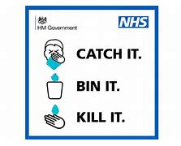

**Operators**

*March 2021*

1. All pupils will return to school and designated contracted school transport bus/taxi networks will return to ‘normal’ within these Covid-19 safety guidelines, from the beginning of March *2021 – all operators have been issued with school start dates.*

*Cleaning*

1. Coronavirus (COVID-19) is understood to be easy to kill on surfaces - normal cleaning products will do this. Operators should ensure that all touch points on school transport vehicles have been cleaned to protect against Coronavirus (Covid-19) prior to and after every new journey – this includes door handles, keys, handrails, armrests, seat backs, seatbelts, driver controls, etc.
2. On-board disposable cleaning fluids/cloths/disposal gloves and a suitable secure on-board bin for disposal of any cleaning items, tissues or PPE, for in-journey use, should be provided.

*Staff*

1. Staff employed by operators should avoid mixing with each other where possible and that operators should support individual workers use face coverings.

*Seating*

1. From March 2021 there will be no social distancing on designated contract (closed) school buses and taxis, which means that vehicles will operate at 100% capacity – it’s important to note that no members of the public travel on these buses and they are restricted to the same group of pupils each day.
2. The default seating arrangement on school buses will mean that each pupil uses the same seat each day and that they are grouped in their Year Groups (‘bubbles’), with the eldest pupils seated at the rear of the bus and progressively younger Year Groups sitting towards the front of the bus, as described in the ‘bubble’ seating examples below. Where it is possible, individual pupils and ‘bubbles’ should be as distanced as much as possible from each other, preferably by an empty row of seats or more. Once the seating arrangements are established, where possible they should be replicated daily.
3. Siblings from the same household can sit next to each other, even if they are in different ‘bubbles’.

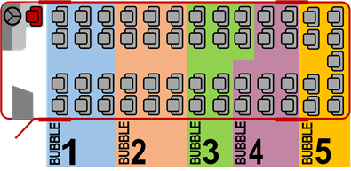

*NB Eldest pupils in Bubble 5, progressing in age reduction order to youngest in Bubble 1*

A ‘Seven-Bubble’ seating example is below.

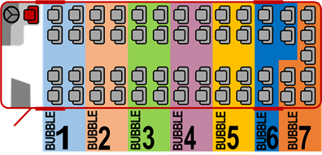

*NB Eldest pupils in Bubble 7, progressing in age reduction order to youngest in Bubble 1*

1. Drivers are expected to advise on safe travel and instruct pupils about safe seating arrangements, but they are not expected to police arrangements such as seating plans, queues or the wearing of face covering – their role is to focus on driving the vehicle safely.

*Ventilation*

1. Operators should provide good vehicle ventilation when carrying passengers (such as opening windows where practical) to help reduce the chance of potential airborne infection.

*Infection Control*

1. Drivers and Passenger Assistants may wish to use alcohol hand sanitiser at intervals throughout the journey and should always do so after performing tasks such as helping a child into the vehicle or handling a child’s belongings.
2. At the end of their shift, drivers and Passenger Assistants (PAs) should minimise possible contamination before entering their own home – key things to do include washing with soap and water, and isolating clothes and personal effects in a box prior to cleaning.
3. Where school ‘link’ or ‘feeder’ transport is provided, we may revise the arrangements and provide the transport directly to the end destination, to reduce contact and journey time.
4. When boarding takes place at school or at a hub, drivers may stand off the bus 2 metres away from boarding pupils/passengers; drivers should not congregate.
5. For Special Needs and Disability Transport (whether by taxior accessible bus) operators should take account of the ambulance trusts’ procedures for transporting someone without covid-19 symptoms where social distancing is not possible (i.e. particularly, please see ‘Table 4’ infection control) shown at:

<https://www.gov.uk/government/publications/covid-19-guidance-for-ambulance-trusts/covid-19-guidance-for-ambulance-trusts>

*Face Coverings*

1. Pupils over 11 years must wear face coverings whilst travelling, they should not be refused transport if they (occasionally) have no face coverings. Wearing face coverings may not always be possible, particularly for SEND pupils or if exemptions apply.  Where pupils who must wear face coverings do not, they should report any such instances to the school.
2. Drivers must wear face coverings/visors to protect themselves.

*Government Guidance*

1. Government (DfT) advice for operators should be adhered to and can be found at the following link:

<https://www.gov.uk/government/publications/coronavirus-covid-19-safer-transport-guidance-for-operators/coronavirus-covid-19-safer-transport-guidance-for-operators>

*Taxis*

1. On Taxis and Private Hire vehicles, drivers and pupils over 11 years must wear face coverings and use sanitising hand gel both on entry and disembarkation.  Whilst ideally we would like to restrict pupil numbers on taxis to two pupils in the rear seat, with the middle rear seat and front seat unoccupied, this may not be possible in many cases.  In reality the infrastructure to provide this is unavailable and/or it is logistically difficult.
2. Taxi operators should follow guidance issued by Blackburn with Darwen Borough Council’s Taxi Licensing Team.
3. Pupils/passengers should follow the advice of the driver. For example, you may be asked to sit in the back left-hand seat if travelling alone.

**Parents/Pupils**

All school designated school buses will be operating a cashless system to minimise risk to pupils travelling on designated school buses. Vouchers are available through the Blackburn with Darwen Council - APP. We are asking that parents fully support this scheme in order to minimise the risk to all travelling.

We also ask the face covering are worn as this is now Law.

We ask that the School Travel Guidance is adhered to at all times by pupils using designated school transport.

*Illness*

1. Pupils should not travel if unwell or if they have been told to isolate.
2. Parents may wish to routinely take the temperature of their children, and whilst a high temperature (e.g. above 37.2 degrees centigrade) is not a method for identifying Coronavirus (COVID-19), it could identify if a child is ill, in which case the child should not attend school whatever the cause of any illness. If in doubt, parents can contact their school for advice.
3. If any pupils become ill during the journey to the school, the school should be notified immediately – the school may then contact their parents to collect them from school.

<https://www.gov.uk/government/publications/covid-19-stay-at-home-guidance/stay-at-home-guidance-for-households-with-possible-coronavirus-covid-19-infection>

*Boarding*

1. Boarding buses should be done one at a time - disembarking buses should also be undertaken one at a time, from the most forward seats first, with pupils staying apart.

*Hand Sanitiser*

1. Pupils should sanitise their hands when boarding buses/taxis – if available, they can use operator provided hand gel and/or they can carry their own (i.e. 60%+ alcohol hand gel); parents may wish to advise pupils to sanitise their hands regularly during the journey as well.

*Seating*

1. See points 22 – 25 above.
2. In particular on boarding, pupils should go straight to their usual seat, and sit down.
3. Where pupils have difficulty fitting seat belts themselves, the driver should offer verbal guidance and support from a safe distance – seat belts should be pre-adjusted for pupil use.
4. Pupils travelling on coaches should stay seated for the whole journey, face forwards, not touch other pupils, not shout or sing and use a tissue to catch any coughs or sneezes.

*Infection Control*

1. On arrival at school, pupils must wash/sanitise their hands immediately for 20 seconds and dispose of disposable face coverings in a covered bin or place reusable face coverings in a plastic bag they can take home with them, and then wash their hands again before heading to their classroom*.*
2. We would encourage pupils to carry tissues with them on the bus/taxi, to use to cover their mouth/face if they sneeze, cough or wish to blow their nose – used tissues should be disposed of safely and not shared.



1. Where possible pupils should social distance on a school site or at a transport hub, where multiple vehicles may be present where loading and unloading is required, and school staff may supervise on-site unloading/loading.

As a general rule, not just when using transport, pupils and staff should maintain good hand hygiene, regularly washing hands with soap and water or alcohol hand sanitiser for 20 seconds. This is particularly important straight before and straight after journeys. As best as they can, everyone should also avoid direct hand contact with eyes, nose and mouth, and use tissues to catch coughs and sneezes (or at least to cough/sneeze into the crook of their elbow), disposing of tissues in a bin as soon as possible.

*Hygiene*

1. At all times, everyone should maintain good hand hygiene (e.g. washing hands with soap and water or alcohol hand sanitiser, particularly straight before and straight after journeys). Avoid direct hand contact with eyes, nose and mouth, and use tissues to catch coughs and sneezes (or at least to cough/sneeze into the crook of their elbow) disposing of tissues in a bin as soon as possible (i.e. ‘catch it, bin it, kill it’).
2. Coronavirus (COVID-19) is an easy virus to kill when it is on skin. This can be done with soap and running water or hand sanitiser prior to and after their journey to school.

*Risk*

1. Where pupils/passengers present an unacceptable safety risk to other pupils/staff, they may be refused transport (e.g. for reasons including displaying illness, deliberate spitting, coughing and sneezing at others, touching others, shouting, singing, not sitting in their ‘bubble’, standing, seat switching, ignoring verbal safety guidance).

*Parental Travel Budgets*

1. Whilst our new arrangements for providing home to school transport follow Government guidance, parents of pupils entitled to free school transport may decide to make alternative arrangements out of personal preference. Parental mileage allowances can be considered as an alternative transport offer, upon application for statutory entitled pupils. The Council will determine whether or not it can provide a mileage in each individual circumstance.

*Public Buses*

1. Where non-entitled pupils travel on public transport (Local Bus Services) also used by the public, loading capacities on public buses will still be less than 50% in September 2020, parents are being encouraged to find alternative ways of getting their children to school.
2. If you live in the same/community as the school, active travel (walking/cycling) should be the first choice. “If you can, please consider whether your child can walk or cycle to school.

Nearly 75% of primary and half of secondary school children in the UK live within 2Km of their school. The Council is introducing new walking and cycling routes to make these journeys safer” The second choice should be travel by car – only if none of these options are available to parents should pupils attempt to use public transport.

1. For pupils not entitled to free school transport, parents will make appropriate arrangements to get their children to and from school.  Many pupils walk or cycle to school themselves.  Where parental cars are used instead, a ‘Park & Stride’ strategy can be used – this is a simple solution that allows pupils to walk for part of their journey and where parents safely park a little further away from school, typically within a 5 to 10 minutes walking distance. Parents will decide whether or not to escort their children to and from school on the ‘Stride’ element of the journey. ’Park & Stride' helps reduce entry risks at the school and eases access overall.

*School Gates*

1. Parents and pupils should avoid congregating at the school gates and keep these areas free for unhindered access and egress of the school site. Any parents who do escort children to the school gates should exercise social distancing at all times.  Also, face coverings must be worn.  This reduces the risk of Coronavirus and helps with road safety

*Government Guidance*

1. Government (DfT) advice for passengers should be adhered to and can be found using the following link:

<https://www.gov.uk/guidance/coronavirus-covid-19-safer-travel-guidance-for-passengers>

**Schools**

*DfE Guidance*

1. Guidance from the DfE about school transport is contained within their publications at the following links:

<https://www.gov.uk/government/publications/what-parents-and-carers-need-to-know-about-early-years-providers-schools-and-colleges-during-the-coronavirus-covid-19-outbreak/what-parents-and-carers-need-to-know-about-early-years-providers-schools-and-colleges-in-the-autumn-term>

*Bus and Taxi Routes*

1. Any changes requested by schools to established transport arrangements to accommodate Covid-19 measures at school will be considered using the following criteria:

* Compliance – are revised arrangements compliant with Government Covid-19 guidance?
* Capability – is the transport operator capable of providing the revised transport?
* Cleaning – has the transport operator time to clean vehicles between trips?
* Consistency – are the transport changes consistent over time?
* Cost – are there any cost implications?

*Face Coverings*

1. Schools should have a process for pupils to remove and safely disposing of face coverings when arriving at school.

*Bus Seating*

1. Seating arrangements on buses are important in making transport safer - we ask that schools support the pupil seating template outlined in the Operator section above, namely that each pupil uses the same seat each day and that pupils be grouped in ‘bubbles’ according to their Year Groups, with the eldest pupils seated at the rear of the bus. Individual pupils and ‘bubbles’ should be distanced as far as practically possible from each other, with a seat row between ‘bubbles’ where loadings allow. Once the seating arrangements are established, they should be replicated each and every day.

*Public Buses*

1. To avoid overloading the public transport network, which is still operating at limited capacity, Government have asked that pupils who normally use public buses to get to and from school should walk or cycle instead, where possible. They say that public buses should be used as little as possible and schools’ support is important in helping achieve this.

*Boarding Buses*

1. Schools are also asked to assist in organising safe queuing and boarding for the return journey home.

*Poster*

1. A Government information poster below emphasises the need to stay alert:

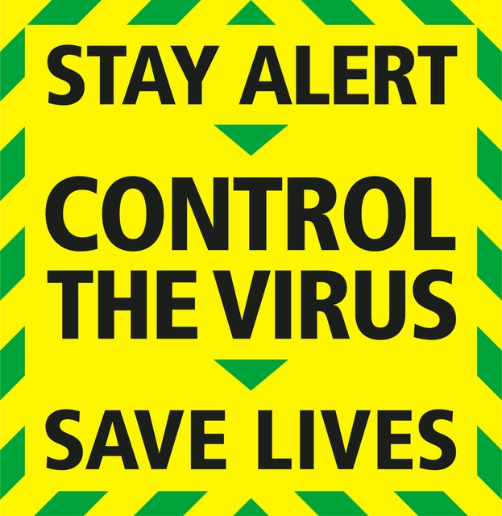

**SEND Transport**

*PPE*

1. Drivers and Passenger Assistants will wear PPE appropriate to the risk assessment for their role, the pupils on board and the nature of the staff interaction with them.
2. When applying or removing fluid resistant face masks or other PPE, it is important that the wearer’s hands are washed/cleansed for 20 seconds before and after each use.
3. Training on Infection and Prevention for frontline staff is mandatory for all Passenger Assistants and In house Drivers along with Covid-19 training.

*Pick Up Points*

1. At pick up points, where passenger assistants receive passengers from their parents/carers, social distancing guidance must be adhered to and alcohol hand sanitiser used by pupils and passenger assistants; passenger assistants should stay as far away as they can from parents/carers and spend as little time near them as possible; passenger assistants should avoid any physical contact with house doors, gates or parent/carer property or belongings.

*Risk Assessment*

1. An additional risk assessment should be carried out where circumstances change or where there are additional issues present. Parents will be contacted directly if they are affected by this.

*Seating*

1. If the passenger assistant needs to fasten a passenger’s seat belt/harness, this should be done with minimal physical contact, wearing appropriate PPE.
2. Where we can, pupils will be seated to reflect schools requests. Whilst this principle accords with general Government guidance, making it meaningful on a SEND bus will be problematic, given that the seating layouts have to accommodate wheelchairs, access needs for individual pupils and passenger assistants, specific medical needs and inter pupil dynamics, amongst other things.  None the less, we will attempt to provide the ‘bubble’ arrangement where we can.

*Wheelchairs/Handling*

1. If drivers or passenger assistants have to manoeuvre wheelchairs, they should clean the wheelchair handles and brake levers prior to pushing the wheelchair. Likewise, if installing car seats or booster seats, clean the hard surface areas (e.g. outer shell, buckles) before installing in the vehicle and clean them after use – for these tasks PPE should be worn, and this should include disposable gloves and fluid resistant face masks/face visors.
2. Proper planning and the use of appropriate PPE will be needed for wheelchair users and those with disabilities where handling and sustained contact may be required for getting on and off vehicles, as in the ambulance procedure.
3. Any unnecessary moving and handling or close sustained contact with the pupil will be avoided.
4. The UK Government have issued advice in respect of ‘COVID-19: infection prevention and control ‘and operators and staff should be aware of this. It can be found at this link:

<https://www.gov.uk/government/publications/wuhan-novel-coronavirus-infection-prevention-and-control>

*Face Coverings*

1. For children over the age of 11,the Law says face coverings must be worn, especially if children are likely to come into very close contact with others outside their year group or who they do not normally meet. So, where SEND pupils can wear face coverings on provided transport, we must encourage this. Ideally pupils should not touch the front of their face covering during use or when removing them. Hands should be washed for 20 seconds immediately on arrival, and disposable face coverings placed in a covered bin or, for reusable face coverings, in a plastic bag. We are mindful that the wearing of a face covering may inhibit communication with people who rely on lip reading, facial expressions and clear sound.

**Local Bus Services (public buses)**

*Government Guidance*

1. Whilst the general principles above will apply, the Government have provided specific guidance for the use of public transport and this should be adhered to. Details can be found within this link:

<https://www.gov.uk/guidance/coronavirus-covid-19-safer-travel-guidance-for-passengers>

*Limited Capacities*

1. Social distancing will still apply on public bus (and Rail, Tube, etc.) services from September 2020, meaning loading capacities will be less than 50%.
2. Government have asked local authorities to liaise with their schools and operators and arrange for additional buses (or coaches) to be provided for school children from September 2020 where loading capacity restrictions on public bus services mean that there won’t be enough on-bus spaces for all. Where this is most likely, the Council have arranged for extra school only buses/coaches (‘duplicates’) to directly follow the main public bus in order to provide extra capacity. Where provided, entitled and non-entitled pupils should only travel on these ‘duplicates’, with adult fare paying passengers continuing to use the main public bus.
3. Where public bus operators take up the option of closing bus services to ‘schools only’, the general public will not be able to travel, meaning that full seating capacities can be used, although there is still unlikely to be any provision for standing passengers.
4. Bus operators may deploy extra buses to supplement ‘school services’ where needs be and they will seek to publicise any new arrangements.

*Face Coverings*

1. Pupils/students travelling on public buses to school/college must wear face coverings whilst travelling. This is mandatory for all passengers, unless exempt.

*Journey Planning*

1. Passengers should leave extra time for their journey and keep their distance from other passengers, cleaning hands frequently and using contactless payment.
2. A Government guidance leaflet is below:

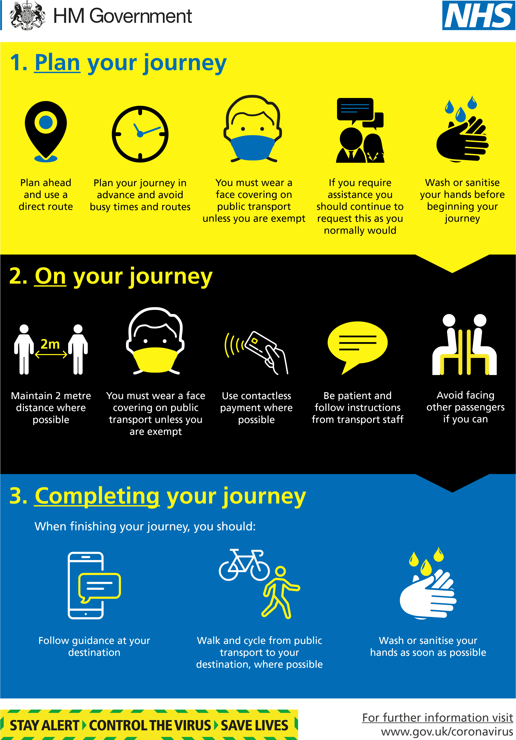

**Summary**

Blackburn with Darwen Borough Council greatly appreciates all the support and effort from school transport operators, schools and our other partners in continuing to provide transport services in the Coronavirus (Covid-19) national emergency and we are always here to support you.

We implore parents, pupils, students, passengers, schools and all others involved in Blackburn with Darwen’s Borough Councils passenger transport network, to take on responsibility for following these safety guidelines and support others in doing so.

**By working together, we can make Blackburn with Darwen safe.**

Please note this is correct at the time of dated and is subject to change.

Finally, for any queries please contact the Council’s Transport Team, using the contact details shown at the foot of this guidance.

Blackburn with Darwen Borough Council Transport Team

*Contact details:*

*Blackburn with Darwen Borough Council, Transport Team*

*Telephone: 01254 585003 Email:* [*Transport@blackburn.gov.uk*](mailto:Transport@blackburn.gov.uk)