Video Meeting Guidance for Parents/Carers
(There’s also a video training video here: https://youtu.be/TlfC_BAF1yg)
- It is crucial that parents/carers use a computer/device which has a webcam and microphone. We would recommend using Google Chrome on a PC/laptop and Android smartphone/tablets, and use Safari on an Apple device iPhone/iPad. It is also advisable to have this device fully charged ahead of the evening.
Parents must use one of the below devices and internet browser combinations for the video meeting technology to work:
- Apple iPhone/iPad (must be iOS 11+): Safari
- Android phone/tablet: Chrome or Firefox
- Linux computer: Chrome or Firefox
- Microsoft Surface: Chrome or Firefox
- Mac computer: Safari (version 11+), Chrome or Firefox
- Windows computer: Chrome, Firefox or Edge (but only the new Edge Chromium)

- On the day of the Parents’ Evening, It is crucial that you log-in via your Parent Firefly account and then click on the button on the top dashboard that looks like this…
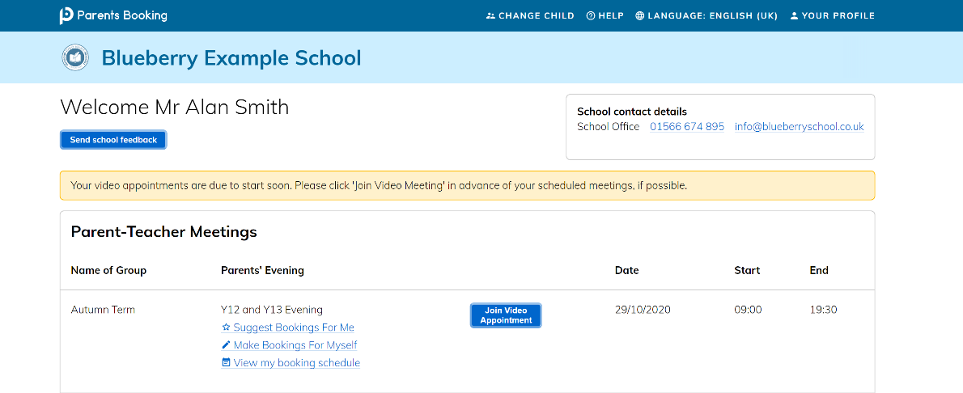
- 15 minutes prior to your first appointment, click the Join video meetings button next to Year 10 Parents’ Evening. This will take you to the appointments that you have been pre-booked.
Year 11Parents’ Evening Spring Term
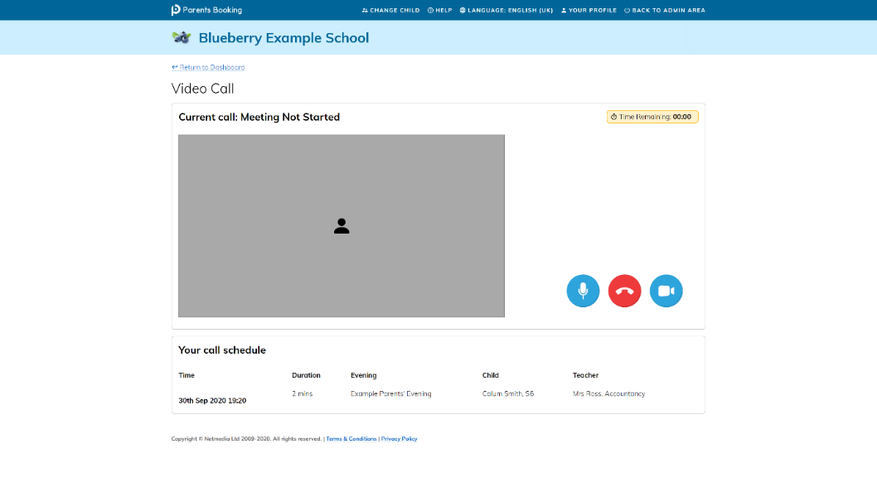
- You will be shown a “Meeting Not Started Yet” message. This will remain until the time your first appointment is due to begin.

- When the time of your first appointment starts, and provided the teacher is also ready for the meeting, your meeting will begin.
Before you can talk, you will need to provide permission to your browser to use its microphone and webcam.
This will appear as a ‘pop-up’ that asks which microphone, and then which webcam, you want to use. Press ‘Allow’ and ‘Apply’ for both.
Your browser should remember these settings; however, Safari on iPad/iPhone does not seem to, and if you need to clear these choices and start again, clear your browser’s cookies.
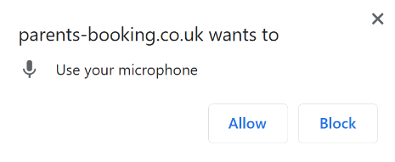
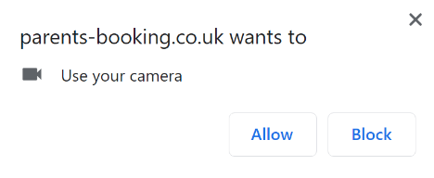

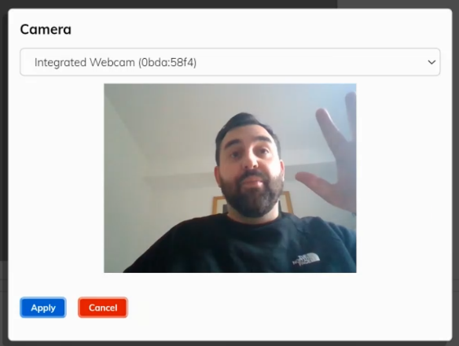
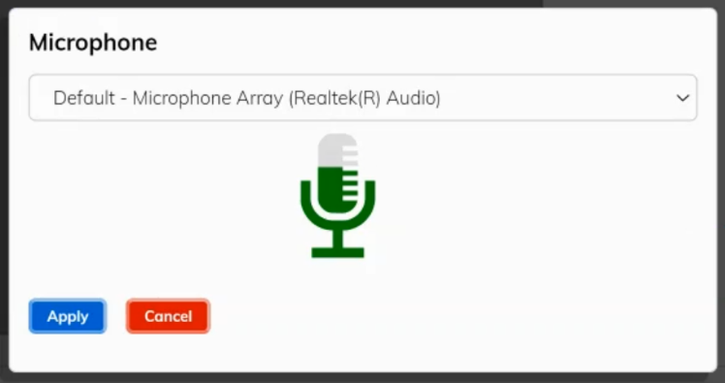

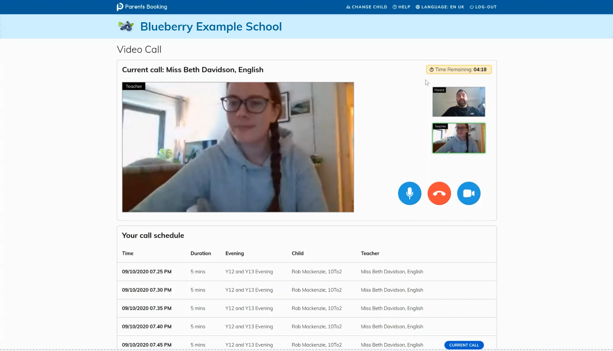
6. Once you have provided permission to the microphone and webcam, your video meeting will begin.
You can turn off your microphone and/or camera at any time here.
You can also cancel the call and go back to your Dashboard here, but please don’t do this unless the teachers ask you to!

7. Appointments are set at 4 minutes and will terminate at this point. Our teachers are not able to extend appointments. Once one appointment has finished the next will start instantaneously, and you do not need to change the web page. Your schedule is shown at the bottom of the page.

