11th February 2021
Year 10 Video Parents’ Evening – Thursday 11th February 2021

Dear Parent/Carer,
We are looking forward to welcoming you to our forthcoming Video Parents’ evening tonight. We thank you for booking your appointments in advance of the evening and appreciate your support during what are extremely challenging times.

The below information and attached guidance have been written to help you to prepare for and get the most out of the evening. Should you have any further questions prior to the evening, please contact parentsevenings@saintwilfrids.com.

Before the evening
- Please ensure you know the log-in details for your Parent Firefly account. Without these you will not be able to access your video appointments on the evening.
- Please check the times of your appointments and ensure you log-in to Firefly 15 minutes prior to your first appointment start time.
- Please ensure you have read the attached guidance regarding: -
  - The compatibility of your device and the recommended browsers.
  - The setting up your devices microphone and video capabilities for the video appointments.
- Please ensure that you have a pen and paper at hand so you can make a note of the key points.
- You may want your son/ daughter to attend alongside you, this will be beneficial for them to hear what staff are saying.

During each appointment
- Staff have been allocated 4 minutes per appointment (this is slightly longer than the allocated time within a face-to-face Parents Evening) Once your appointment begins the timer will start. The meeting is automated and as such staff cannot continue the conversation or extend the appointment beyond the 4-minute time. After the time has expired, the video session will automatically cease and move on to your next appointment.
- Please ensure you are dressed appropriately and in a quiet place, free from background noise.
- Please ensure you device is fully charged or powered from a wall socket, being mindful of trip hazards when extension cords are used and being sure not to overload any single socket with multiple devices.
- Parents/carers and students must not take any video or audio recordings or pictures of the screen during the video meeting. Any unauthorised distribution of images or recordings could be a criminal offence under the Data Protection Act and could be subject to disciplinary measures by the Academy.
- Although we have invested a lot of time into ensuring our video parents’ evening runs as smoothly as possible, we do ask for your patience and understanding if you do experience any technical difficulties on the evening.

Following the evening
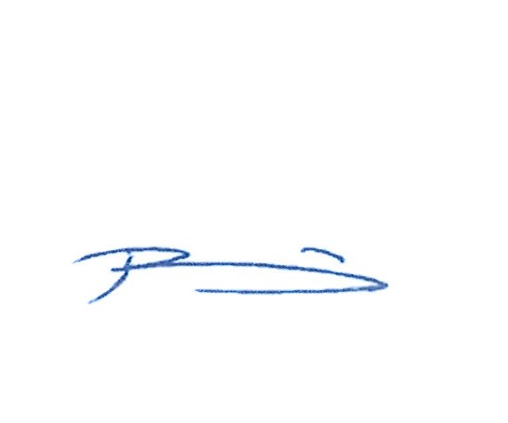
- If you were not able to book a video appointment with a certain subject or member of staff or if following your video call you would like to discuss a matter further, please email this request to parentsevenings@saintwilfrids.com. Your query will be sent on to the appropriate member of staff, who will endeavour to respond in due course.

Thank you for your continued support,

Yours sincerely
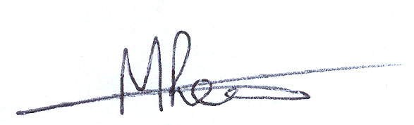

Mrs N Pyper-Mann Mr P Lewis
Year 10 Manager KS4 Assistant Principal

